**INDEX**

**Subject:**  Mobile Application Development(3170726)

**Enrollment No: 180170107030**

**Name of the Student: Gabu Siddharth**

|  |  |  |  |  |  |  |
| --- | --- | --- | --- | --- | --- | --- |
| **Sr.**  **No** | **Aim** | **CO addressed** | **Date** | **Page No** | **Marks**  **(out of 10)** | **Faculty**  **Signature** |
| 1 | Practical Set 1:  Develope and Mobile Application for following topic   1. Design Login activity and implement control events : Use EditText, Checkbox and Buttons 2. Create Activities & implement following   1. Implicit intent  2. Explicit Intent  3. StartActivityForResult   1. Implement activity Lifecycle and State Callbacks | CO1 | 29/6 | 1 |  |  |
| 2 | **Practical Set 2:**  Develope and Mobile Application for following topic   1. Implement Practical 1.1 using following layouts:   1. Linear Layout  2. Relative Layout  3. Table Layout   1. Use an Options Menu 2. Create a Recycler View and list the details of student using following fields:   1. Name  2. Address  3. Photo (Image)  4. Delete ( Button Operation) | CO2 | 6/7 | 8 |  |  |
| 3 | **Practical Set 3:**  Develop and Mobile Application for following topic   1. Theme, 2. Custom Styles | CO2 | 13/7 | 20 |  |  |
| 4 | **Practical Set 4:**  Develop and Mobile Application for storing Data and Retrieve and Manipulate data Using SQLite database | CO3 | 27/7 | 26 |  |  |
| 5 | **Practical Set 5 :**  Develop and Mobile Application for following topic   1. Use an AsyncTask to access remote database (make a use of simple PhP Web service) 2. Use Retrofit to access remote database (make a use of simple PhP Web service) | CO3 | 3/8 | 37 |  |  |
| 6 | **Practical Set 6 :**  Develop and Mobile Application for following topic   1. Get and Save User Preferences 2. Use Firebase to perform CRUID operation | CO3 | 10/8 | 46 |  |  |
| 7 | **Practical Set 7:**  Develop and Mobile Application for following topic   1. BroadcastReceiver 2. Notifications | CO4 | 24/8 | 60 |  |  |
| 8 | **Practical Set 8 :**  Develop and Mobile Application for following topic   1. Make a use of android system like play audio,Video,Send SMS,Email, 2. Using location service get the current location 3. Display the use of animations | CO4 | 7/9 | 66 |  |  |
| 9 | **Practical Set 9**  Develop a Mobile application for any topic (Mini Project) | CO5 | 21/9 | 88 |  |  |
| 10 | **Practical 10:**  Write Steps to generate a APK File of Mini Project and publish the Application | CO5 | 28/9 | 93 |  |  |

**Practical – 1**

**AIM:** Develop and Mobile Application for following topic

1. Design Login activity and implement control events: Use Edit Text, Checkbox and Buttons

2. Create Activities & implement following

1. Implicit intent

2. Explicit Intent

3. StartActivityForResult

3. Implement activity Lifecycle and State Callbacks

***Activity_preactical1.xml***

*<?***xml version="1.0" encoding="utf-8"***?>*<**androidx.constraintlayout.widget.ConstraintLayout xmlns:android="http://schemas.android.com/apk/res/android"  
 xmlns:app="http://schemas.android.com/apk/res-auto"  
 xmlns:tools="http://schemas.android.com/tools"  
 android:layout_width="match_parent"  
 android:layout_height="match_parent"  
 android:background="@drawable/gradient"  
 tools:context=".Practical1"**>  
  
 <**ScrollView  
 android:layout_width="match_parent"  
 android:layout_height="match_parent"  
 android:background="@drawable/gradient"  
 app:layout_constraintBottom_toBottomOf="parent"  
 app:layout_constraintEnd_toEndOf="parent"  
 app:layout_constraintStart_toStartOf="parent"  
 app:layout_constraintTop_toTopOf="parent"**>  
  
 <**androidx.constraintlayout.widget.ConstraintLayout  
 android:layout_width="match_parent"  
 android:layout_height="wrap_content"**>  
  
 <**ImageView  
 android:id="@+id/imageView"  
 android:layout_width="120dp"  
 android:layout_height="150dp"  
 android:layout_marginStart="32dp"  
 android:layout_marginLeft="32dp"  
 android:layout_marginTop="80dp"  
 android:layout_marginEnd="32dp"  
 android:layout_marginRight="32dp"  
 android:contentDescription="@string/Co512"  
 app:layout_constraintEnd_toEndOf="parent"  
 app:layout_constraintStart_toStartOf="parent"  
 app:layout_constraintTop_toTopOf="parent"  
 app:srcCompat="@drawable/co_512"** />  
  
 <**TextView  
 android:id="@+id/errorTxtView"  
 android:layout_width="wrap_content"  
 android:layout_height="wrap_content"  
 android:layout_marginBottom="8dp"  
 android:text="@string/blank"  
 android:textColor="#ff0000"  
 android:textSize="20sp"  
 app:layout_constraintBottom_toTopOf="@+id/editTextTextPersonName"  
 app:layout_constraintEnd_toEndOf="parent"  
 app:layout_constraintHorizontal_bias="0.498"  
 app:layout_constraintStart_toStartOf="parent"** />  
  
 <**EditText  
 android:id="@+id/editTextTextPersonName"  
 android:layout_width="wrap_content"  
 android:layout_height="wrap_content"  
 android:layout_marginStart="32dp"  
 android:layout_marginLeft="32dp"  
 android:layout_marginTop="80dp"  
 android:layout_marginEnd="32dp"  
 android:layout_marginRight="32dp"  
 android:background="#11000000"  
 android:drawableStart="@drawable/ic_action_username"  
 android:drawableLeft="@drawable/ic_action_username"  
 android:ems="10"  
 android:hint="@string/username_hint"  
 android:importantForAutofill="no"  
 android:inputType="textPersonName"  
 android:padding="10dp"  
 android:textColor="#fff"  
 android:textColorHint="#9e9e9e"  
 android:textSize="20sp"  
 app:layout_constraintEnd_toEndOf="parent"  
 app:layout_constraintStart_toStartOf="parent"  
 app:layout_constraintTop_toBottomOf="@+id/imageView"** />  
  
 <**EditText  
 android:id="@+id/editTextTextPassword"  
 android:layout_width="wrap_content"  
 android:layout_height="wrap_content"  
 android:layout_marginStart="32dp"  
 android:layout_marginLeft="32dp"  
 android:layout_marginTop="16dp"  
 android:layout_marginEnd="32dp"  
 android:layout_marginRight="32dp"  
 android:background="#11000000"  
 android:drawableStart="@drawable/ic_action_password"  
 android:drawableLeft="@drawable/ic_action_password"  
 android:ems="10"  
 android:hint="@string/password_hint"  
 android:importantForAutofill="no"  
 android:inputType="textPassword"  
 android:padding="10dp"  
 android:textColor="#fff"  
 android:textColorHint="#9e9e9e"  
 android:textSize="20sp"  
 app:layout_constraintEnd_toEndOf="parent"  
 app:layout_constraintStart_toStartOf="parent"  
 app:layout_constraintTop_toBottomOf="@+id/editTextTextPersonName"** />  
  
 <**CheckBox  
 android:id="@+id/checkBox"  
 android:layout_width="wrap_content"  
 android:layout_height="wrap_content"  
 android:text="@string/remember"  
 android:textColor="#9e9e9e"  
 android:textSize="20sp"  
 app:layout_constraintStart_toStartOf="@+id/editTextTextPassword"  
 app:layout_constraintTop_toBottomOf="@+id/editTextTextPassword"** />  
  
 <**Button  
 android:id="@+id/button"  
 android:layout_width="300dp"  
 android:layout_height="wrap_content"  
 android:layout_marginStart="32dp"  
 android:layout_marginLeft="32dp"  
 android:layout_marginTop="88dp"  
 android:layout_marginEnd="32dp"  
 android:layout_marginRight="32dp"  
 android:background="@drawable/button_background"  
 android:onClick="ValidInput"  
 android:padding="10dp"  
 android:text="@string/login"  
 android:textColor="#fff"  
 android:textSize="24sp"  
 app:backgroundTint="#FA46E8"  
 app:layout_constraintEnd_toEndOf="parent"  
 app:layout_constraintStart_toStartOf="parent"  
 app:layout_constraintTop_toBottomOf="@+id/editTextTextPassword"** />  
  
 <**TextView  
 android:id="@+id/textView"  
 android:layout_width="wrap_content"  
 android:layout_height="wrap_content"  
 android:layout_marginTop="24dp"  
 android:layout_marginBottom="32dp"  
 android:text="@string/register"  
 android:textColor="#fff"  
 android:textSize="16sp"  
 app:layout_constraintBottom_toBottomOf="parent"  
 app:layout_constraintEnd_toEndOf="parent"  
 app:layout_constraintStart_toStartOf="parent"  
 app:layout_constraintTop_toBottomOf="@+id/button"** />  
  
 </**androidx.constraintlayout.widget.ConstraintLayout**>  
 </**ScrollView**>  
</**androidx.constraintlayout.widget.ConstraintLayout**>

***Practical1.java***

**package** com.example.madpractical;  
  
**import** android.content.Intent;  
**import** android.net.Uri;  
**import** android.os.Bundle;  
**import** android.util.Log;  
**import** android.view.View;  
**import** android.widget.EditText;  
**import** android.widget.ImageView;  
**import** android.widget.TextView;  
**import** android.widget.Toast;  
  
**import** androidx.appcompat.app.AppCompatActivity;  
  
**public class** Practical1 **extends** AppCompatActivity {  
 @Override  
 **protected void** onCreate(Bundle savedInstanceState) {  
 **super**.onCreate(savedInstanceState);  
 setContentView(R.layout.***activity_practical1***);  
 Log.*d*(**"lifecycle"**, **"onCreate invoked"**);  
 */* Implicit intent */  
 // it is used to communicate between two different apps  
 // For example, if you want to show the user a Web page or website,  
 // you can use an implicit intent to request that another capable  
 // app show a specified Web page or website.* ImageView imgClick = (ImageView) findViewById(R.id.***imageView***);  
 imgClick.setOnClickListener(**new** View.OnClickListener() {  
 @Override  
 **public void** onClick(View v) {  
 Toast.*makeText*(Practical1.**this**, **"You clicked on collegeek.com"**, Toast.***LENGTH_LONG***).show();  
 Intent intent = **new** Intent(Intent.***ACTION_VIEW***);  
 intent.setData(Uri.*parse*(**"https://collegeek.com"**));  
 startActivity(intent);  
 }  
 });  
 }  
  
 */* Control events */* **public void** ValidInput(View view) {  
 EditText editText = findViewById(R.id.***editTextTextPersonName***);  
 EditText editText1 = findViewById(R.id.***editTextTextPassword***);  
 String username = editText.getText().toString();  
 String password = editText1.getText().toString();  
 **if** (username.isEmpty() || password.isEmpty()) {  
 TextView textView = findViewById(R.id.***errorTxtView***);  
 textView.setText(**"Username and Password required!"**);  
 } **else** {  
 */* Explicit intent */  
 // use an explicit intent to start a component in your own app,*

*// because you know the class name of the activity or service you*

*// want to start. For example, you might start a new activity*

*// within your app in response to a user action, or start a*

*// service to download a file in the background.* Intent intent = **new** Intent(**this**, Login_message.**class**);  
 intent.putExtra(**"Username"**, username);  
 intent.putExtra(**"Password"**, password);  
 startActivity(intent);  
 }  
 }  
  
 */* Android Activity Lifecycle */  
 // onCreate is above* @Override  
 **protected void** onStart() {  
 **super**.onStart();  
 Log.*d*(**"lifecycle"**, **"onStart invoked"**);  
 }  
  
 @Override  
 **protected void** onResume() {  
 **super**.onResume();  
 Log.*d*(**"lifecycle"**, **"onResume invoked"**);  
 }  
  
 @Override  
 **protected void** onPause() {  
 **super**.onPause();  
 Log.*d*(**"lifecycle"**, **"onPause invoked"**);  
 }  
  
 @Override  
 **protected void** onStop() {  
 **super**.onStop();  
 Log.*d*(**"lifecycle"**, **"onStop invoked"**);  
 }  
  
 @Override  
 **protected void** onRestart() {  
 **super**.onRestart();  
 Log.*d*(**"lifecycle"**, **"onRestart invoked"**);  
 }  
  
 @Override  
 **protected void** onDestroy() {  
 **super**.onDestroy();  
 Log.*d*(**"lifecycle"**, **"onDestroy invoked"**);  
 }  
}

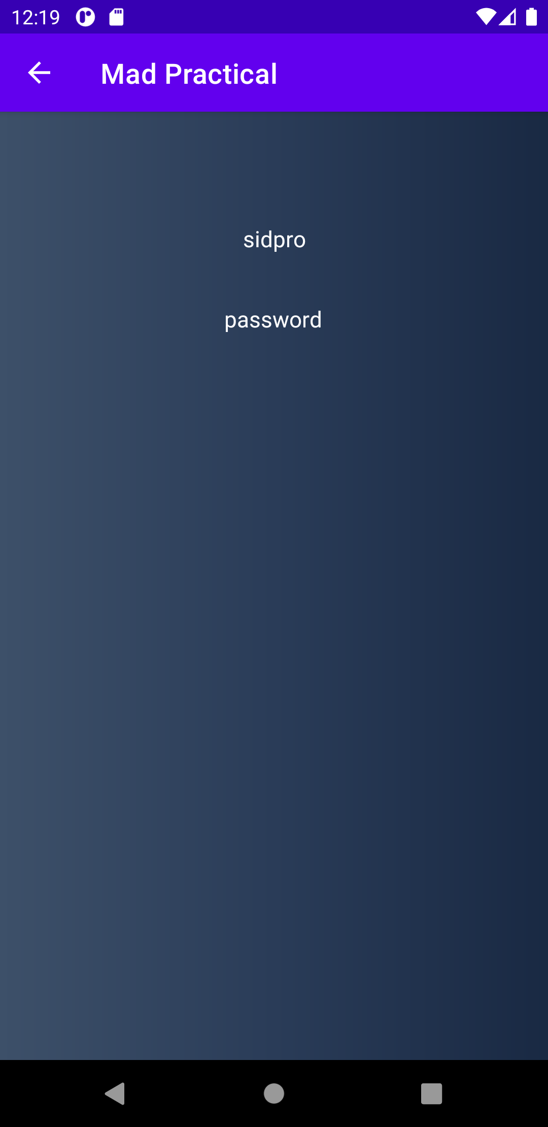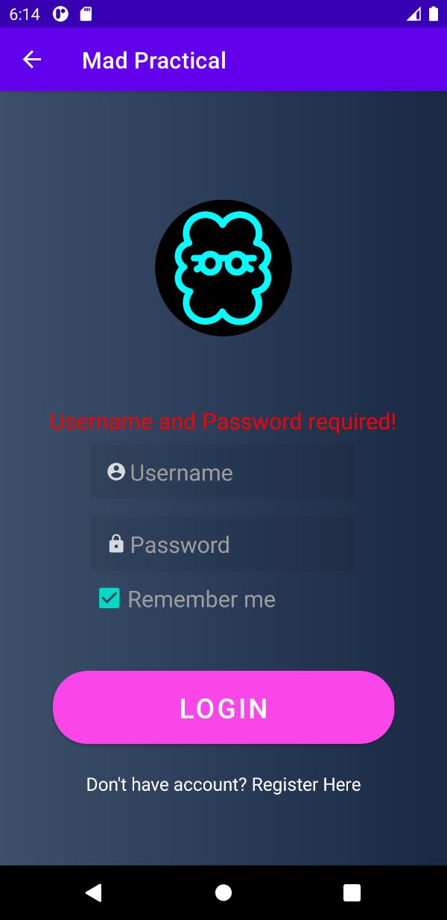

Fig 1.1 and Fig 1.2 Login activity with control events and explicit intent

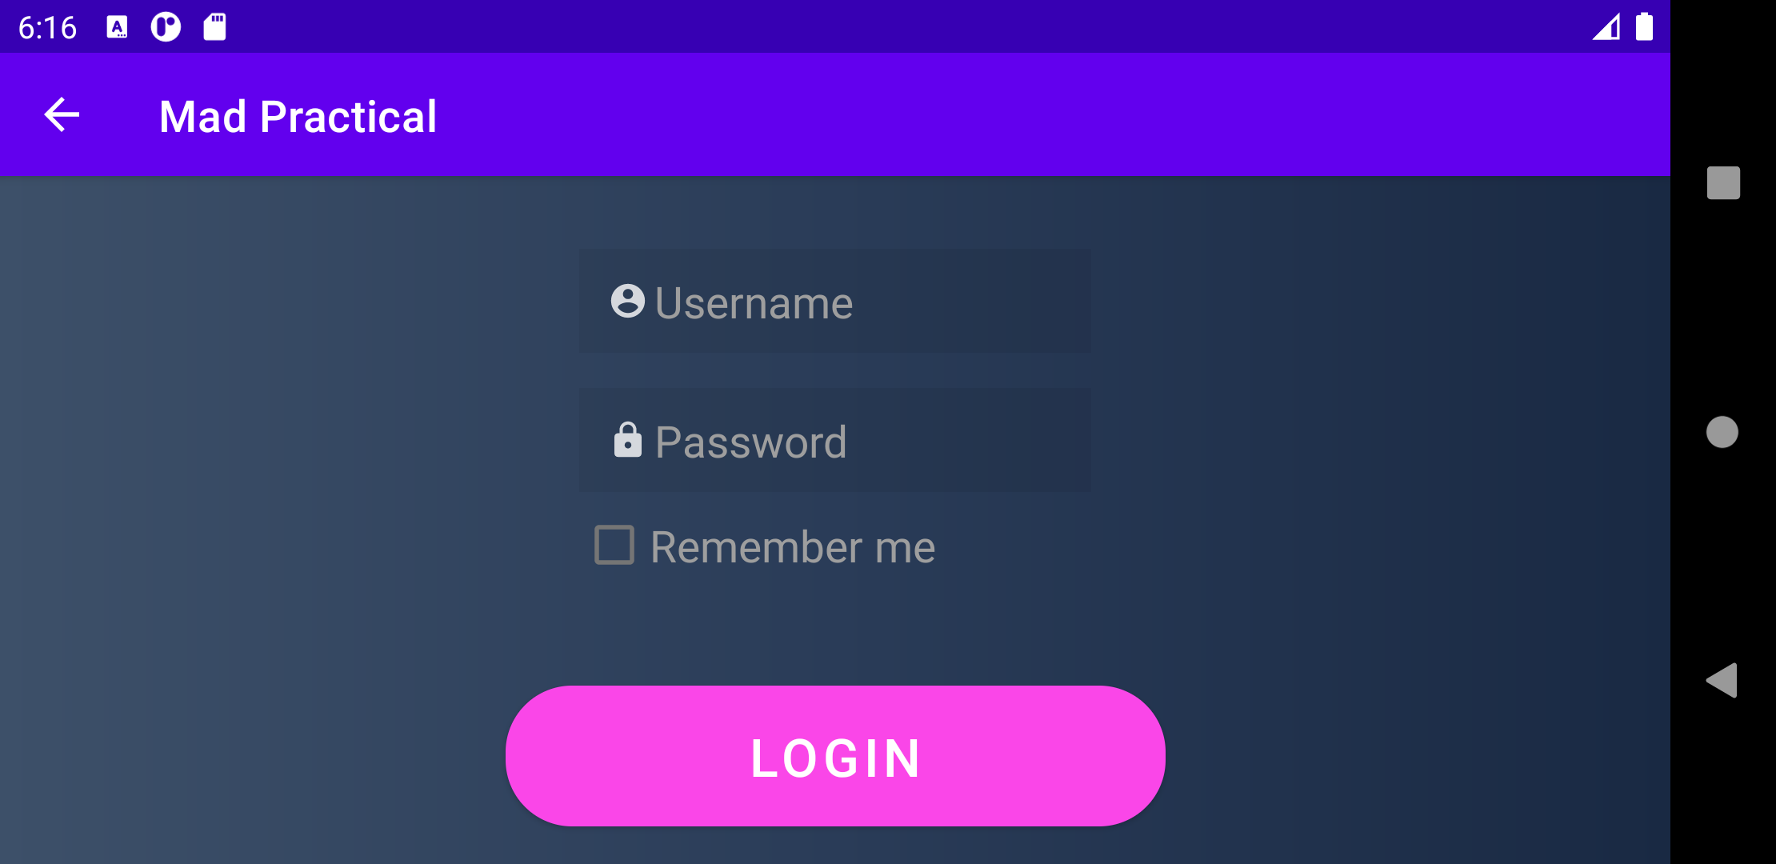

Fig 1.3 Screen compatibility

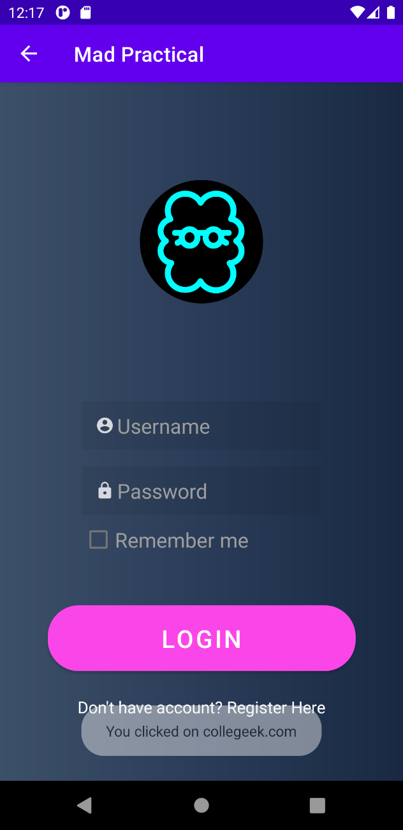

Fig 1.4 and Fig 1.5 By clicking on image it will open web page using implicit intent

|  |
| --- |
| logcat  2021-08-21 11:33:20.314 9789-9789/com.example.madpractical D/lifecycle: onCreate invoked  2021-08-21 11:33:48.025 9789-9789/com.example.madpractical D/lifecycle: onStart invoked  2021-08-21 11:33:48.026 9789-9789/com.example.madpractical D/lifecycle: onResume invoked  2021-08-21 11:33:58.733 9789-9789/com.example.madpractical D/lifecycle: onPause invoked  2021-08-21 11:33:59.370 9789-9789/com.example.madpractical D/lifecycle: onStop invoked  2021-08-21 11:33:59.372 9789-9789/com.example.madpractical D/lifecycle: onDestroy invoked |

Fig 1.6 Activity life cycle

**Practical – 2**

**AIM:** Develop and Mobile Application for following topic

1. Implement Practical 1.1 using following layouts:

1. Linear Layout

2. Relative Layout

3. Table Layout

2. Use an Options Menu

3. Create a Recycler View and list the details of student using following fields:

1. Name

2. Address

3. Photo (Image)

4. Delete (Button Operation)

***Linear Layout.xml***

*<?***xml version="1.0" encoding="utf-8"***?>*<**LinearLayout xmlns:android="http://schemas.android.com/apk/res/android"  
 xmlns:app="http://schemas.android.com/apk/res-auto"  
 xmlns:tools="http://schemas.android.com/tools"  
 android:layout_width="match_parent"  
 android:layout_height="match_parent"  
 android:orientation="vertical"  
 android:background="@drawable/gradient"  
 tools:context=".Practical_2a"**>  
  
 <**ImageView  
 android:id="@+id/imageView"  
 android:layout_width="120dp"  
 android:layout_height="150dp"  
 android:layout_marginTop="80dp"  
 android:layout_gravity="center"  
 android:contentDescription="@string/Co512"  
 app:srcCompat="@drawable/co_512"** />  
  
 <**TextView  
 android:id="@+id/errorTxtView"  
 android:layout_width="wrap_content"  
 android:layout_height="wrap_content"  
 android:layout_marginBottom="8dp"  
 android:layout_gravity="center"  
 android:layout_marginTop="50dp"  
 android:text="@string/blank"  
 android:textColor="#ff0000"  
 android:textSize="20sp"** />  
  
 <**EditText  
 android:id="@+id/editTextTextPersonName"  
 android:layout_width="wrap_content"  
 android:layout_height="wrap_content"  
 android:layout_gravity="center"  
 android:background="#11000000"  
 android:drawableStart="@drawable/ic_action_username"  
 android:drawableLeft="@drawable/ic_action_username"  
 android:ems="10"  
 android:hint="@string/username_hint"  
 android:importantForAutofill="no"  
 android:inputType="textPersonName"  
 android:padding="10dp"  
 android:textColor="#fff"  
 android:textColorHint="#9e9e9e"  
 android:textSize="20sp"** />  
  
 <**EditText  
 android:id="@+id/editTextTextPassword"  
 android:layout_width="wrap_content"  
 android:layout_height="wrap_content"  
 android:layout_marginTop="16dp"  
 android:layout_gravity="center"  
 android:background="#11000000"  
 android:drawableStart="@drawable/ic_action_password"  
 android:drawableLeft="@drawable/ic_action_password"  
 android:ems="10"  
 android:hint="@string/password_hint"  
 android:importantForAutofill="no"  
 android:inputType="textPassword"  
 android:padding="10dp"  
 android:textColor="#fff"  
 android:textColorHint="#9e9e9e"  
 android:textSize="20sp"** />  
  
 <**CheckBox  
 android:id="@+id/checkBox"  
 android:layout_width="wrap_content"  
 android:layout_height="wrap_content"  
 android:layout_gravity="center"  
 android:text="@string/remember"  
 android:textColor="#9e9e9e"  
 android:textSize="20sp"  
 android:layout_marginStart="-34dp"  
 android:layout_marginLeft="-34dp"** />  
  
 <**Button  
 android:id="@+id/button"  
 android:layout_width="300dp"  
 android:layout_height="wrap_content"  
 android:layout_gravity="center"  
 android:layout_marginTop="48dp"  
 android:background="@drawable/button_background"  
 android:onClick="ValidInput"  
 android:padding="10dp"  
 android:text="@string/login"  
 android:textColor="#fff"  
 android:textSize="24sp"  
 app:backgroundTint="#FA46E8"** />  
  
 <**TextView  
 android:id="@+id/textView"  
 android:layout_width="wrap_content"  
 android:layout_height="wrap_content"  
 android:layout_marginTop="24dp"  
 android:layout_gravity="center"  
 android:text="@string/register"  
 android:textColor="#fff"  
 android:textSize="16sp"** />  
</**LinearLayout**>

***Relative Layout.xml***

*<?***xml version="1.0" encoding="utf-8"***?>*<**RelativeLayout xmlns:android="http://schemas.android.com/apk/res/android"  
 xmlns:tools="http://schemas.android.com/tools"  
 android:layout_width="match_parent"  
 android:layout_height="match_parent"  
 xmlns:app="http://schemas.android.com/apk/res-auto"  
 android:background="@drawable/gradient"  
 tools:context=".Practical_2b"**>  
  
 <**ImageView  
 android:id="@+id/imageView"  
 android:layout_width="120dp"  
 android:layout_height="150dp"  
 android:layout_centerHorizontal="true"  
 android:layout_marginTop="80dp"  
 android:contentDescription="@string/Co512"  
 app:srcCompat="@drawable/co_512"** />  
  
 <**TextView  
 android:id="@+id/errorTxtView"  
 android:layout_width="wrap_content"  
 android:layout_height="wrap_content"  
 android:layout_below="@id/imageView"  
 android:layout_centerHorizontal="true"  
 android:layout_marginTop="50dp"  
 android:layout_marginBottom="8dp"  
 android:text="@string/blank"  
 android:textColor="#ff0000"  
 android:textSize="20sp"** />  
  
 <**EditText  
 android:id="@+id/editTextTextPersonName"  
 android:layout_width="wrap_content"  
 android:layout_height="wrap_content"  
 android:layout_below="@id/errorTxtView"  
 android:layout_centerHorizontal="true"  
 android:background="#11000000"  
 android:drawableStart="@drawable/ic_action_username"  
 android:drawableLeft="@drawable/ic_action_username"  
 android:ems="10"  
 android:hint="@string/username_hint"  
 android:importantForAutofill="no"  
 android:inputType="textPersonName"  
 android:padding="10dp"  
 android:textColor="#fff"  
 android:textColorHint="#9e9e9e"  
 android:textSize="20sp"** />  
  
 <**EditText  
 android:id="@+id/editTextTextPassword"  
 android:layout_width="wrap_content"  
 android:layout_height="wrap_content"  
 android:layout_marginTop="16dp"  
 android:layout_centerHorizontal="true"  
 android:layout_below="@id/editTextTextPersonName"  
 android:background="#11000000"  
 android:drawableStart="@drawable/ic_action_password"  
 android:drawableLeft="@drawable/ic_action_password"  
 android:ems="10"  
 android:hint="@string/password_hint"  
 android:importantForAutofill="no"  
 android:inputType="textPassword"  
 android:padding="10dp"  
 android:textColor="#fff"  
 android:textColorHint="#9e9e9e"  
 android:textSize="20sp"** />  
  
 <**CheckBox  
 android:id="@+id/checkBox"  
 android:layout_width="wrap_content"  
 android:layout_height="wrap_content"  
 android:layout_below="@id/editTextTextPassword"  
 android:layout_alignStart="@id/editTextTextPassword"  
 android:text="@string/remember"  
 android:textColor="#9e9e9e"  
 android:textSize="20sp"  
 android:layout_alignLeft="@id/editTextTextPassword"** />  
  
 <**Button  
 android:id="@+id/button"  
 android:layout_width="300dp"  
 android:layout_height="wrap_content"  
 android:layout_below="@id/checkBox"  
 android:layout_centerHorizontal="true"  
 android:layout_marginTop="48dp"  
 android:background="@drawable/button_background"  
 android:onClick="ValidInput"  
 android:padding="10dp"  
 android:text="@string/login"  
 android:textColor="#fff"  
 android:textSize="24sp"  
 app:backgroundTint="#FA46E8"** />  
  
 <**TextView  
 android:id="@+id/textView2"  
 android:layout_width="wrap_content"  
 android:layout_height="wrap_content"  
 android:layout_below="@id/button"  
 android:layout_marginTop="24dp"  
 android:layout_centerHorizontal="true"  
 android:textColor="#fff"  
 android:text="@string/register"** />  
</**RelativeLayout**>

***Table Layout.xml***

*<?***xml version="1.0" encoding="utf-8"***?>*<**TableLayout xmlns:android="http://schemas.android.com/apk/res/android"  
 xmlns:app="http://schemas.android.com/apk/res-auto"  
 xmlns:tools="http://schemas.android.com/tools"  
 android:layout_width="match_parent"  
 android:layout_height="match_parent"  
 android:background="@drawable/gradient"  
 tools:context=".Practical_2c"**>  
  
 <**TableRow  
 android:layout_width="match_parent"  
 android:layout_height="wrap_content"  
 android:gravity="center_horizontal"  
 android:layout_marginTop="80dp"**>  
 <**ImageView  
 android:id="@+id/imageView"  
 android:layout_width="120dp"  
 android:layout_height="150dp"  
 android:contentDescription="@string/Co512"  
 app:srcCompat="@drawable/co_512"** />  
 </**TableRow**>  
  
 <**TableRow  
 android:layout_width="match_parent"  
 android:layout_height="wrap_content"  
 android:gravity="center_horizontal"  
 android:layout_marginTop="50dp"  
 android:layout_marginBottom="8dp"**>  
 <**TextView  
 android:id="@+id/errorTxtView"  
 android:layout_gravity="center"  
 android:layout_width="wrap_content"  
 android:layout_height="wrap_content"  
 android:text="@string/blank"  
 android:textColor="#ff0000"  
 android:textSize="20sp"** />  
 </**TableRow**>  
  
 <**TableRow  
 android:layout_width="match_parent"  
 android:layout_height="wrap_content"  
 android:gravity="center_horizontal"**>  
 <**EditText  
 android:id="@+id/editTextTextPersonName"  
 android:layout_width="wrap_content"  
 android:layout_height="wrap_content"  
 android:layout_gravity="center"  
 android:background="#11000000"  
 android:drawableStart="@drawable/ic_action_username"  
 android:drawableLeft="@drawable/ic_action_username"  
 android:ems="10"  
 android:hint="@string/username_hint"  
 android:importantForAutofill="no"  
 android:inputType="textPersonName"  
 android:padding="10dp"  
 android:textColor="#fff"  
 android:textColorHint="#9e9e9e"  
 android:textSize="20sp"** />  
 </**TableRow**>  
  
 <**TableRow  
 android:layout_width="match_parent"  
 android:layout_height="wrap_content"  
 android:gravity="center_horizontal"  
 android:layout_marginTop="16dp"**>  
 <**EditText  
 android:id="@+id/editTextTextPassword"  
 android:layout_width="wrap_content"  
 android:layout_height="wrap_content"  
 android:layout_gravity="center"  
 android:background="#11000000"  
 android:drawableStart="@drawable/ic_action_password"  
 android:drawableLeft="@drawable/ic_action_password"  
 android:ems="10"  
 android:hint="@string/password_hint"  
 android:importantForAutofill="no"  
 android:inputType="textPassword"  
 android:padding="10dp"  
 android:textColor="#fff"  
 android:textColorHint="#9e9e9e"  
 android:textSize="20sp"** />  
 </**TableRow**>  
  
 <**TableRow  
 android:layout_width="match_parent"  
 android:layout_height="wrap_content"  
 android:gravity="center_horizontal"**>  
 <**CheckBox  
 android:id="@+id/checkBox"  
 android:layout_gravity="center"  
 android:layout_width="wrap_content"  
 android:layout_height="wrap_content"  
 android:text="@string/remember"  
 android:textColor="#9e9e9e"  
 android:textSize="20sp"  
 android:layout_marginStart="-70dp"  
 android:layout_marginLeft="-70dp"**/>  
 </**TableRow**>  
  
 <**TableRow  
 android:layout_width="match_parent"  
 android:layout_height="wrap_content"  
 android:gravity="center_horizontal"  
 android:layout_marginTop="48dp"**>  
  
 <**Button  
 android:id="@+id/button"  
 android:layout_width="300dp"  
 android:layout_height="wrap_content"  
 android:background="@drawable/button_background"  
 android:onClick="ValidInput"  
 android:padding="10dp"  
 android:text="@string/login"  
 android:textColor="#fff"  
 android:textSize="24sp"  
 app:backgroundTint="#FA46E8"** />  
 </**TableRow**>  
  
 <**TableRow  
 android:layout_width="match_parent"  
 android:layout_height="wrap_content"  
 android:gravity="center_horizontal"  
 android:layout_marginTop="24dp"**>  
 <**TextView  
 android:id="@+id/textView"  
 android:layout_width="wrap_content"  
 android:layout_height="wrap_content"  
 android:layout_gravity="center"  
 android:text="@string/register"  
 android:textColor="#fff"  
 android:textSize="16sp"** />  
 </**TableRow**>  
  
</**TableLayout**>

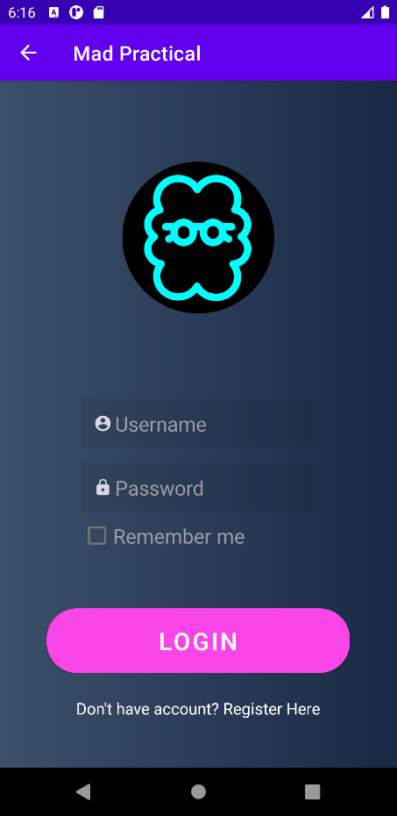

Fig 2.1 – Login Activity

***activity_recyclerview.xml***

*<?***xml version="1.0" encoding="utf-8"***?>*<**androidx.constraintlayout.widget.ConstraintLayout xmlns:android="http://schemas.android.com/apk/res/android"  
 xmlns:app="http://schemas.android.com/apk/res-auto"  
 xmlns:tools="http://schemas.android.com/tools"  
 android:layout_width="match_parent"  
 android:layout_height="match_parent"  
 tools:context=".Practical2d"**>  
  
 <**androidx.recyclerview.widget.RecyclerView  
 android:id="@+id/recyclerview"  
 android:layout_width="match_parent"  
 android:layout_height="match_parent"**>  
 </**androidx.recyclerview.widget.RecyclerView**>  
</**androidx.constraintlayout.widget.ConstraintLayout**>

***menu_layout.xml***

*<?***xml version="1.0" encoding="utf-8"***?>*<**menu  
 xmlns:android="http://schemas.android.com/apk/res/android"  
 xmlns:app="http://schemas.android.com/apk/res-auto"**>  
 <**item  
 android:title=""  
 app:showAsAction="always"  
 android:icon="@drawable/ic_baseline_white_more_vert"  
 android:id="@+id/vec"**>  
 <**menu**>  
 <**item  
 app:showAsAction="never"  
 android:id="@+id/home"  
 android:icon="@drawable/ic_baseline_home"  
 android:title="@string/home"** />  
 <**item  
 app:showAsAction="never"  
 android:icon="@drawable/ic_baseline_account"  
 android:title="@string/profile"  
 android:id="@+id/profile"** />  
 <**item  
 app:showAsAction="never"  
 android:icon="@drawable/ic_baseline_exit"  
 android:title="@string/exit"  
 android:id="@+id/exit"**/>  
 </**menu**>  
 </**item**>  
</**menu**>

***Adapter.java***

**package** com.example.madpractical;  
  
**import** android.content.Context;  
**import** android.view.LayoutInflater;  
**import** android.view.View;  
**import** android.view.ViewGroup;  
**import** android.widget.Button;  
**import** android.widget.ImageView;  
**import** android.widget.TextView;  
  
**import** androidx.annotation.NonNull;  
**import** androidx.recyclerview.widget.RecyclerView;  
  
**import** java.util.List;  
  
**public class** Adapter **extends** RecyclerView.Adapter<Adapter.ViewHolder> {  
  
 **private** List<recyclerModel> **studentList**;  
 **private** Context **context**;  
  
 **public** Adapter(List<recyclerModel> studentList,Context context){  
 **this**.**studentList** = studentList;  
 **this**.**context** = context;  
 }  
  
 @NonNull  
 @Override  
 **public** Adapter.ViewHolder onCreateViewHolder(@NonNull ViewGroup parent, **int** viewType) {  
 View view = LayoutInflater.*from*(parent.getContext()).inflate(R.layout.***recycleview***,parent,**false**);  
 **return new** ViewHolder(view);  
 }  
  
 @Override  
 **public void** onBindViewHolder(@NonNull Adapter.ViewHolder holder, **int** position) {  
 **int** imageview = **studentList**.get(position).getImageView();  
 String name = **studentList**.get(position).getName();  
 String address = **studentList**.get(position).getAddress();  
 holder.**delete**.setOnClickListener(**new** View.OnClickListener() {  
 @Override  
 **public void** onClick(View v) {  
 **studentList**.remove(position);  
 notifyDataSetChanged();  
 }  
 });  
 holder.setData(imageview,name,address);  
 }  
  
 @Override  
 **public int** getItemCount() {  
 **return studentList**.size();  
 }  
  
 **public class** ViewHolder **extends** RecyclerView.ViewHolder{  
  
 **private** ImageView **imageView**;  
 **private** TextView **name**;  
 **private** TextView **address**;  
 **private** Button **delete**;  
  
  
  
 **public** ViewHolder(@NonNull View itemView) {  
 **super**(itemView);  
  
 **imageView** = (ImageView)itemView.findViewById(R.id.***imageView***);  
 **name** = itemView.findViewById(R.id.***name***);  
 **address** = itemView.findViewById(R.id.***address***);  
 **delete** = (Button) itemView.findViewById(R.id.***delete***);  
 }  
  
 **public void** setData(**int** imageview, String name, String address) {  
 **imageView**.setImageResource(imageview);  
 **this**.**name**.setText(name);  
 **this**.**address**.setText(address);  
 }  
 }  
}

***recyclerModel.java***

**package** com.example.madpractical;  
  
**public class** recyclerModel {  
 **private int imageView**;  
 **private** String **name**;  
 **private** String **address**;  
  
 **public** recyclerModel(**int** imageView, String name, String address) {  
 **this**.**imageView** = imageView;  
 **this**.**name** = name;  
 **this**.**address** = address;  
 }  
  
 **public int** getImageView() {  
 **return imageView**;  
 }  
  
 **public** String getName() {  
 **return name**;  
 }  
  
 **public** String getAddress() {  
 **return address**;  
 }  
}

***Practical2d.java***

**package** com.example.madpractical;  
  
**import** androidx.appcompat.app.AppCompatActivity;  
**import** androidx.recyclerview.widget.LinearLayoutManager;  
**import** androidx.recyclerview.widget.RecyclerView;  
  
**import** android.os.Bundle;  
**import** android.view.Menu;  
**import** android.widget.LinearLayout;  
  
**import** java.util.ArrayList;  
**import** java.util.List;  
  
**public class** Practical2d **extends** AppCompatActivity {  
  
 RecyclerView **recyclerView**;  
 LinearLayoutManager **layoutManager**;  
 List<recyclerModel> **studentList**;  
 Adapter **adapter**;  
  
 @Override  
 **protected void** onCreate(Bundle savedInstanceState) {  
 **super**.onCreate(savedInstanceState);  
 setContentView(R.layout.***activity_practical3***);  
  
 initData();  
 initRecyclerView();  
 }  
  
 **private void** initData() {  
 **studentList** = **new** ArrayList<>();  
 **studentList**.add(**new** recyclerModel(R.drawable.***sid1***,**"Siddharth"**,**"Gundiyavada, Sayla, Surendranagar, Gujarat, 363440"**));  
 **studentList**.add(**new** recyclerModel(R.drawable.***img3***,**"Dhruvi"**,**"Sun Plaza, Navrangpura, Ahmedabad, Gujarat 380009"**));  
 **studentList**.add(**new** recyclerModel(R.drawable.***img2***,**"Johny"**,**"Jodhpur 4 Rasta, Satellite, Ahmedabad, Gujarat 380015"**));  
 **studentList**.add(**new** recyclerModel(R.drawable.***img1***,**"Apexa"**,**"Shefali House, Ellisbridge, Ahmedabad, Gujarat 380006"**));  
 **studentList**.add(**new** recyclerModel(R.drawable.***co_512***,**"Collegeek"**,**"80 Feet Road, Anand Bagh, Surendranagar, Gujarat 363001"**));  
 **studentList**.add(**new** recyclerModel(R.drawable.***img4***,**"Ajay"**,**"31nd Floor, Ghanshyam Chambers, Mithakhali, Ahmedabad, Gujarat 380006"**));  
 }  
  
 **private void** initRecyclerView() {  
 **recyclerView** = (RecyclerView) findViewById(R.id.***recyclerview***);  
 **layoutManager** = **new** LinearLayoutManager(**this**);  
 **layoutManager**.setOrientation(RecyclerView.***VERTICAL***);  
 **recyclerView**.setLayoutManager(**layoutManager**);  
 **adapter** = **new** Adapter(**studentList**,getApplicationContext());  
 **recyclerView**.setAdapter(**adapter**);  
 **adapter**.notifyDataSetChanged();  
 }  
  
 @Override  
 **public boolean** onCreateOptionsMenu(Menu menu) {  
 getMenuInflater().inflate(R.menu.***menu_layout***,menu);  
 **return true**;  
 }  
}

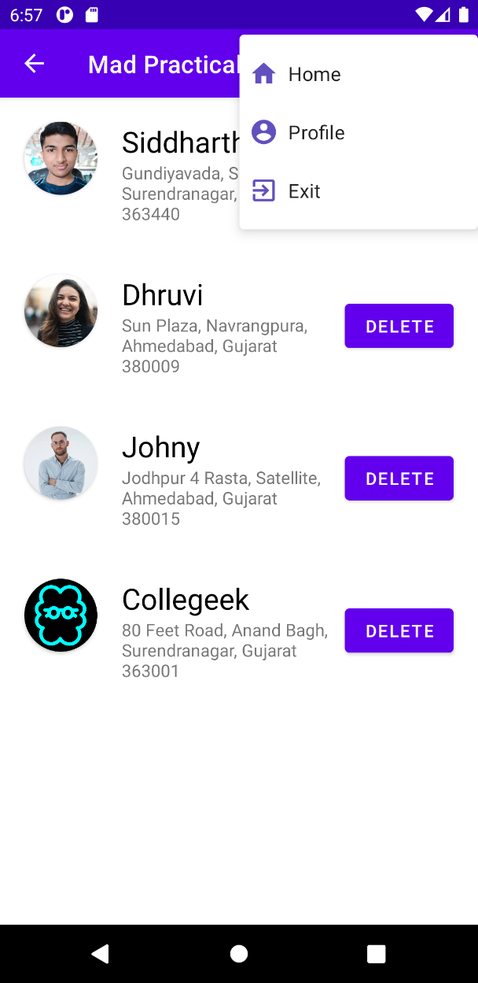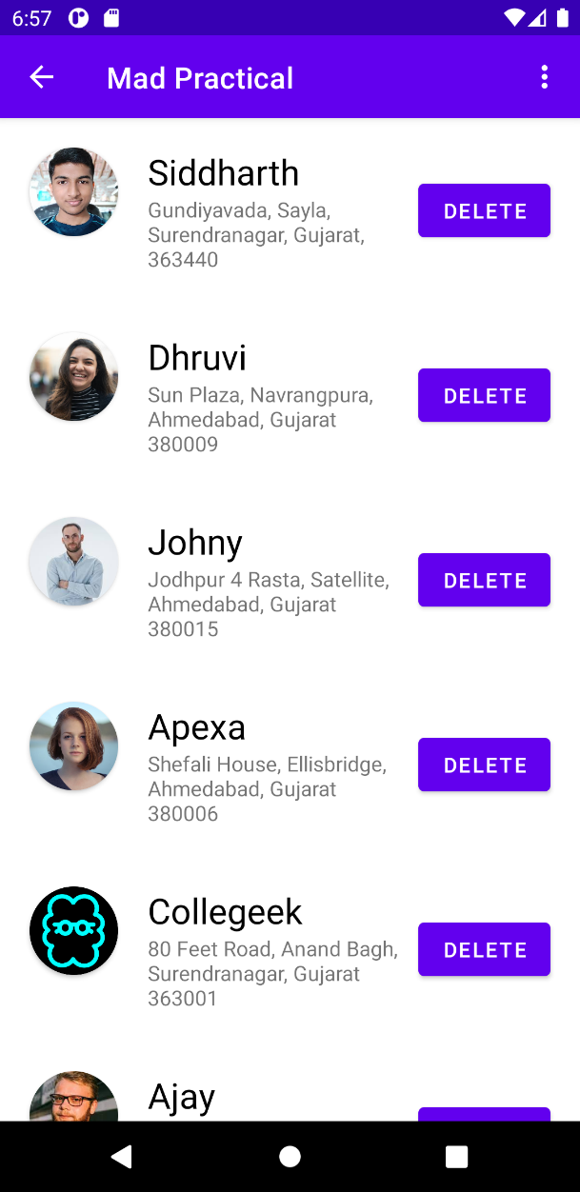

Fig 2.2 Recycler view with Student info Fig 2.3 Option menu and Delete Operation

Practical – 3

**AIM:** Develop and Mobile Application for following topic

1. Theme,

2. Custom Styles

***ThemeActivity.java***

public class ThemeActivity extends AppCompatActivity {

private Spinner spThemes;

// Here we set the theme for the activity

// Note `Utils.onActivityCreateSetTheme` must be called before `setContentView`

@Override

protected void onCreate(Bundle savedInstanceState) {

super.onCreate(savedInstanceState);

// MUST BE SET BEFORE setContentView

Utils.onActivityCreateSetTheme(this);

// AFTER SETTING THEME

setContentView(R.layout.activity_theme);

setupSpinnerItemSelection();

}

private void setupSpinnerItemSelection() {

spThemes = (Spinner) findViewById(R.id.spThemes);

spThemes.setSelection(ThemeApplication.currentPosition);

ThemeApplication.currentPosition = spThemes.getSelectedItemPosition();

spThemes.setOnItemSelectedListener(new AdapterView.OnItemSelectedListener() {

@Override

public void onItemSelected(AdapterView<?> parent, View view,

int position, long id) {

if (ThemeApplication.currentPosition != position) {

Utils.changeToTheme(ThemeActivity.this, position);

}

ThemeApplication.currentPosition = position;

}

@Override

public void onNothingSelected(AdapterView<?> parent) {

}

});

}

}

***Layout.xml***

*<?***xml version="1.0" encoding="utf-8"***?>*<**RelativeLayout xmlns:android="http://schemas.android.com/apk/res/android"  
 xmlns:app="http://schemas.android.com/apk/res-auto"  
 xmlns:tools="http://schemas.android.com/tools"  
 android:layout_width="match_parent"  
 android:layout_height="match_parent"  
 style="?pageBackground"  
 tools:context=".Practical3a"**>  
  
 <**TextView  
 android:id="@+id/tvSelectTheme"  
 style="?textLarge"  
 android:layout_width="wrap_content"  
 android:layout_height="wrap_content"  
 android:text="@string/settings_text_select_theme"** />  
  
 <**Spinner  
 android:id="@+id/spThemes"  
 style="?spinner"  
 android:layout_width="wrap_content"  
 android:layout_height="wrap_content"  
 android:layout_alignBaseline="@+id/tvSelectTheme"  
 android:layout_alignParentRight="true"  
 android:layout_marginLeft="@dimen/spinner_margin_left"  
 android:layout_toRightOf="@+id/tvSelectTheme"  
 android:entries="@array/theme_array"  
 android:spinnerMode="dropdown"** />  
  
 <**RelativeLayout  
 android:id="@+id/rlCredentials"  
 style="?whiteBackground"  
 android:layout_width="wrap_content"  
 android:layout_height="wrap_content"  
 android:layout_below="@+id/tvSelectTheme"** >  
  
 <**TextView  
 android:id="@+id/tvCredentials"  
 style="?textSubheader"  
 android:layout_width="wrap_content"  
 android:layout_height="wrap_content"  
 android:text="@string/settings_text_credentials"** />  
  
 <**EditText  
 android:id="@+id/tvUsername"  
 style="?textRegular"  
 android:layout_width="match_parent"  
 android:layout_height="wrap_content"  
 android:layout_below="@+id/tvCredentials"  
 android:hint="@string/settings_text_username_hint"  
 android:inputType="text"  
 android:lines="1"** />  
  
 <**EditText  
 android:id="@+id/tvpassword"  
 style="?textRegular"  
 android:layout_width="match_parent"  
 android:layout_height="wrap_content"  
 android:layout_below="@+id/tvUsername"  
 android:layout_marginTop="@dimen/edittext_margin_top"  
 android:hint="@string/settings_text_password_hint"  
 android:inputType="textPassword"  
 android:lines="1"** />  
 </**RelativeLayout**>  
  
 <**TextView  
  
 android:id="@+id/tvSync"  
 style="?textRegular"  
 android:layout_width="wrap_content"  
 android:layout_height="wrap_content"  
 android:layout_below="@+id/rlCredentials"  
 android:text="@string/settings_text_sync_automatically"  
 android:textSize="17sp"** />  
 <**CheckBox  
 android:id="@+id/checkbox_sync_automatically"  
 android:layout_width="wrap_content"  
 android:layout_height="wrap_content"  
 android:layout_alignBaseline="@+id/tvSync"  
 android:layout_alignParentRight="true"  
 android:checked="true"** />  
 <**TextView  
 android:id="@+id/tvLocation"  
 style="?textRegular"  
 android:layout_width="wrap_content"  
 android:layout_height="wrap_content"  
 android:layout_below="@+id/tvSync"  
 android:layout_marginTop="@dimen/view_margin"  
 android:text="@string/settings_text_location"  
 android:textSize="17sp"** />  
  
 <**Switch  
 android:id="@+id/toggle_google"  
 android:layout_width="wrap_content"  
 android:layout_height="wrap_content"  
 android:layout_alignBaseline="@+id/tvLocation"  
 android:layout_alignParentRight="true"  
 android:layout_toRightOf="@+id/tvLocation"  
 android:switchTextAppearance="@style/switch_text_appearance"  
 android:textOff="@string/settings_text_state_off"  
 android:textOn="@string/settings_text_state_on"** />  
  
 <**Button  
 android:id="@+id/btnClearData"  
 style="?button"  
 android:layout_width="wrap_content"  
 android:layout_height="wrap_content"  
 android:layout_alignParentBottom="true"  
 android:layout_centerHorizontal="true"  
 android:layout_marginBottom="@dimen/view_margin"  
 android:text="@string/settings_text_clear_data"** />  
  
</**RelativeLayout**>

***Style.xml***

*<?***xml version="1.0" encoding="utf-8"***?>*<**resources xmlns:app="http://schemas.android.com/apk/res-auto" xmlns:android="http://schemas.android.com/apk/res/android"** >  
 *<!--  
 Base application theme, dependent on API level. This theme is replaced  
 by AppBaseTheme from res/values-vXX/styles.xml on newer devices.  
 -->* <**style name="AppBaseTheme" parent="Theme.AppCompat.Light"**>  
 *<!--  
 Theme customizations available in newer API levels can go in  
 res/values-vXX/styles.xml, while customizations related to  
 backward-compatibility can go here.  
 -->* </**style**>  
  
 *<!-- Application theme. -->* <**style name="AppTheme" parent="AppBaseTheme"**>  
 *<!-- All customizations that are NOT specific to a particular API-level can go here. -->* </**style**>  
  
 <**style name="switch_text_appearance" parent="@android:style/TextAppearance.Holo.Small"**>  
 <**item name="android:textColor"**>#FFF</**item**>  
 </**style**>  
  
 *<!-- =============================================================== -->  
  
 <!-- Material-Light styles -->  
  
 <!-- =============================================================== -->* <**style name="page_background_wh"**>  
 <**item name="android:background"**>@drawable/white_gray_gradient_background</**item**>  
 <**item name="android:paddingLeft"**>@dimen/activity_horizontal_padding</**item**>  
 <**item name="android:paddingRight"**>@dimen/activity_horizontal_padding</**item**>  
 </**style**>  
  
 <**style name="text_subheader_wh"**>  
 <**item name="android:textColor"**>#000</**item**>  
 <**item name="android:textSize"**>@dimen/text_subheader_text_size</**item**>  
 <**item name="android:shadowDy"**>1.0</**item**>  
 <**item name="android:shadowRadius"**>1</**item**>  
 <**item name="android:shadowColor"**>#000</**item**>  
 </**style**>  
  
 <**style name="text_large_wh"**>  
 <**item name="android:textColor"**>@android:color/background_dark</**item**>  
 <**item name="android:textSize"**>@dimen/text_large_text_size</**item**>  
 <**item name="android:shadowDy"**>1.0</**item**>  
 <**item name="android:shadowRadius"**>1</**item**>  
 <**item name="android:shadowColor"**>#888</**item**>  
 <**item name="android:textStyle"**>bold</**item**>  
 <**item name="android:layout_marginTop"**>@dimen/text_large_margin_top</**item**>  
 </**style**>  
  
 <**style name="text_regular_wh"**>  
 <**item name="android:textColor"**>@android:color/background_dark</**item**>  
 <**item name="android:textSize"**>@dimen/text_regular_text_size</**item**>  
 </**style**>  
  
 <**style name="white_background_wh"**>  
 <**item name="android:background"**>@android:drawable/dialog_holo_light_frame</**item**>  
 <**item name="android:layout_marginTop"**>@dimen/card_margin_top</**item**>  
 <**item name="android:layout_marginBottom"**>@dimen/card_margin_top</**item**>  
 <**item name="android:padding"**>@dimen/white_background_padding</**item**>  
 </**style**>  
  
  
  
 <**style name="button_wh" parent="text_large_wh"**>  
 <**item name="android:background"**>@drawable/button_wh</**item**>  
 <**item name="android:layout_marginTop"**>@dimen/view_margin</**item**>  
 </**style**>  
  
  
  
 <**style name="spinner_wh"**>  
 <**item name="android:background"**>@drawable/spinner_wh_background</**item**>  
 </**style**>  
  
 <**style name="horizontal_line_wh"**>  
 <**item name="android:background"**>#00000000</**item**>  
 </**style**>  
 <**color name="actionbar_bg_wh"**>#AFAFAF</**color**>  
  
  
 <**style name="action_bar_wh" parent="@style/Widget.AppCompat.Light.ActionBar.Solid.Inverse"**>  
 <**item name="android:background"**>@color/actionbar_bg_wh</**item**>  
 <**item name="background"**>@color/actionbar_bg_wh</**item**>  
 </**style**>  
 *<!-- =============================================================== -->  
 <!-- Customize YOUR_CUSTOM_THEME Styles -->  
 <!-- Define your own styles below. -->  
 <!-- =============================================================== -->*</**resources**>

***Thems.xml***

*<?***xml version="1.0" encoding="utf-8"***?>*<**resources  
 xmlns:android="http://schemas.android.com/apk/res/android"  
 xmlns:android="http://schemas.android.com/apk/res/android"**>  
  
 <**style name="Theme.Material_Light" parent="Theme.AppCompat.Light"**>  
 <**item name="pageBackground"**>@style/page_background_wh</**item**>  
 <**item name="textSubheader"**>@style/text_subheader_wh</**item**>  
 <**item name="textLarge"**>@style/text_large_wh</**item**>  
 <**item name="textRegular"**>@style/text_regular_wh</**item**>  
 <**item name="whiteBackground"**>@style/white_background_wh</**item**>  
 <**item name="button"**>@style/button_wh</**item**>  
 <**item name="spinner"**>@style/spinner_wh</**item**>  
 <**item name="actionBarStyle"**>@style/action_bar_wh</**item**>  
 </**style**>  
  
 <**style name="Theme.YOUR_CUSTOM_THEME" parent="Theme.AppCompat.Light"**>  
 *<!-- Define styles for YOUR_CUSTOM_THEME here. -->* </**style**>  
</**resources**>

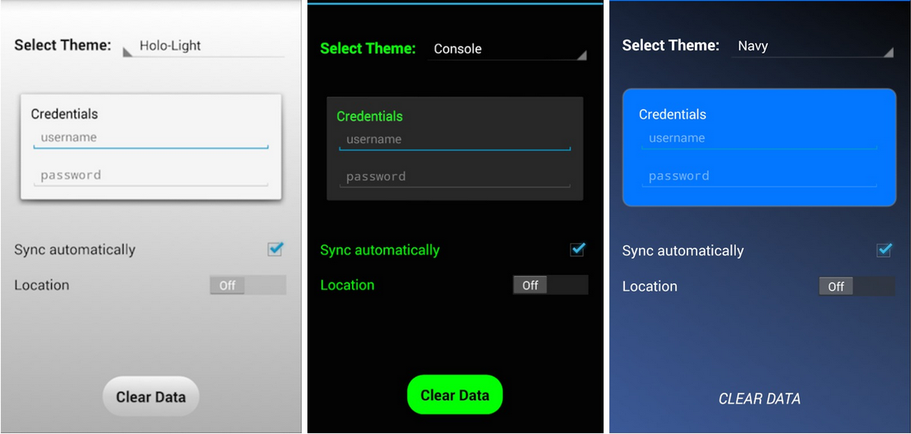

Fig 3.1 Custom style with themes

Practical – 4

**AIM:** Develop and Mobile Application for storing Data and Retrieve and

Manipulate data Using SQLite database.

***Activity_practical4.xml***

*<?***xml version="1.0" encoding="utf-8"***?>*<**androidx.constraintlayout.widget.ConstraintLayout xmlns:android="http://schemas.android.com/apk/res/android"  
 xmlns:app="http://schemas.android.com/apk/res-auto"  
 xmlns:tools="http://schemas.android.com/tools"  
 android:layout_width="match_parent"  
 android:layout_height="match_parent"  
 android:background="@drawable/gradient"  
 tools:context=".Practical4"**>  
  
 <**TextView  
 android:id="@+id/textView3"  
 android:layout_width="wrap_content"  
 android:layout_height="wrap_content"  
 android:layout_marginStart="24dp"  
 android:layout_marginLeft="24dp"  
 android:layout_marginTop="80dp"  
 android:layout_marginEnd="24dp"  
 android:layout_marginRight="24dp"  
 android:text="@string/add_info"  
 android:textColor="@color/white"  
 android:textSize="32sp"  
 app:layout_constraintEnd_toEndOf="parent"  
 app:layout_constraintStart_toStartOf="parent"  
 app:layout_constraintTop_toTopOf="parent"** />  
  
 <**EditText  
 android:id="@+id/contact_id"  
 android:layout_width="wrap_content"  
 android:layout_height="wrap_content"  
 android:layout_marginStart="24dp"  
 android:layout_marginLeft="24dp"  
 android:layout_marginTop="48dp"  
 android:layout_marginEnd="24dp"  
 android:layout_marginRight="24dp"  
 android:background="#11000000"  
 android:ems="10"  
 android:hint="@string/contact"  
 android:importantForAutofill="no"  
 android:inputType="textPersonName"  
 android:padding="10dp"  
 android:textColor="#9e9e9e"  
 android:textColorHint="#9e9e9e"  
 android:textSize="20sp"  
 app:layout_constraintEnd_toEndOf="parent"  
 app:layout_constraintStart_toStartOf="parent"  
 app:layout_constraintTop_toBottomOf="@+id/textView3"** />  
  
 <**EditText  
 android:id="@+id/name"  
 android:layout_width="wrap_content"  
 android:layout_height="wrap_content"  
 android:layout_marginStart="24dp"  
 android:layout_marginLeft="24dp"  
 android:layout_marginTop="16dp"  
 android:layout_marginEnd="24dp"  
 android:layout_marginRight="24dp"  
 android:background="#11000000"  
 android:ems="10"  
 android:hint="@string/name"  
 android:importantForAutofill="no"  
 android:inputType="textPersonName"  
 android:padding="10dp"  
 android:textColor="#9e9e9e"  
 android:textColorHint="#9e9e9e"  
 android:textSize="20sp"  
 app:layout_constraintEnd_toEndOf="parent"  
 app:layout_constraintStart_toStartOf="parent"  
 app:layout_constraintTop_toBottomOf="@+id/contact_id"** />  
  
 <**EditText  
 android:id="@+id/email"  
 android:layout_width="wrap_content"  
 android:layout_height="wrap_content"  
 android:layout_marginStart="24dp"  
 android:layout_marginLeft="24dp"  
 android:layout_marginTop="16dp"  
 android:layout_marginEnd="24dp"  
 android:layout_marginRight="24dp"  
 android:background="#11000000"  
 android:ems="10"  
 android:hint="@string/email"  
 android:importantForAutofill="no"  
 android:inputType="textPersonName"  
 android:padding="10dp"  
 android:textColor="#9e9e9e"  
 android:textColorHint="#9e9e9e"  
 android:textSize="20sp"  
 app:layout_constraintEnd_toEndOf="parent"  
 app:layout_constraintStart_toStartOf="parent"  
 app:layout_constraintTop_toBottomOf="@+id/name"** />  
  
 <**EditText  
 android:id="@+id/city"  
 android:layout_width="wrap_content"  
 android:layout_height="wrap_content"  
 android:layout_marginStart="24dp"  
 android:layout_marginLeft="24dp"  
 android:layout_marginTop="16dp"  
 android:layout_marginEnd="24dp"  
 android:layout_marginRight="24dp"  
 android:background="#11000000"  
 android:ems="10"  
 android:hint="@string/city"  
 android:importantForAutofill="no"  
 android:inputType="textPersonName"  
 android:padding="10dp"  
 android:textColor="#9e9e9e"  
 android:textColorHint="#9e9e9e"  
 android:textSize="20sp"  
 app:layout_constraintEnd_toEndOf="parent"  
 app:layout_constraintStart_toStartOf="parent"  
 app:layout_constraintTop_toBottomOf="@+id/email"** />  
  
 <**Button  
 android:id="@+id/save_btn"  
 android:layout_width="wrap_content"  
 android:layout_height="wrap_content"  
 android:layout_marginStart="24dp"  
 android:layout_marginLeft="24dp"  
 android:layout_marginTop="20dp"  
 android:layout_marginEnd="24dp"  
 android:layout_marginRight="24dp"  
 android:background="@drawable/button_background"  
 android:padding="10dp"  
 android:text="@string/save"  
 android:textColor="#fff"  
 android:textSize="24sp"  
 app:backgroundTint="#FA46E8"  
 app:layout_constraintEnd_toEndOf="parent"  
 app:layout_constraintHorizontal_bias="0.497"  
 app:layout_constraintStart_toStartOf="parent"  
 app:layout_constraintTop_toBottomOf="@+id/city"** />  
  
 <**Button  
 android:id="@+id/view_btn"  
 android:layout_width="wrap_content"  
 android:layout_height="wrap_content"  
 android:layout_marginStart="24dp"  
 android:layout_marginLeft="24dp"  
 android:layout_marginTop="16dp"  
 android:layout_marginEnd="24dp"  
 android:layout_marginRight="24dp"  
 android:text="@string/view"  
 android:textSize="24sp"  
 app:layout_constraintEnd_toEndOf="parent"  
 app:layout_constraintStart_toStartOf="parent"  
 app:layout_constraintTop_toBottomOf="@+id/save_btn"** />  
  
 <**Button  
 android:id="@+id/delete_btn"  
 android:layout_width="wrap_content"  
 android:layout_height="wrap_content"  
 android:layout_marginStart="24dp"  
 android:layout_marginLeft="24dp"  
 android:layout_marginTop="16dp"  
 android:layout_marginEnd="24dp"  
 android:layout_marginRight="24dp"  
 android:text="@string/delete"  
 android:textSize="24sp"  
 app:layout_constraintEnd_toEndOf="parent"  
 app:layout_constraintStart_toStartOf="parent"  
 app:layout_constraintTop_toBottomOf="@+id/view_btn"** />  
  
</**androidx.constraintlayout.widget.ConstraintLayout**>

***Activity_practical4a.xml***

*<?***xml version="1.0" encoding="utf-8"***?>*<**androidx.constraintlayout.widget.ConstraintLayout xmlns:android="http://schemas.android.com/apk/res/android"  
 xmlns:app="http://schemas.android.com/apk/res-auto"  
 xmlns:tools="http://schemas.android.com/tools"  
 android:layout_width="match_parent"  
 android:layout_height="match_parent"  
 android:background="@drawable/gradient"  
 tools:context=".Practical4a"**>  
  
 <**ScrollView  
 android:layout_width="match_parent"  
 android:layout_height="match_parent"  
 android:background="@drawable/gradient"  
 app:layout_constraintBottom_toBottomOf="parent"  
 app:layout_constraintEnd_toEndOf="parent"  
 app:layout_constraintStart_toStartOf="parent"  
 app:layout_constraintTop_toTopOf="parent"**>  
  
 <**androidx.constraintlayout.widget.ConstraintLayout  
 android:layout_width="match_parent"  
 android:layout_height="wrap_content"**>  
  
 <**TextView  
 android:id="@+id/view_head_text"  
 android:layout_width="wrap_content"  
 android:layout_height="wrap_content"  
 android:layout_marginStart="24dp"  
 android:layout_marginLeft="24dp"  
 android:layout_marginTop="40dp"  
 android:layout_marginEnd="24dp"  
 android:layout_marginRight="24dp"  
 android:text="@string/view_head"  
 android:textColor="#fff"  
 android:textSize="32sp"  
 app:layout_constraintEnd_toEndOf="parent"  
 app:layout_constraintStart_toStartOf="parent"  
 app:layout_constraintTop_toTopOf="parent"** />  
  
 <**TextView  
 android:id="@+id/data_text"  
 android:layout_width="wrap_content"  
 android:layout_height="wrap_content"  
 android:layout_marginStart="32dp"  
 android:layout_marginLeft="32dp"  
 android:layout_marginTop="32dp"  
 android:layout_marginEnd="32dp"  
 android:layout_marginRight="32dp"  
 android:layout_marginBottom="32dp"  
 android:text="@string/nothing"  
 android:textColor="#fff"  
 android:textSize="20sp"  
 app:layout_constraintBottom_toBottomOf="parent"  
 app:layout_constraintEnd_toEndOf="parent"  
 app:layout_constraintHorizontal_bias="0.501"  
 app:layout_constraintStart_toStartOf="parent"  
 app:layout_constraintTop_toBottomOf="@+id/view_head_text"** />  
  
 </**androidx.constraintlayout.widget.ConstraintLayout**>  
 </**ScrollView**>  
</**androidx.constraintlayout.widget.ConstraintLayout**>

***Practical4a.java***

**package** com.example.madpractical;  
  
**import** androidx.appcompat.app.AppCompatActivity;  
  
**import** android.content.Intent;  
**import** android.os.Bundle;  
**import** android.widget.TextView;  
  
**public class** Practical4a **extends** AppCompatActivity {  
  
 @Override  
 **protected void** onCreate(Bundle savedInstanceState) {  
 **super**.onCreate(savedInstanceState);  
 setContentView(R.layout.***activity_practical4a***);  
  
 Intent intent = getIntent();  
 String data = intent.getStringExtra(**"Data"**);  
 TextView textview = findViewById(R.id.***data_text***);  
 **if** (!data.isEmpty()) textview.setText(data);  
 }  
}

***StudentInfo.java***

**package** com.example.madpractical;  
  
**public final class** Studentinfo {  
 **private** Studentinfo() {  
 }  
  
 **public static final** String ***TABLE_NAME*** = **"student_info"**;  
 **public static final** String ***NAME*** = **"name"**;  
 **public static final** String ***EMAIL*** = **"email"**;  
 **public static final** String ***CITY*** = **"city"**;  
 **public static final** String ***CONTACT*** = **"contact"**;  
}

***Practical4.java***

**package** com.example.madpractical;  
  
**import** androidx.appcompat.app.AppCompatActivity;  
  
**import** android.app.AlertDialog;  
**import** android.content.Intent;  
**import** android.database.Cursor;  
**import** android.database.SQLException;  
**import** android.database.sqlite.SQLiteDatabase;  
**import** android.os.Bundle;  
**import** android.view.View;  
**import** android.widget.Button;  
**import** android.widget.EditText;  
**import** android.widget.Toast;  
  
**public class** Practical4 **extends** AppCompatActivity {  
  
 @Override  
 **protected void** onCreate(Bundle savedInstanceState) {  
 **super**.onCreate(savedInstanceState);  
 setContentView(R.layout.***activity_practical4***);  
  
 EditText contact, name, email, city;  
 contact = findViewById(R.id.***contact_id***);  
 name = findViewById(R.id.***name***);  
 email = findViewById(R.id.***email***);  
 city = findViewById(R.id.***city***);  
  
 *// save button to insert data* Button save_btn = findViewById(R.id.***save_btn***);  
  
 save_btn.setOnClickListener(v -> {  
 String Name = name.getText().toString();  
 String Contact = contact.getText().toString();  
 String City = city.getText().toString();  
 String Email = email.getText().toString();  
  
 **if** (Name.isEmpty() || Contact.isEmpty() || City.isEmpty() || Email.isEmpty()) {  
 Toast.*makeText*(Practical4.**this**, **"Every field is required!"**, Toast.***LENGTH_LONG***).show();  
 } **else** {  
 StudentDbHelper helper = **new** StudentDbHelper(getApplicationContext());  
 SQLiteDatabase db = helper.getWritableDatabase();  
 helper.addInfo(Contact, Name, Email, City, db);  
 helper.close();  
 name.setText(**""**);  
 contact.setText(**""**);  
 email.setText(**""**);  
 city.setText(**""**);  
 Toast.*makeText*(Practical4.**this**, **"Student Info saved Successfully"**, Toast.***LENGTH_LONG***).show();  
 }  
 });  
  
  
 *// view button to read data* Button view_btn = findViewById(R.id.***view_btn***);  
  
 view_btn.setOnClickListener(v -> {  
  
 StudentDbHelper helper = **new** StudentDbHelper(getApplicationContext());  
 SQLiteDatabase db = helper.getReadableDatabase();  
 Cursor cursor = helper.readInfo(db);  
  
 String info = **""**;  
  
 **while** (cursor.moveToNext()) {  
 String id = cursor.getString(cursor.getColumnIndex(Studentinfo.***CONTACT***));  
 String name1 = cursor.getString(cursor.getColumnIndex(Studentinfo.***NAME***));  
 String City = cursor.getString(cursor.getColumnIndex(Studentinfo.***CITY***));  
 String Email = cursor.getString(cursor.getColumnIndex(Studentinfo.***EMAIL***));  
 info = info + **"\n\nID: "** + id + **"\nName: "** + name1 + **"\nEmail: "** + Email + **"\nCity: "** + City;  
 }  
  
 Intent intent = **new** Intent(Practical4.**this**, Practical4a.**class**);  
 intent.putExtra(**"Data"**, info);  
 startActivity(intent);  
 });  
  
 *// delete data by id* Button delete_btn = findViewById(R.id.***delete_btn***);  
  
 delete_btn.setOnClickListener(**this**::btn_showMessage);  
  
 }  
  
 **public void** btn_showMessage(View view) {  
 **final** AlertDialog.Builder alert = **new** AlertDialog.Builder(Practical4.**this**);  
  
 *// get layout* View dialog_layout_view = getLayoutInflater().inflate(R.layout.***dilog_layout***, **null**);  
  
 EditText txt_inputText = (EditText) dialog_layout_view.findViewById(R.id.***txt_input***);  
 Button btn_cancel = (Button) dialog_layout_view.findViewById(R.id.***btn_cancel***);  
 Button btn_okay = (Button) dialog_layout_view.findViewById(R.id.***btn_okay***);  
  
 *// insert layout into dialog box* alert.setView(dialog_layout_view);  
 *// create dialog box* **final** AlertDialog alertDialog = alert.create();  
 *// around area : false* alertDialog.setCanceledOnTouchOutside(**false**);  
  
 *// on cancel* btn_cancel.setOnClickListener(v -> alertDialog.dismiss());  
 *// on okay* btn_okay.setOnClickListener(v -> {  
 StudentDbHelper helper = **new** StudentDbHelper(getApplicationContext());  
 SQLiteDatabase db = helper.getWritableDatabase();  
 String Id = txt_inputText.getText().toString();  
 **if** (!Id.isEmpty()) {  
 helper.deleteInfo(Id, db);  
 helper.close();  
 txt_inputText.setText(**""**);  
 Toast.*makeText*(Practical4.**this**, **"Student Info Deleted Successfully"**, Toast.***LENGTH_LONG***).show();  
 } **else** {  
 Toast.*makeText*(Practical4.**this**, **"Student ID is required!"**, Toast.***LENGTH_LONG***).show();  
 }  
 alertDialog.dismiss();  
 });  
  
 alertDialog.show();  
 }  
  
}

***StudentDbHelper.java***

**package** com.example.madpractical;  
  
**import** android.content.ContentValues;  
**import** android.content.Context;  
**import** android.database.Cursor;  
**import** android.database.sqlite.SQLiteDatabase;  
**import** android.database.sqlite.SQLiteOpenHelper;  
**import** android.util.Log;  
  
**public class** StudentDbHelper **extends** SQLiteOpenHelper {  
  
 **public static final** String ***DATABASE_NAME*** = **"student_db"**;  
 **public static final int *DATABASE_VERSION*** = 1;  
  
  
 *// create table query* **public static final** String ***CREATE_TABLE*** = **"create table "** + Studentinfo.***TABLE_NAME*** + **"("** +  
 Studentinfo.***CONTACT*** + **" text,"** +  
 Studentinfo.***NAME*** + **" text,"** +  
 Studentinfo.***EMAIL*** + **" text,"** +  
 Studentinfo.***CITY*** + **" text)"**;  
  
 **public static final** String ***DROP_TABLE*** = **"drop table if exists "** + Studentinfo.***TABLE_NAME***;  
  
 **public** StudentDbHelper(Context context) {  
 **super**(context, ***DATABASE_NAME***, **null**, ***DATABASE_VERSION***);  
 Log.*d*(**"Database Operation"**, **"Database Created..."**);  
 }  
  
 @Override  
 **public void** onCreate(SQLiteDatabase db) {  
 db.execSQL(***CREATE_TABLE***);  
 Log.*d*(**"Database Operation"**, **"Table Created..."**);  
 }  
  
 @Override  
 **public void** onUpgrade(SQLiteDatabase db, **int** oldVersion, **int** newVersion) {  
 db.execSQL(***DROP_TABLE***);  
 onCreate(db);  
 }  
  
 *// insert data into table* **public void** addInfo(String id, String name, String email, String city, SQLiteDatabase db) {  
 *// to store key value pair* ContentValues contentValues = **new** ContentValues();  
 *// column name => value* contentValues.put(Studentinfo.***CONTACT***, id);  
 contentValues.put(Studentinfo.***NAME***, name);  
 contentValues.put(Studentinfo.***EMAIL***, email);  
 contentValues.put(Studentinfo.***CITY***, city);  
  
 db.insert(Studentinfo.***TABLE_NAME***, **null**, contentValues);  
 Log.*d*(**"Database Operation"**, **"row(s) inserted..."**);  
 }  
  
 *// read from table* **public** Cursor readInfo(SQLiteDatabase db) {  
 String[] projections = {Studentinfo.***CONTACT***, Studentinfo.***NAME***, Studentinfo.***EMAIL***, Studentinfo.***CITY***};  
 Cursor cursor = db.query(Studentinfo.***TABLE_NAME***, projections, **null**, **null**, **null**, **null**, **null**);  
 **return** cursor;  
 }  
  
 *// delete* **public void** deleteInfo(String id, SQLiteDatabase db) {  
 String selection = Studentinfo.***CONTACT*** + **" = "** + id;  
 db.delete(Studentinfo.***TABLE_NAME***, selection, **null**);  
 Log.*d*(**"Database Operation"**, **"row(s) deleted..."**);  
 }  
  
}

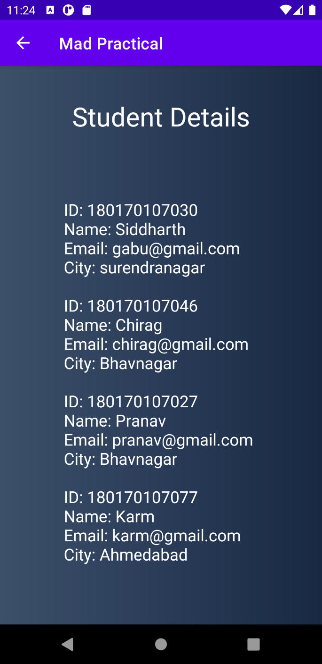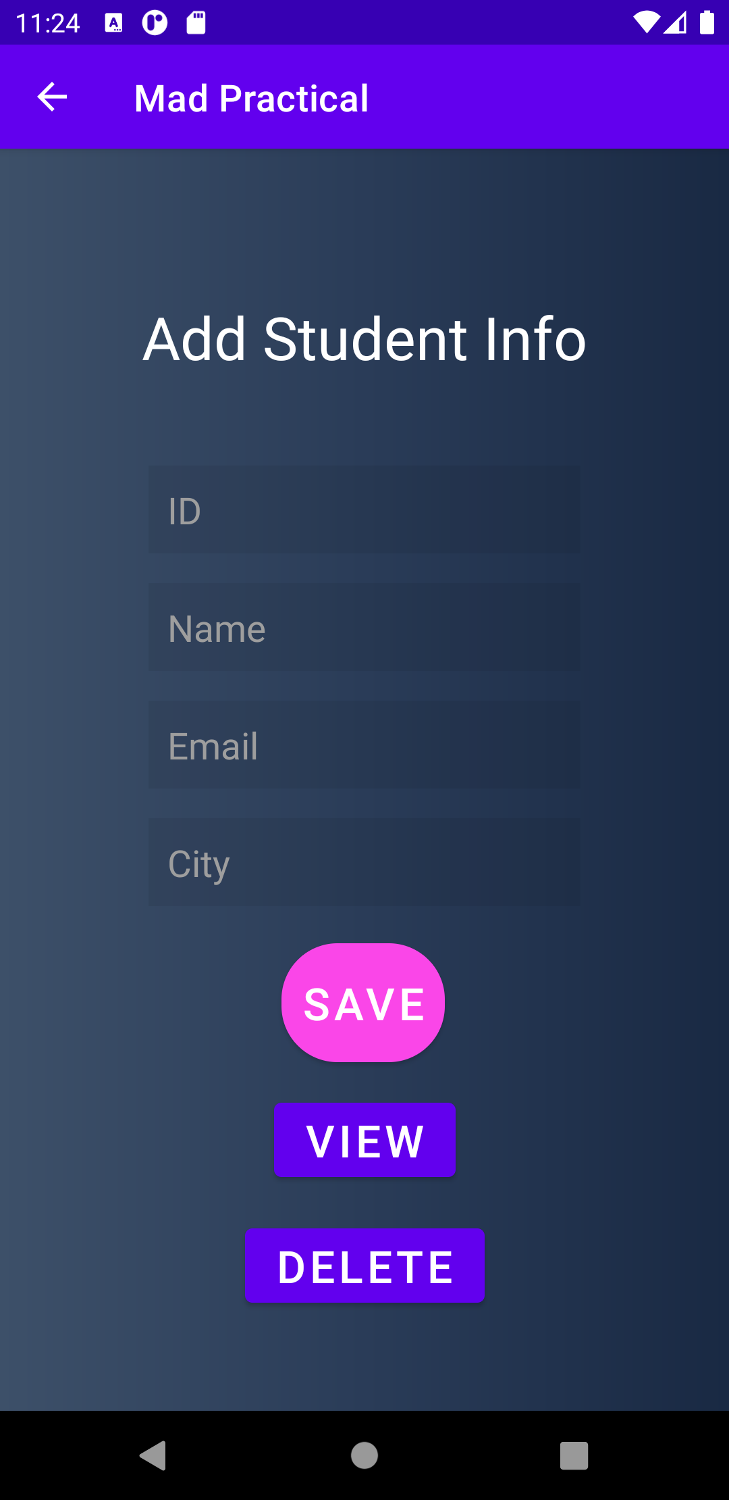

Fig 4.1 Add student data to database Fig 4.2 view student data

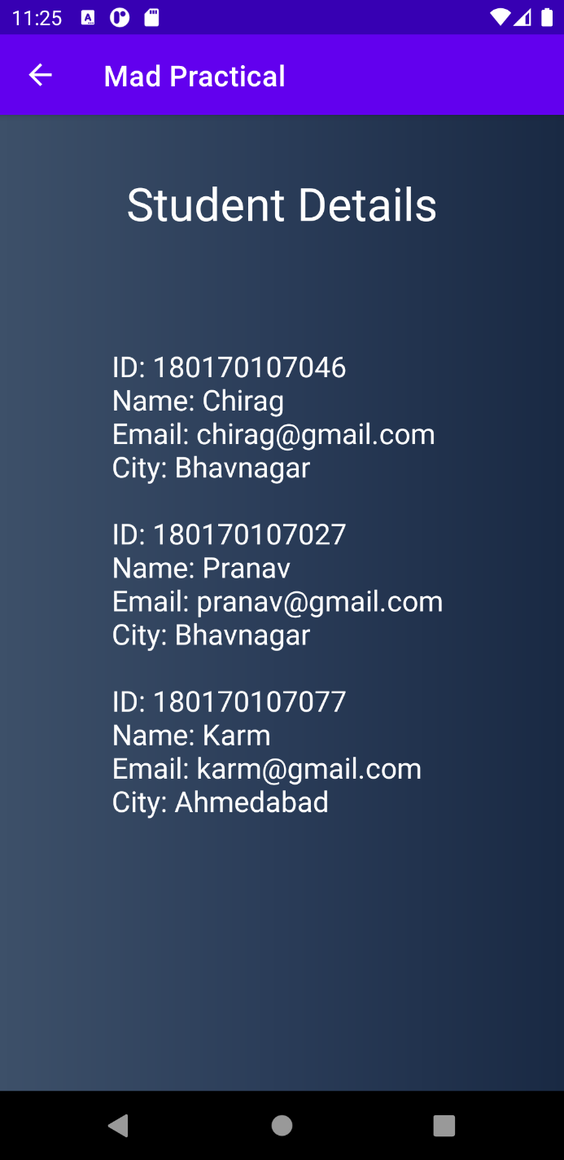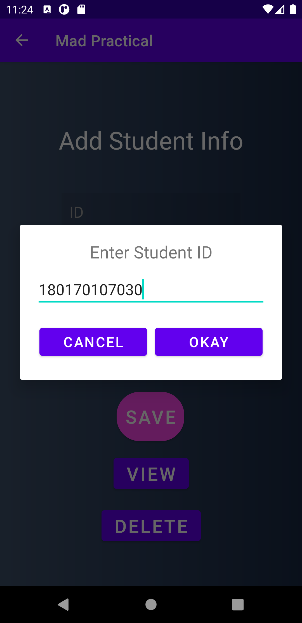

Fig 4.3 Delete Operation Fig 4.4 After Delete Operation

**Practical – 5**

AIM: Develop and Mobile Application for following topic

1. Use an AsyncTask to access remote database (make a use of simple PhP

Web service)

1. Use Retrofit to access remote database (make a use of simple PhP Web

service)

***activity_Practical5a.xml***

*<?***xml version="1.0" encoding="utf-8"***?>*<**LinearLayout xmlns:android="http://schemas.android.com/apk/res/android"  
 xmlns:app="http://schemas.android.com/apk/res-auto"  
 xmlns:tools="http://schemas.android.com/tools"  
 android:layout_width="match_parent"  
 android:layout_height="match_parent"  
 android:orientation="vertical"  
 android:background="@drawable/gradient"  
 tools:context=".Practical5a"**>  
  
 <**LinearLayout  
 android:orientation="horizontal"  
 android:layout_width="match_parent"  
 android:gravity="center"  
 android:layout_height="wrap_content"**>  
  
 <**TextView  
 android:id="@+id/view_head_text"  
 android:layout_width="wrap_content"  
 android:layout_height="wrap_content"  
 android:textColor="#fff"  
 android:textSize="24sp"  
 android:text="@string/view_head"** />  
  
 <**ImageView  
 android:id="@+id/reload_icon"  
 android:layout_width="42dp"  
 android:src="@drawable/ic_reload"  
 android:layout_height="42dp"**/>  
  
 </**LinearLayout**>  
  
 <**ListView  
 android:id="@+id/list_view"  
 android:layout_width="match_parent"  
 android:layout_height="match_parent"  
 android:textColor="#fff"  
 android:padding="20dp"  
 android:textSize="24sp"** />  
  
</**LinearLayout**>

***Practical5a.java***

**package** com.example.madpractical;  
  
**import** android.app.ProgressDialog;  
**import** android.os.AsyncTask;  
**import** android.os.Bundle;  
**import** android.util.Log;  
**import** android.view.View;  
**import** android.widget.ArrayAdapter;  
**import** android.widget.ImageView;  
**import** android.widget.ListView;  
**import** android.widget.Toast;  
  
**import** androidx.appcompat.app.AppCompatActivity;  
  
**import** org.json.JSONArray;  
**import** org.json.JSONObject;  
  
**import** java.io.BufferedReader;  
**import** java.io.IOException;  
**import** java.io.InputStream;  
**import** java.io.InputStreamReader;  
**import** java.io.UnsupportedEncodingException;  
**import** java.net.HttpURLConnection;  
**import** java.net.URL;  
**import** java.util.ArrayList;  
  
**public class** Practical5a **extends** AppCompatActivity **implements** View.OnClickListener {  
  
 ListView **listStudent**;  
 ImageView **refresh**;  
 ArrayList<String> **list_student**;  
  
 @Override  
 **protected void** onCreate(Bundle savedInstanceState) {  
 **super**.onCreate(savedInstanceState);  
 setContentView(R.layout.***activity_practical5a***);  
 **refresh** = findViewById(R.id.***reload_icon***);  
 **listStudent** = findViewById(R.id.***list_view***);  
 **refresh**.setOnClickListener(**this**);  
 }  
  
 @Override  
 **public void** onClick(View v) {  
 ReadData readData = **new** ReadData();  
 *//readData.execute(new String[]{"https://collegeek.com/"});* readData.execute(**new** String[]{**"http://192.168.43.217/MAD/readjson.php"**});  
 }  
  
 **private class** ReadData **extends** AsyncTask<String, Void, Boolean> {  
  
 ProgressDialog **dialog** = **new** ProgressDialog(Practical5a.**this**);  
  
 @Override  
 **protected void** onPreExecute() {  
 **dialog**.setMessage(**"Reading Data..."**);  
 **dialog**.show();  
 }  
  
 @Override  
 **protected** Boolean doInBackground(String... data) {  
 InputStream stream;  
 **for** (String data1 : data) {  
 **try** {  
 URL url = **new** URL(data1);  
 HttpURLConnection con = (HttpURLConnection) url.openConnection();  
 con.setRequestMethod(**"GET"**);  
 con.connect();  
  
 stream = con.getInputStream();  
  
 BufferedReader reader;  
 String text = **""**;  
  
 reader = **new** BufferedReader(**new** InputStreamReader(stream, **"iso-8859-1"**), 8);  
 String line;  
 **while** ((line = reader.readLine()) != **null**) {  
 text += line + **"\n"**;  
 }  
 *//Log.d("Data",text);* stream.close();  
  
 **list_student** = **new** ArrayList<>();  
 JSONArray jsonArray = **new** JSONArray(text);  
 **for** (**int** i = 0; i < jsonArray.length(); ++i) {  
 JSONObject jsonObject = jsonArray.getJSONObject(i);  
 **list_student**.add(jsonObject.getString(**"en_no"**));  
 **list_student**.add(jsonObject.getString(**"firstname"**));  
 **list_student**.add(jsonObject.getString(**"email"**));  
 **list_student**.add(jsonObject.getString(**"city"**));  
 **list_student**.add(**" "**);  
 }  
  
  
 } **catch** (Exception e) {  
 Log.*d*(**"Error"**, e.toString());  
 **return false**;  
 }  
 }  
 **return true**;  
 }  
  
 @Override  
 **protected void** onPostExecute(Boolean result) {  
 **if** (result) {  
 Toast.*makeText*(Practical5a.**this**, **"Read Data Success"**, Toast.***LENGTH_LONG***).show();  
 ArrayAdapter<String> arrayAdapter = **new** ArrayAdapter<String>(Practical5a.**this**, R.layout.***simple_list***, **list_student**);  
 **listStudent**.setAdapter(arrayAdapter);  
 } **else** {  
 Log.*d*(**"Error"**, **"Error"**);  
 }  
 **dialog**.dismiss();  
 }  
 }  
}

***simple_list.xml***

*<?***xml version="1.0" encoding="utf-8"***?>*<**TextView xmlns:android="http://schemas.android.com/apk/res/android"  
 android:id="@+id/sample_text"  
 android:layout_width="wrap_content"  
 android:layout_height="wrap_content"  
 android:text="Medium Text"  
 android:textStyle="bold"  
 android:textAppearance="?android:attr/textAppearanceMedium"  
 android:layout_marginTop="5dp"  
 android:padding="2dp"  
 android:textColor="#fff"** />

***Connection.php***

<?php

$server_name = "localhost";

$user_name = "root";

$password = "";

$con = **mysqli_connect**($server_name,$user_name,$password) **or** **die**('Server Error: '.**mysqli_error**());

$database_name = "madman";

**mysqli_select_db**($con,$database_name) **or** **die**("DB Error: ".**mysqli_error**());

**mysqli_query**($con,"SET NAMES 'utf8'");

?>

***Readjson.php***

<?php

**include_once**("connection.php");

$query = "SELECT en_no,firstname,email,city from studentinfo";

$result = **mysqli_query**($con,$query) **or** **die**("Error in query: **$query** ".**mysqli_error**());

**while**($row=**mysqli_fetch_assoc**($result)){

$output[] = $row;

}

**print**(**json_encode**($output));

?>

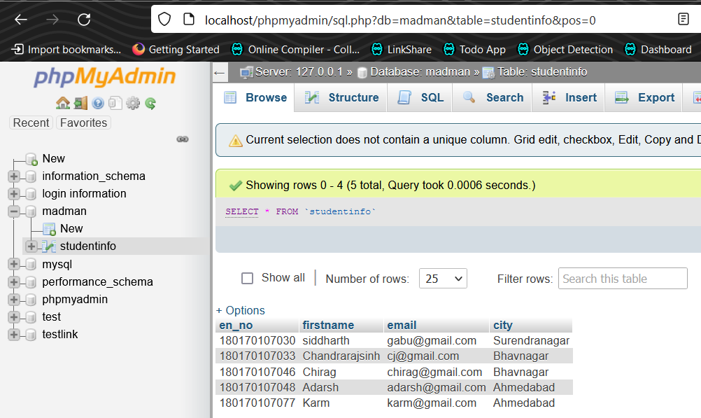

Fig 5a.1 – remote database

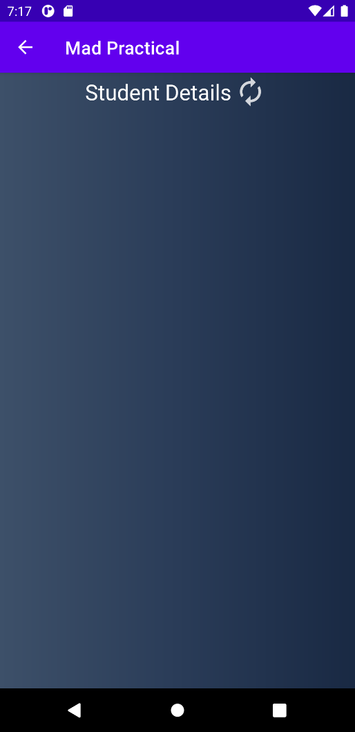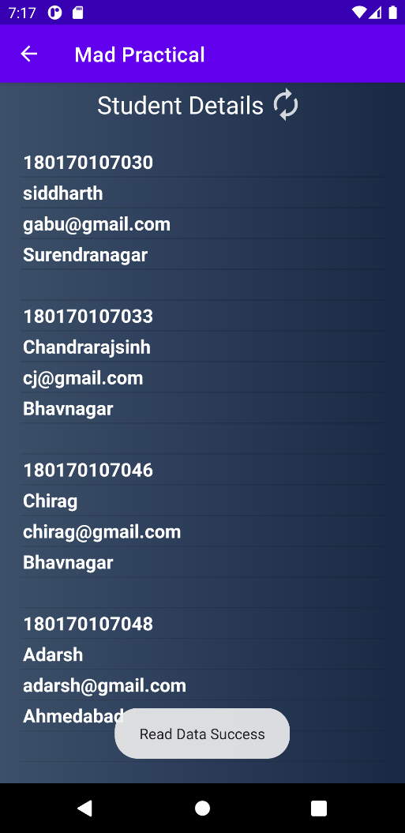

Fig5a.2 & 5a.3 - Use of Simple PHP web service to access remote database

***activity_Practical5b.xml***

*<?***xml version="1.0" encoding="utf-8"***?>*<**androidx.constraintlayout.widget.ConstraintLayout xmlns:android="http://schemas.android.com/apk/res/android"  
 xmlns:app="http://schemas.android.com/apk/res-auto"  
 xmlns:tools="http://schemas.android.com/tools"  
 android:layout_width="match_parent"  
 android:layout_height="match_parent"  
 android:background="@drawable/gradient"  
 tools:context=".Practical5b"**>  
  
 <**ScrollView  
 android:layout_width="match_parent"  
 android:layout_height="match_parent"  
 app:layout_constraintBottom_toBottomOf="parent"  
 app:layout_constraintEnd_toEndOf="parent"  
 app:layout_constraintStart_toStartOf="parent"  
 app:layout_constraintTop_toTopOf="parent"**>  
  
 <**LinearLayout  
 android:layout_width="match_parent"  
 android:layout_height="match_parent"  
 android:orientation="vertical"**>  
  
 <**TextView  
 android:id="@+id/textView5"  
 android:layout_width="match_parent"  
 android:layout_height="wrap_content"  
 android:layout_marginTop="10dp"  
 android:gravity="center_horizontal"  
 android:text="Data From Web Service"  
 android:textAlignment="center"  
 android:textColor="#fff"  
 android:textSize="24sp"** />  
  
 <**TextView  
 android:id="@+id/text_retrofit"  
 android:layout_width="match_parent"  
 android:layout_height="wrap_content"  
 android:layout_margin="20dp"  
 android:text="@string/blank"  
 android:textColor="#fff"  
 android:textSize="20sp"** />  
  
 </**LinearLayout**>  
 </**ScrollView**>  
</**androidx.constraintlayout.widget.ConstraintLayout**>

***JsonPlaceHolderApi.java***

**package** com.example.madpractical;  
  
**import** java.util.List;  
  
**import** retrofit2.Call;  
**import** retrofit2.http.GET;  
  
**public interface** JsonPlaceHolderApi {  
 *// posts is relative url of https://jsonplaceholder.typicode.com/posts  
 // to guide retrofit we have to annotate* @GET(**"posts"**)  
 Call<List<Post>> getPosts();  
 *// retrofit will autogenerate all code  
 // to get result*}

***Post.java***

**package** com.example.madpractical;  
  
**import** com.google.gson.annotations.SerializedName;  
  
**public class** Post {  
  
 **private int userId**;  
 **private int id**;  
 **private** String **title**;  
 *// this will bind body variable of json result to text variable* @SerializedName(**"body"**)  
 **private** String **text**;  
  
 **public int** getUserId() {  
 **return userId**;  
 }  
  
 **public int** getId() {  
 **return id**;  
 }  
  
 **public** String getTitle() {  
 **return title**;  
 }  
  
 **public** String getText() {  
 **return text**;  
 }  
}

***Practical5b.java***

**package** com.example.madpractical;  
  
**import** androidx.appcompat.app.AppCompatActivity;  
  
**import** android.app.ProgressDialog;  
**import** android.os.Bundle;  
**import** android.widget.TextView;  
  
**import** java.util.List;  
  
**import** retrofit2.Call;  
**import** retrofit2.Callback;  
**import** retrofit2.Response;  
**import** retrofit2.Retrofit;  
**import** retrofit2.converter.gson.GsonConverterFactory;  
  
**public class** Practical5b **extends** AppCompatActivity {  
  
 **private** TextView **textResult**;  
   
 @Override  
 **protected void** onCreate(Bundle savedInstanceState) {  
 **super**.onCreate(savedInstanceState);  
 setContentView(R.layout.***activity_practical5b***);  
  
 **textResult** = findViewById(R.id.***text_retrofit***);  
 Retrofit retrofit = **new** Retrofit.Builder()  
 .baseUrl(**"https://jsonplaceholder.typicode.com/"**)  
 .addConverterFactory(GsonConverterFactory.*create*())  
 .build();  
  
 JsonPlaceHolderApi jsonPlaceHolderApi = retrofit.create(JsonPlaceHolderApi.**class**);*//getposts() method body created* ProgressDialog dialog = **new** ProgressDialog(Practical5b.**this**);  
 dialog.setMessage(**"Reading Data..."**);  
 dialog.show();  
 Call<List<Post>> call = jsonPlaceHolderApi.getPosts();  
 *// execute will run on main thread causing app to stop for second(s)  
 // enqueue will run on separate thread* call.enqueue(**new** Callback<List<Post>>() {  
 @Override  
 **public void** onResponse(Call<List<Post>> call, Response<List<Post>> response) {  
 **if**(!response.isSuccessful()){  
 **textResult**.setText(**"Code: "**+response.code());  
 **return**;  
 }  
 List<Post> posts = response.body();  
 **for**(Post post: posts){  
 String content=**""**;  
 content += **"ID: "**+ post.getId() + **"\n"**;  
 content += **"User ID: "**+ post.getUserId() + **"\n"**;  
 content += **"Title: "**+ post.getTitle() + **"\n"**;  
 content += **"Text: "**+ post.getText() + **"\n\n"**;  
  
 **textResult**.append(content);  
 }  
 dialog.dismiss();  
 }  
  
 @Override  
 **public void** onFailure(Call<List<Post>> call, Throwable t) {  
 **textResult**.setText(t.getMessage());  
 }  
 });  
 }  
}

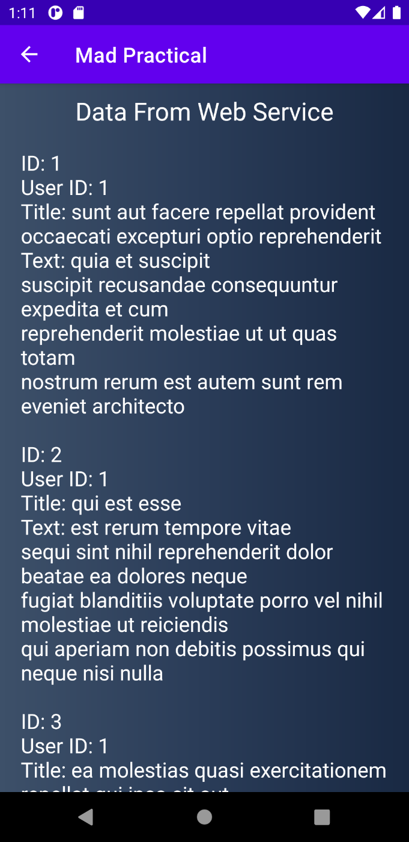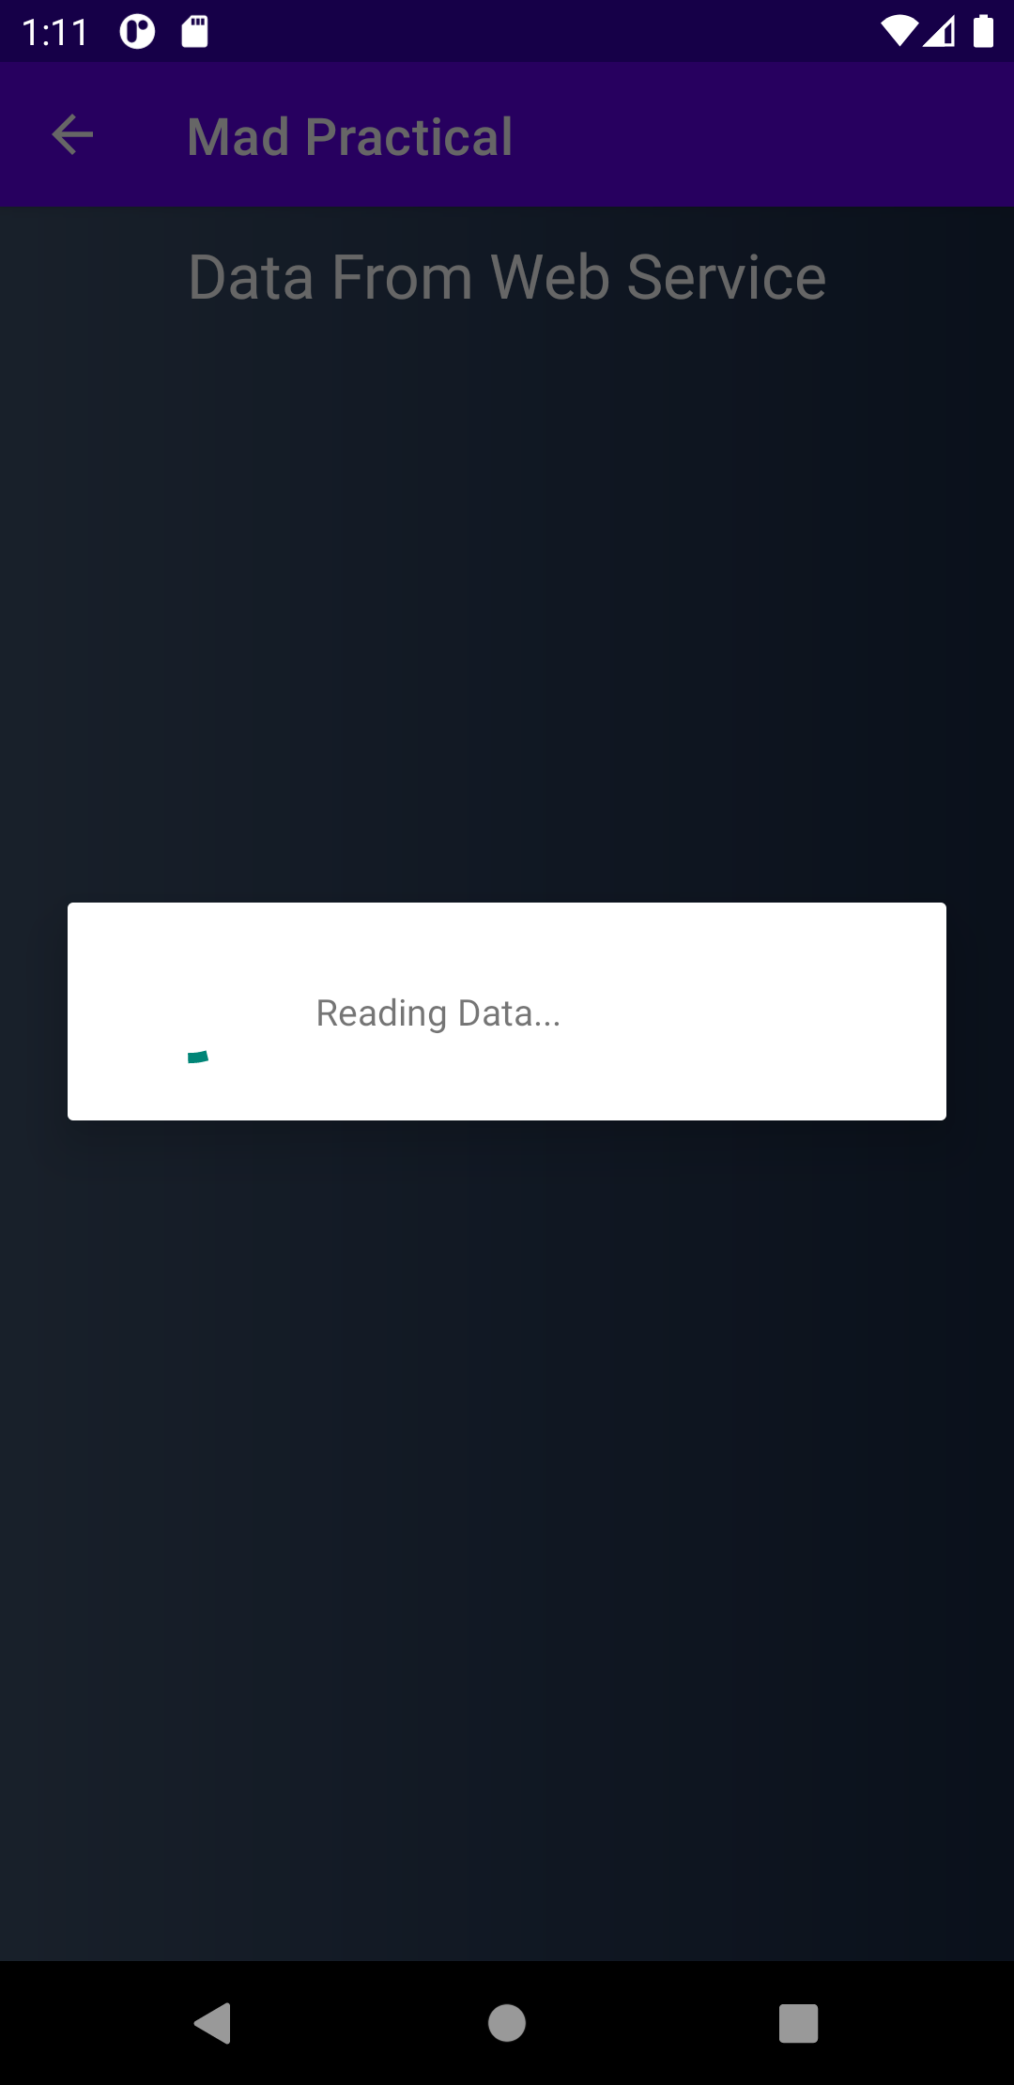

Fig 5b.1 & Fig 5b.2 Reading Data from Web Service using Retrofit

Practical – 6

**AIM:** Develop and Mobile Application for following topic

1. Get and Save User Preferences

2. Use Firebase to perform CRUID

***activity_practical6.xml***

*<?***xml version="1.0" encoding="utf-8"***?>*<**LinearLayout xmlns:android="http://schemas.android.com/apk/res/android"  
 xmlns:app="http://schemas.android.com/apk/res-auto"  
 xmlns:tools="http://schemas.android.com/tools"  
 android:layout_width="match_parent"  
 android:layout_height="match_parent"  
 android:background="@drawable/gradient"  
 android:orientation="vertical"  
 tools:context=".Practical6"**>  
  
 <**ImageView  
 android:id="@+id/imageView"  
 android:layout_width="120dp"  
 android:layout_height="150dp"  
 android:layout_gravity="center_horizontal"  
 android:layout_marginTop="80dp"  
 android:contentDescription="@string/Co512"  
 app:srcCompat="@drawable/co_512"** />  
  
 <**TextView  
 android:id="@+id/textView3"  
 android:layout_width="wrap_content"  
 android:layout_height="wrap_content"  
 android:layout_gravity="center_horizontal"  
 android:layout_marginTop="48dp"  
 android:text="@string/add_info"  
 android:textColor="@color/white"  
 android:textSize="32sp"** />  
  
 <**EditText  
 android:id="@+id/contact_id"  
 android:layout_width="wrap_content"  
 android:layout_height="wrap_content"  
 android:layout_gravity="center_horizontal"  
 android:layout_marginTop="48dp"  
 android:background="#11000000"  
 android:ems="10"  
 android:hint="@string/contact"  
 android:importantForAutofill="no"  
 android:inputType="textPersonName"  
 android:padding="10dp"  
 android:textColor="#9e9e9e"  
 android:textColorHint="#9e9e9e"  
 android:textSize="20sp"  
 app:layout_constraintEnd_toEndOf="parent"  
 app:layout_constraintStart_toStartOf="parent"  
 app:layout_constraintTop_toBottomOf="@+id/textView3"** />  
  
 <**EditText  
 android:id="@+id/name"  
 android:layout_width="wrap_content"  
 android:layout_height="wrap_content"  
 android:layout_gravity="center_horizontal"  
 android:layout_marginTop="16dp"  
 android:background="#11000000"  
 android:ems="10"  
 android:hint="@string/name"  
 android:importantForAutofill="no"  
 android:inputType="textPersonName"  
 android:padding="10dp"  
 android:textColor="#9e9e9e"  
 android:textColorHint="#9e9e9e"  
 android:textSize="20sp"** />  
  
 <**EditText  
 android:id="@+id/email"  
 android:layout_width="wrap_content"  
 android:layout_height="wrap_content"  
 android:layout_gravity="center_horizontal"  
 android:layout_marginTop="16dp"  
 android:background="#11000000"  
 android:ems="10"  
 android:hint="@string/email"  
 android:importantForAutofill="no"  
 android:inputType="textEmailAddress"  
 android:padding="10dp"  
 android:textColor="#9e9e9e"  
 android:textColorHint="#9e9e9e"  
 android:textSize="20sp"** />  
  
 <**LinearLayout  
 android:layout_width="wrap_content"  
 android:layout_height="wrap_content"  
 android:layout_gravity="center_horizontal"  
 android:layout_marginTop="20dp"  
 android:orientation="horizontal"**>  
  
 <**Button  
 android:id="@+id/save_btn"  
 android:layout_width="wrap_content"  
 android:layout_height="wrap_content"  
 android:layout_marginRight="10dp"  
 android:padding="10dp"  
 android:text="@string/save"  
 android:textColor="#fff"  
 android:textSize="24sp"** />  
  
 <**Button  
 android:id="@+id/view_btn"  
 android:layout_width="wrap_content"  
 android:layout_height="wrap_content"  
 android:layout_marginLeft="10dp"  
 android:padding="10dp"  
 android:text="@string/view"  
 android:textColor="#fff"  
 android:textSize="24sp"** />  
  
 </**LinearLayout**>  
  
</**LinearLayout**>

***recycler_firebase.xml***

*<?***xml version="1.0" encoding="utf-8"***?>*<**RelativeLayout xmlns:android="http://schemas.android.com/apk/res/android"  
 xmlns:app="http://schemas.android.com/apk/res-auto"  
 android:layout_width="match_parent"  
 android:layout_height="125dp"**>  
  
 <**TextView  
 android:id="@+id/name"  
 android:layout_width="wrap_content"  
 android:layout_height="wrap_content"  
 android:layout_marginLeft="20dp"  
 android:layout_marginTop="20dp"  
 android:text="@string/siddharth"  
 android:textColor="@color/white"  
 android:textSize="24sp"** />  
  
 <**TextView  
 android:id="@+id/contact_id"  
 android:layout_width="wrap_content"  
 android:layout_height="wrap_content"  
 android:layout_below="@id/name"  
 android:layout_marginLeft="20dp"  
 android:text="180170107030"  
 android:textColor="#9e9e9e"  
 android:textSize="20sp"** />  
  
 <**TextView  
 android:id="@+id/email"  
 android:layout_width="wrap_content"  
 android:layout_height="wrap_content"  
 android:layout_below="@id/contact_id"  
 android:layout_marginLeft="20dp"  
 android:text="gabu@gmail.com"  
 android:textColor="#9e9e9e"  
 android:textSize="20sp"** />  
  
 <**Button  
 android:id="@+id/update"  
 android:layout_width="95dp"  
 android:layout_height="wrap_content"  
 android:layout_alignParentTop="true"  
 android:layout_alignParentRight="true"  
 android:layout_marginTop="15dp"  
 android:layout_marginRight="20dp"  
 android:text="@string/update"** />  
  
 <**Button  
 android:id="@+id/delete"  
 android:layout_width="95dp"  
 android:layout_height="wrap_content"  
 android:layout_alignParentRight="true"  
 android:layout_alignParentBottom="true"  
 android:layout_marginRight="20dp"  
 android:layout_marginBottom="15dp"  
 android:text="@string/delete"** />  
  
</**RelativeLayout**>

***activity_practical6a.xml***

*<?***xml version="1.0" encoding="utf-8"***?>*<**androidx.constraintlayout.widget.ConstraintLayout xmlns:android="http://schemas.android.com/apk/res/android"  
 xmlns:app="http://schemas.android.com/apk/res-auto"  
 xmlns:tools="http://schemas.android.com/tools"  
 android:layout_width="match_parent"  
 android:layout_height="match_parent"  
 android:background="@drawable/gradient"  
 tools:context=".Practical6a"**>  
  
 <**androidx.recyclerview.widget.RecyclerView  
 android:id="@+id/recyclerview_fire"  
 android:layout_width="match_parent"  
 android:layout_height="match_parent"** />  
  
</**androidx.constraintlayout.widget.ConstraintLayout**>

***Practical6.java***

**package** com.example.madpractical;  
  
**import** androidx.appcompat.app.AppCompatActivity;  
  
**import** android.content.Intent;  
**import** android.content.SharedPreferences;  
**import** android.os.Bundle;  
**import** android.widget.Button;  
**import** android.widget.EditText;  
**import** android.widget.Toast;  
  
**public class** Practical6 **extends** AppCompatActivity {  
  
 @Override  
 **protected void** onCreate(Bundle savedInstanceState) {  
 **super**.onCreate(savedInstanceState);  
 setContentView(R.layout.***activity_practical6***);  
  
 EditText id = findViewById(R.id.***contact_id***);  
 EditText name = findViewById(R.id.***name***);  
 EditText email = findViewById(R.id.***email***);  
 Button save_btn = findViewById(R.id.***save_btn***);  
 Button view_btn = findViewById(R.id.***view_btn***);  
 DAOstudent dao = **new** DAOstudent();  
  
 save_btn.setOnClickListener(v -> {  
 String Id = id.getText().toString();  
 String Name = name.getText().toString();  
 String Email = email.getText().toString();  
 **if** (Id.isEmpty() || Name.isEmpty() || Email.isEmpty()) {  
 Toast.*makeText*(**this**, **"All Fields required!"**, Toast.***LENGTH_LONG***).show();  
 } **else** {  
 Student student = **new** Student(Id, Name, Email);  
 *// save user details in SharedPreferences* SharedPreferences preferences = getSharedPreferences(**"student_info"**, ***MODE_PRIVATE***);  
 SharedPreferences.Editor editor = preferences.edit();  
 editor.putString(**"id"**, Id);  
 editor.putString(**"name"**, Name);  
 editor.putString(**"email"**, Email);  
 editor.apply();  
 dao.add(student).addOnSuccessListener(suc -> {  
 Toast.*makeText*(**this**, **"Record is inserted"**, Toast.***LENGTH_LONG***).show();  
 id.setText(**""**);  
 name.setText(**""**);  
 email.setText(**""**);  
 }).addOnFailureListener(er -> {  
 Toast.*makeText*(**this**, er.getMessage(), Toast.***LENGTH_LONG***).show();  
 });  
 }  
 });  
  
 *// get data from preferences* SharedPreferences preferences = getSharedPreferences(**"student_info"**, ***MODE_PRIVATE***);  
 String Id = preferences.getString(**"id"**, **""**);  
 String Name = preferences.getString(**"name"**, **""**);  
 String Email = preferences.getString(**"email"**, **""**);  
 id.setText(Id);  
 name.setText(Name);  
 email.setText(Email);  
  
 view_btn.setOnClickListener(v -> {  
 Intent intent = **new** Intent(**this**, Practical6a.**class**);  
 startActivity(intent);  
 });  
 }  
}

***Practical6a.java***

**package** com.example.madpractical;  
  
**import** androidx.annotation.NonNull;  
**import** androidx.appcompat.app.AppCompatActivity;  
**import** androidx.recyclerview.widget.LinearLayoutManager;  
**import** androidx.recyclerview.widget.RecyclerView;  
  
  
**import** android.app.ProgressDialog;  
**import** android.os.AsyncTask;  
**import** android.os.Bundle;  
**import** android.util.Log;  
**import** android.view.Menu;  
**import** android.widget.ArrayAdapter;  
**import** android.widget.Toast;  
  
  
**import** com.google.firebase.database.DataSnapshot;  
**import** com.google.firebase.database.DatabaseError;  
**import** com.google.firebase.database.DatabaseReference;  
**import** com.google.firebase.database.FirebaseDatabase;  
**import** com.google.firebase.database.ValueEventListener;  
  
**import** org.json.JSONArray;  
**import** org.json.JSONObject;  
  
**import** java.io.BufferedReader;  
**import** java.io.InputStream;  
**import** java.io.InputStreamReader;  
**import** java.net.HttpURLConnection;  
**import** java.net.URL;  
**import** java.util.ArrayList;  
**import** java.util.List;  
  
**public class** Practical6a **extends** AppCompatActivity {  
  
 RecyclerView **recyclerView**;  
 LinearLayoutManager **layoutManager**;  
 List<Student> **studentList** = **new** ArrayList<>();  
 Adapter_fire **adapter**;  
 ProgressDialog **dialog**;  
  
 @Override  
 **protected void** onCreate(Bundle savedInstanceState) {  
 **super**.onCreate(savedInstanceState);  
 setContentView(R.layout.***activity_practical6a***);  
 initRecyclerView();  
 **dialog** = **new** ProgressDialog(Practical6a.**this**);  
 ReadData readData = **new** ReadData();  
 readData.execute(**new** String[]{**"http://192.168.43.217/MAD/readjson.php"**});  
 }  
  
 **private class** ReadData **extends** AsyncTask<String, Void, Boolean> {  
  
 @Override  
 **protected void** onPreExecute() {  
 **dialog**.setMessage(**"Reading Data..."**);  
 **dialog**.show();  
 }  
  
 @Override  
 **protected** Boolean doInBackground(String... data) {  
 FirebaseDatabase db = FirebaseDatabase.*getInstance*();  
 DatabaseReference databaseReference = db.getReference(Student.**class**.getSimpleName());  
  
 databaseReference.addValueEventListener(**new** ValueEventListener() {  
 @Override  
 **public void** onDataChange(@NonNull DataSnapshot snapshot) {  
 **for** (DataSnapshot snap : snapshot.getChildren()) {  
 Student student = snap.getValue(Student.**class**);  
 **studentList**.add(student);  
 *//Log.d("FireBase",student.getName());  
 //Log.d("FireBase",Integer.toString(studentList.size()));* }  
 **adapter**.notifyDataSetChanged();  
 }  
  
 @Override  
 **public void** onCancelled(@NonNull DatabaseError error) {  
 Log.*d*(**"FireBase"**, error.toString());  
 }  
 });  
  
 **return true**;  
 }  
  
 @Override  
 **protected void** onPostExecute(Boolean result) {  
 **if** (result) {  
 Toast.*makeText*(Practical6a.**this**, **"Read Data Success"**, Toast.***LENGTH_LONG***).show();  
 Log.*d*(**"Post FireBase"**, Integer.*toString*(**studentList**.size()));  
 } **else** {  
 Log.*d*(**"Error"**, **"Error"**);  
 }  
 **dialog**.dismiss();  
 }  
 }  
  
 **private void** initRecyclerView() {  
 **recyclerView** = findViewById(R.id.***recyclerview_fire***);  
 **layoutManager** = **new** LinearLayoutManager(**this**);  
 **layoutManager**.setOrientation(RecyclerView.***VERTICAL***);  
 **recyclerView**.setLayoutManager(**layoutManager**);  
 **adapter** = **new** Adapter_fire(**studentList**, Practical6a.**this**);  
 **recyclerView**.setAdapter(**adapter**);  
 }  
  
 @Override  
 **public boolean** onCreateOptionsMenu(Menu menu) {  
 getMenuInflater().inflate(R.menu.***menu_layout***, menu);  
 **return true**;  
 }  
  
}

***Adapter_fire.java***

**package** com.example.madpractical;  
  
**import** android.app.AlertDialog;  
**import** android.content.Context;  
**import** android.database.sqlite.SQLiteDatabase;  
**import** android.view.LayoutInflater;  
**import** android.view.View;  
**import** android.view.ViewGroup;  
**import** android.widget.Button;  
**import** android.widget.EditText;  
**import** android.widget.TextView;  
**import** android.widget.Toast;  
  
**import** androidx.annotation.NonNull;  
**import** androidx.recyclerview.widget.RecyclerView;  
  
**import** com.google.firebase.database.DataSnapshot;  
  
**import** java.util.HashMap;  
**import** java.util.List;  
  
**public class** Adapter_fire **extends** RecyclerView.Adapter<Adapter_fire.ViewHolder> {  
  
 **private** List<Student> **studentList**;  
 **private** Context **context**;  
  
 **public** Adapter_fire(List<Student> studentList, Context context) {  
 **this**.**studentList** = studentList;  
 **this**.**context** = context;  
 }  
  
 @NonNull  
 @Override  
 **public** Adapter_fire.ViewHolder onCreateViewHolder(@NonNull ViewGroup parent, **int** viewType) {  
 View view = LayoutInflater.*from*(parent.getContext()).inflate(R.layout.***recycler_firebase***, parent, **false**);  
 **return new** ViewHolder(view);  
 }  
  
 @Override  
 **public void** onBindViewHolder(@NonNull Adapter_fire.ViewHolder holder, **int** position) {  
 String id = **studentList**.get(position).getId();  
 String name = **studentList**.get(position).getName();  
 String email = **studentList**.get(position).getEmail();  
 holder.**delete**.setOnClickListener(**new** View.OnClickListener() {  
 @Override  
 **public void** onClick(View v) {  
 String id = **studentList**.get(position).getId();  
 DAOstudent dao = **new** DAOstudent();  
 dao.delete(id).addOnSuccessListener(suc -> {  
 Toast.*makeText*(**context**, **"Record is Deleted"**, Toast.***LENGTH_LONG***).show();  
 }).addOnFailureListener(er -> {  
 Toast.*makeText*(**context**, er.getMessage(), Toast.***LENGTH_LONG***).show();  
 });  
 *// due to addValueEventListener it will add all value again in list  
 // to remove duplicate we clear list first than notify change* **studentList**.clear();  
 notifyDataSetChanged();  
 }  
 });  
 holder.**update**.setOnClickListener(**new** View.OnClickListener() {  
 @Override  
 **public void** onClick(View v) {  
  
 **final** AlertDialog.Builder alert = **new** AlertDialog.Builder(**context**);  
  
 *// get context : pain in ass* LayoutInflater inflater = LayoutInflater.*from*(**context**);  
 *// get layout from inflater* View dialog_layout_view = inflater.inflate(R.layout.***dialog_layout_fire***, **null**);  
 *// to recognize student by click on recycler view* String id = **studentList**.get(position).getId();  
  
 EditText name = (EditText) dialog_layout_view.findViewById(R.id.***name***);  
 EditText email = (EditText) dialog_layout_view.findViewById(R.id.***email***);  
  
 Button btn_cancel = (Button) dialog_layout_view.findViewById(R.id.***btn_cancel***);  
 Button btn_okay = (Button) dialog_layout_view.findViewById(R.id.***btn_okay***);  
  
 *// insert layout into dialog box* alert.setView(dialog_layout_view);  
 *// create dialog box* **final** AlertDialog alertDialog = alert.create();  
 *// around area : false* alertDialog.setCanceledOnTouchOutside(**false**);  
  
 *// on cancel* btn_cancel.setOnClickListener(v1 -> alertDialog.dismiss());  
 *// on okay* btn_okay.setOnClickListener(v1 -> {  
 String Name = name.getText().toString();  
 String Email = email.getText().toString();  
  
 **if** (Name.isEmpty() || Email.isEmpty()) {  
 Toast.*makeText*(**context**, **"Student ALL info is required!"**, Toast.***LENGTH_LONG***).show();  
 } **else** {  
 DAOstudent daOstudent = **new** DAOstudent();  
  
 HashMap<String, Object> hashMap = **new** HashMap<>();  
 hashMap.put(**"name"**, Name);  
 hashMap.put(**"email"**, Email);  
 daOstudent.update(id, hashMap).addOnSuccessListener(suc -> {  
 Toast.*makeText*(**context**, **"Student Info Updated Successfully"**, Toast.***LENGTH_LONG***).show();  
 }).addOnFailureListener(er -> {  
 Toast.*makeText*(**context**, er.getMessage(), Toast.***LENGTH_LONG***).show();  
 });  
 *// due to addValueEventListener it will add all value again in list  
 // to remove duplicate we clear list first than notify change* **studentList**.clear();  
 notifyDataSetChanged();  
 }  
 alertDialog.dismiss();  
 });  
  
 alertDialog.show();  
  
 *//studentList.remove(position);  
 //notifyDataSetChanged();* }  
 });  
 holder.setData(id, name, email);  
 }  
  
 @Override  
 **public int** getItemCount() {  
 **return studentList**.size();  
 }  
  
 **public class** ViewHolder **extends** RecyclerView.ViewHolder {  
  
 **private** TextView **id**;  
 **private** TextView **name**;  
 **private** TextView **email**;  
 **private** Button **delete**;  
 **private** Button **update**;  
  
  
 **public** ViewHolder(@NonNull View itemView) {  
 **super**(itemView);  
  
 **id** = itemView.findViewById(R.id.***contact_id***);  
 **name** = itemView.findViewById(R.id.***name***);  
 **email** = itemView.findViewById(R.id.***email***);  
 **delete** = (Button) itemView.findViewById(R.id.***delete***);  
 **update** = (Button) itemView.findViewById(R.id.***update***);  
 }  
  
 **public void** setData(String id, String name, String email) {  
 **this**.**id**.setText(id);  
 **this**.**name**.setText(name);  
 **this**.**email**.setText(email);  
 }  
 }  
}

***DAOstudent.java***

**package** com.example.madpractical;  
  
**import** android.util.Log;  
  
**import** androidx.annotation.NonNull;  
  
**import** com.google.android.gms.tasks.Task;  
**import** com.google.firebase.database.DataSnapshot;  
**import** com.google.firebase.database.DatabaseError;  
**import** com.google.firebase.database.DatabaseReference;  
**import** com.google.firebase.database.FirebaseDatabase;  
**import** com.google.firebase.database.ValueEventListener;  
  
**import** java.util.ArrayList;  
**import** java.util.HashMap;  
**import** java.util.List;  
  
**public class** DAOstudent {  
 **private** DatabaseReference **databaseReference**;  
  
 **public** DAOstudent() {  
 FirebaseDatabase db = FirebaseDatabase.*getInstance*();  
 **databaseReference** = db.getReference(Student.**class**.getSimpleName());  
 }  
  
 **public** Task<Void> add(Student student) {  
 **return databaseReference**.child(student.getId()).setValue(student);  
 }  
  
 **public** Task<Void> update(String key, HashMap<String, Object> hashMap) {  
 **return databaseReference**.child(key).updateChildren(hashMap);  
 }  
 *// we can use read operation from here also but somehow it's not working  
 // due to main thread, we have run it using AsyncTask in separate thread  
  
  
 /*public void read(List<Student> studentList){  
 databaseReference.addValueEventListener(new ValueEventListener() {  
 @Override  
 public void onDataChange(@NonNull DataSnapshot snapshot) {  
 for(DataSnapshot snap:snapshot.getChildren()){  
 Student student = snap.getValue(Student.class);  
 studentList.add(new Student(student.getId(),student.getName(),student.getEmail()));  
 Log.d("FireBase",student.getName());  
 Log.d("FireBase",Integer.toString(studentList.size()));  
 }  
 }  
 @Override  
 public void onCancelled(@NonNull DatabaseError error) {  
 Log.d("FireBase",error.toString());  
 }  
 });  
 //Log.d("FireBase",studentList.get(0).getName());  
 }*/* **public** Task<Void> delete(String key) {  
 **return databaseReference**.child(key).removeValue();  
 }  
  
}

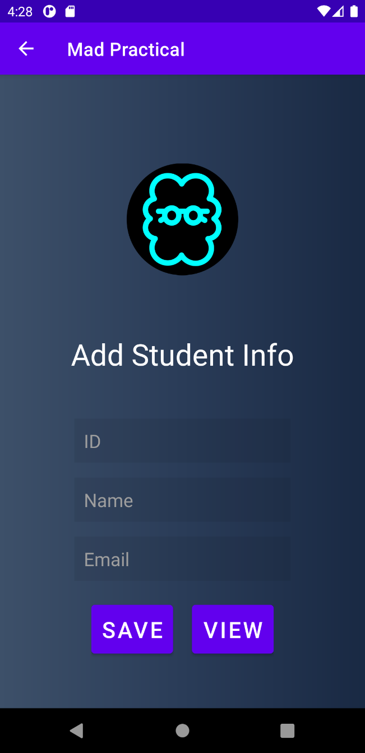

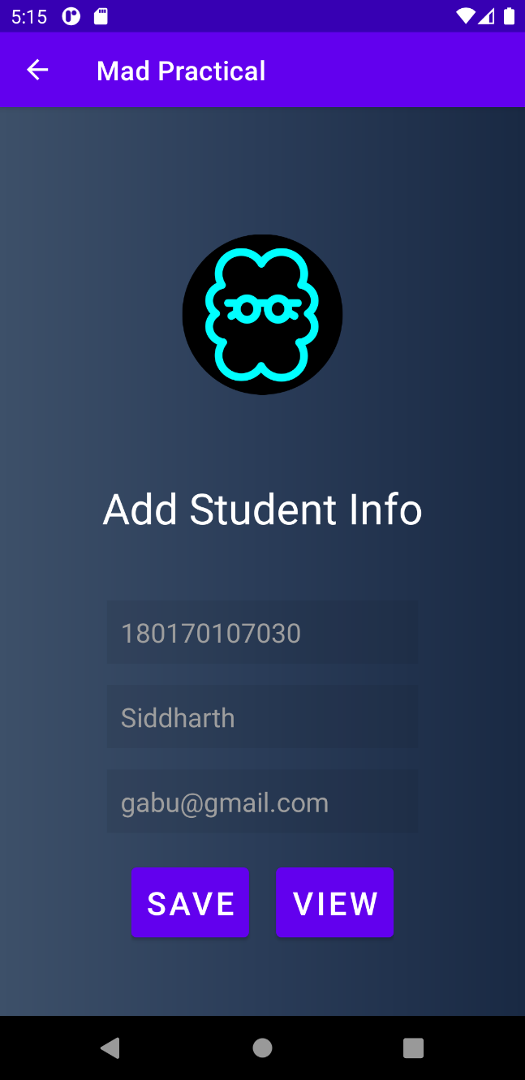

Fig 6.1 – Add to Firebase Fig 6.2 – User Preferences after user

Open app again

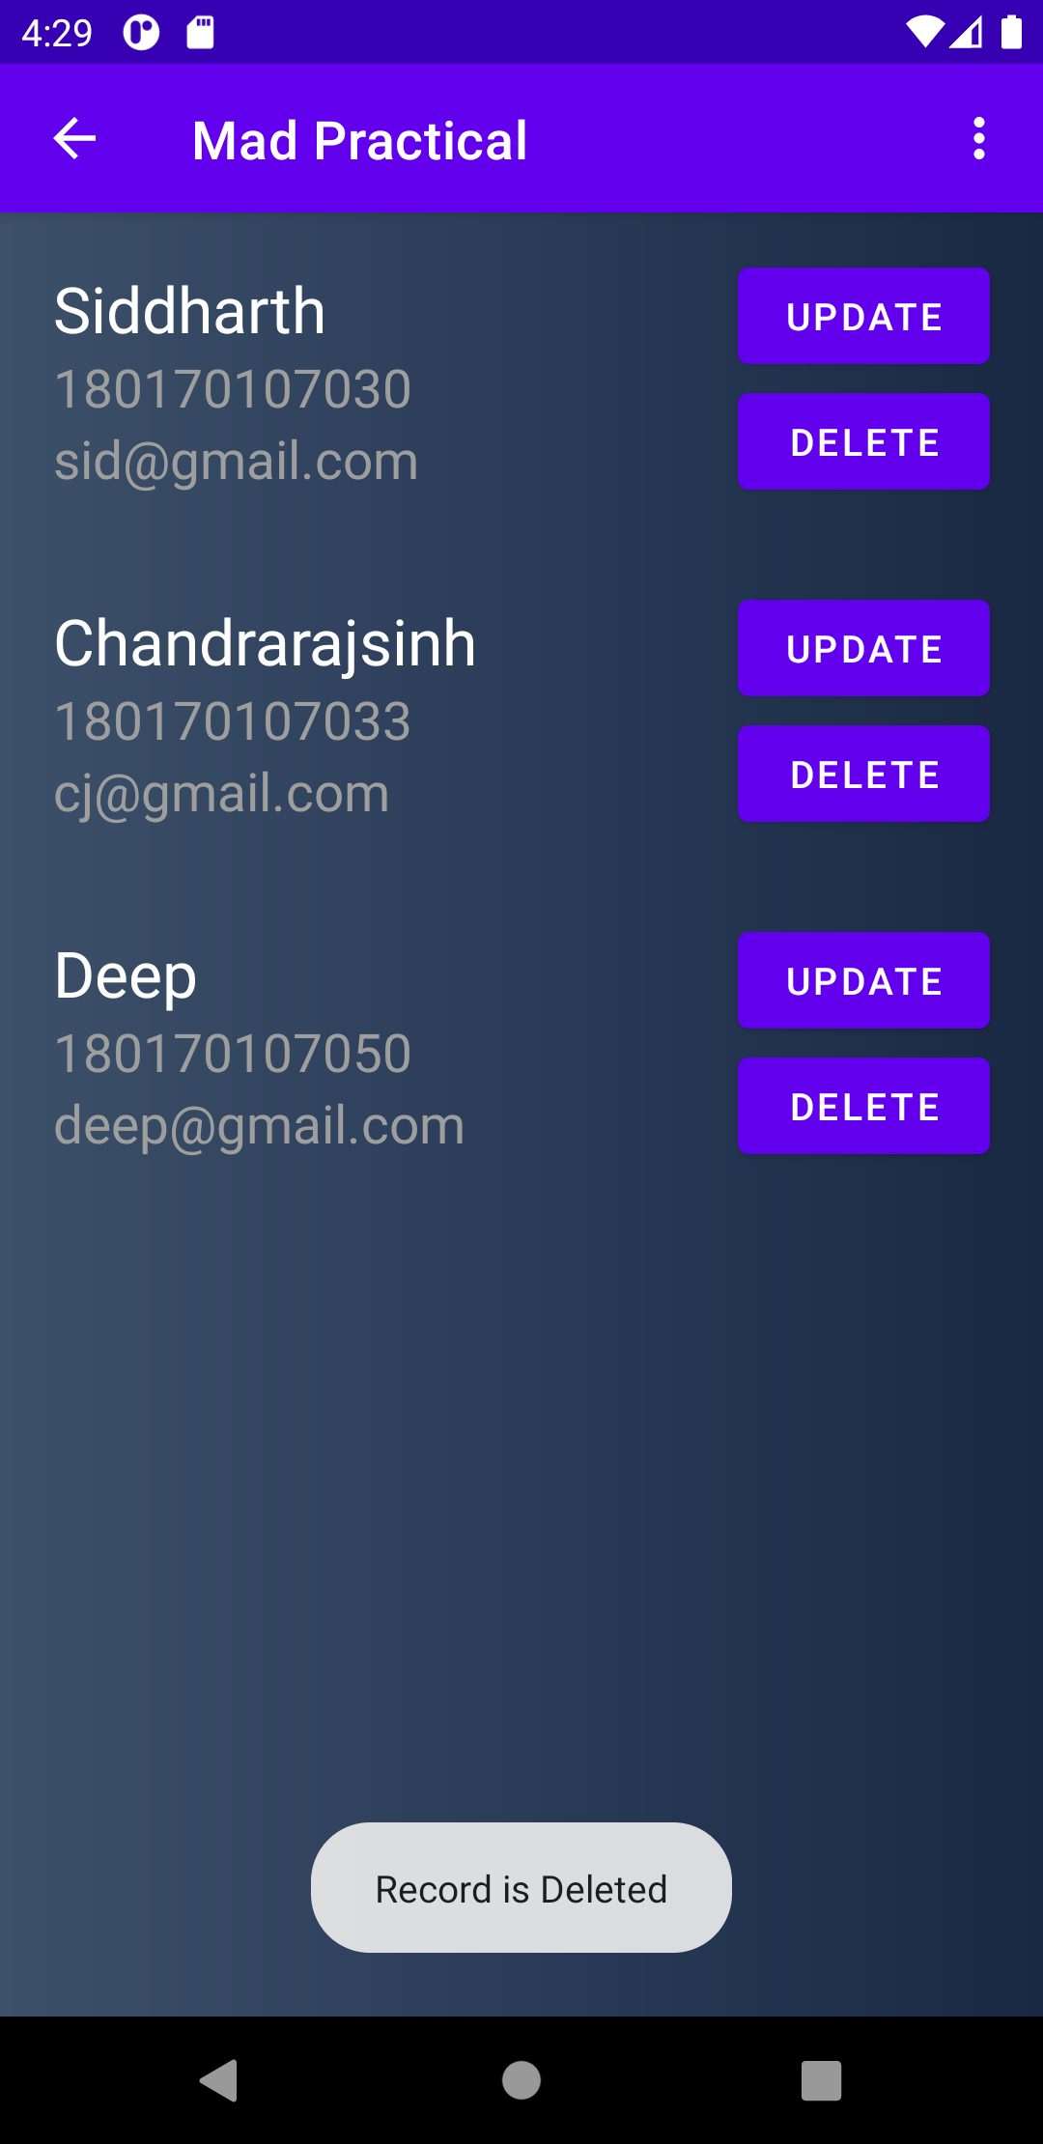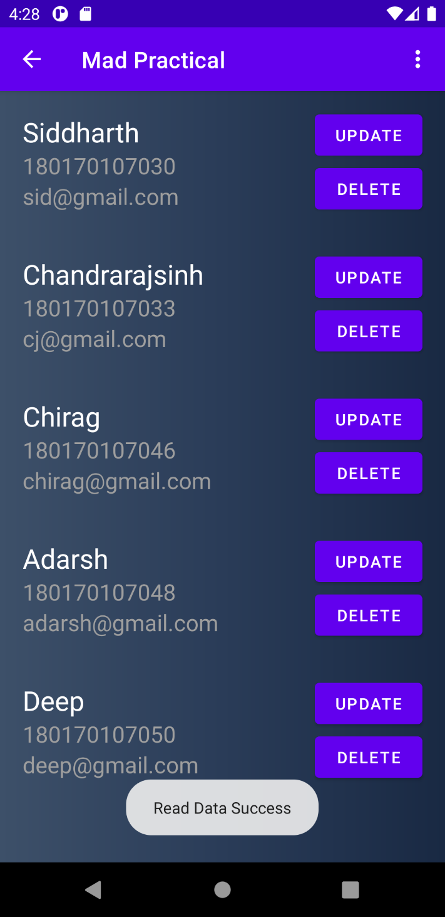

Fig 6.3 – Read Data from Firebase Fig 6.4 – Delete Data from firebase

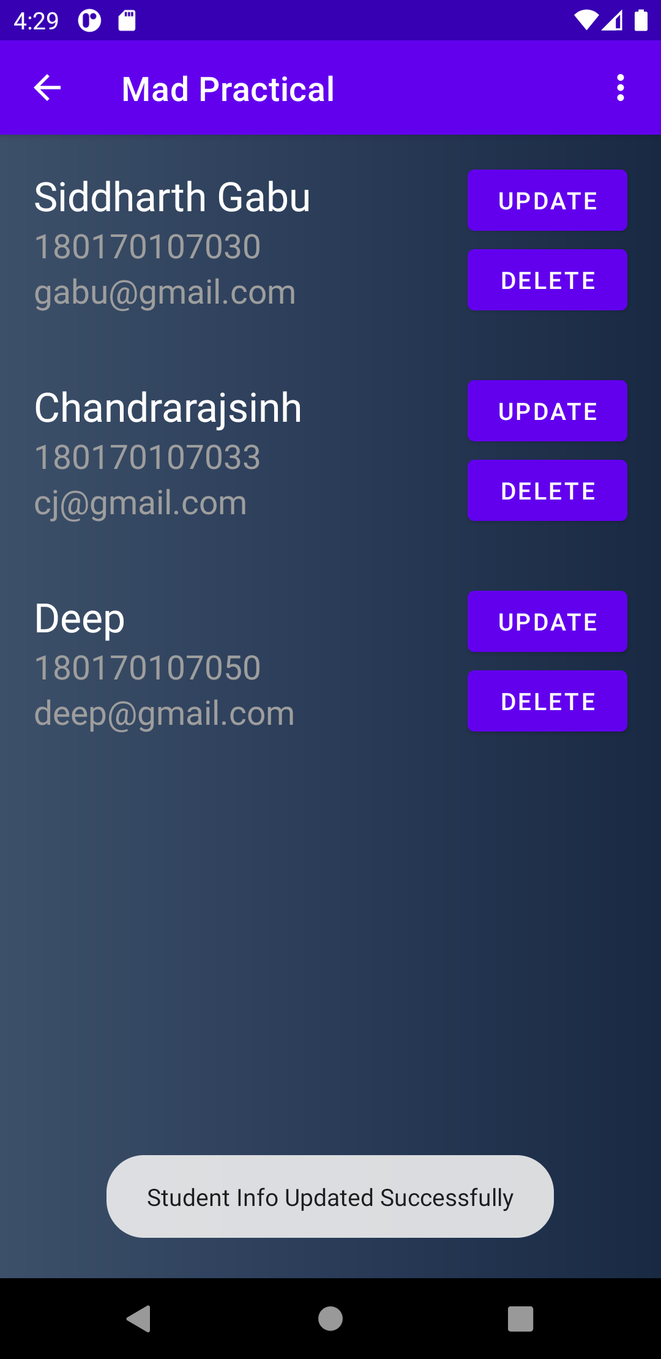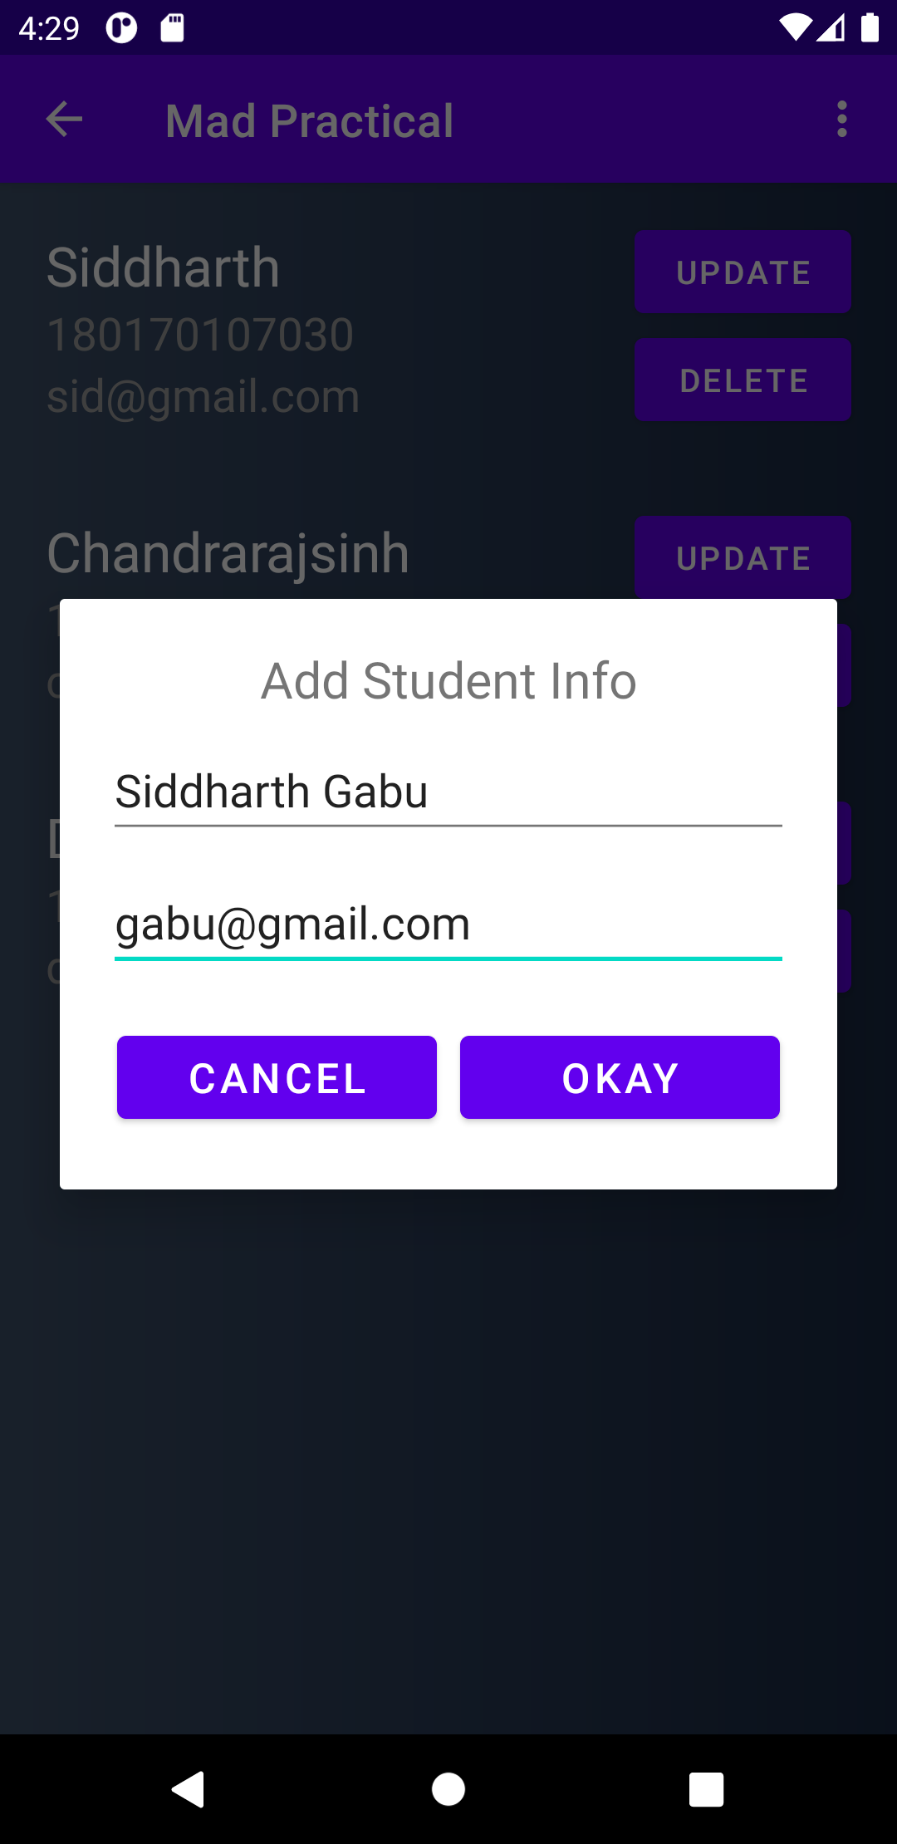

Fig 6.5 & Fig 6.6 Updating Student Info into firebase Database

Practical – 7

AIM: Develop and Mobile Application for following topic

1. BroadcastReceiver

2. Notifications

***activity_practical7.xml***

*<?***xml version="1.0" encoding="utf-8"***?>*<**androidx.constraintlayout.widget.ConstraintLayout xmlns:android="http://schemas.android.com/apk/res/android"  
 xmlns:app="http://schemas.android.com/apk/res-auto"  
 xmlns:tools="http://schemas.android.com/tools"  
 android:layout_width="match_parent"  
 android:layout_height="match_parent"  
 android:background="@drawable/gradient"  
 tools:context=".Practical7"**>  
  
 <**TextView  
 android:id="@+id/brod_text"  
 android:layout_width="wrap_content"  
 android:layout_height="wrap_content"  
 android:text="TextView"  
 android:textSize="24sp"  
 android:textColor="@color/white"  
 app:layout_constraintBottom_toBottomOf="parent"  
 app:layout_constraintEnd_toEndOf="parent"  
 app:layout_constraintStart_toStartOf="parent"  
 app:layout_constraintTop_toTopOf="parent"** />  
  
 <**Button  
 android:id="@+id/notify"  
 android:layout_width="wrap_content"  
 android:layout_height="wrap_content"  
 android:text="Notify"  
 app:layout_constraintBottom_toBottomOf="parent"  
 app:layout_constraintEnd_toEndOf="parent"  
 app:layout_constraintHorizontal_bias="0.496"  
 app:layout_constraintStart_toStartOf="parent"  
 app:layout_constraintTop_toBottomOf="@+id/brod_text"  
 app:layout_constraintVertical_bias="0.135"** />  
  
 <**TextView  
 android:id="@+id/textView6"  
 android:layout_width="wrap_content"  
 android:layout_height="wrap_content"  
 android:text="@string/broad_cast_text"  
 android:textSize="20sp"  
 android:textColor="@color/white"  
 app:layout_constraintBottom_toTopOf="@+id/brod_text"  
 app:layout_constraintEnd_toEndOf="parent"  
 app:layout_constraintStart_toStartOf="parent"  
 app:layout_constraintTop_toTopOf="parent"** />  
  
  
</**androidx.constraintlayout.widget.ConstraintLayout**>

***Practical7.java***

**package** com.example.madpractical;  
  
**import** androidx.appcompat.app.AppCompatActivity;  
**import** androidx.core.app.NotificationCompat;  
**import** androidx.core.app.NotificationManagerCompat;  
  
**import** android.app.Notification;  
**import** android.app.NotificationChannel;  
**import** android.app.NotificationManager;  
**import** android.content.Intent;  
**import** android.content.IntentFilter;  
**import** android.net.ConnectivityManager;  
**import** android.os.Build;  
**import** android.os.Bundle;  
**import** android.view.View;  
**import** android.widget.Button;  
**import** android.widget.TextView;  
  
**public class** Practical7 **extends** AppCompatActivity {  
 BroadcastReceiverExample **broad**;  
 @Override  
 **protected void** onCreate(Bundle savedInstanceState) {  
 **super**.onCreate(savedInstanceState);  
 setContentView(R.layout.***activity_practical7***);  
  
 *// BroadcastReceiver* TextView brod_text = findViewById(R.id.***brod_text***);  
 **broad** = **new** BroadcastReceiverExample(brod_text);  
 *// if we register this BroadcastReceiver by putting it in manifest file then it's statically register.  
 // but here we have done dynamically* registerReceiver(**broad**,**new** IntentFilter(Intent.***ACTION_BATTERY_CHANGED***));  
 registerReceiver(**broad**,**new** IntentFilter(Intent.***ACTION_BOOT_COMPLETED***));  
 registerReceiver(**broad**,**new** IntentFilter(Intent.***ACTION_POWER_CONNECTED***));  
 registerReceiver(**broad**,**new** IntentFilter(Intent.***ACTION_AIRPLANE_MODE_CHANGED***));  
 registerReceiver(**broad**,**new** IntentFilter(ConnectivityManager.***CONNECTIVITY_ACTION***));  
 *// Notification* **if**(Build.VERSION.***SDK_INT*** >= Build.VERSION_CODES.***O***){  
 NotificationChannel channel = **new** NotificationChannel(**"Mad Practical"**,**"Mad Practical"**, NotificationManager.***IMPORTANCE_DEFAULT***);  
 NotificationManager manager = getSystemService(NotificationManager.**class**);  
 manager.createNotificationChannel(channel);  
 }  
  
 Button notify = findViewById(R.id.***notify***);  
 notify.setOnClickListener(**new** View.OnClickListener() {  
 @Override  
 **public void** onClick(View v) {  
 *// create notification* NotificationCompat.Builder builder = **new** NotificationCompat.Builder(Practical7.**this**,**"Mad Practical"**);  
 builder.setContentTitle(**"MAD Practical"**);  
 builder.setContentText(**"Alert: You are viewing Practical 7!"**);  
 builder.setSmallIcon(R.drawable.***ic_stat_name***);  
 builder.setAutoCancel(**true**);  
  
 *// notify user* NotificationManagerCompat managerCompat = NotificationManagerCompat.*from*(Practical7.**this**);  
 managerCompat.notify(1,builder.build());  
 }  
 });  
  
 }  
  
 @Override  
 **protected void** onStop() {  
 **super**.onStop();  
 unregisterReceiver(**broad**);  
 }  
}

***BroadcastReceiverExample.java***

**package** com.example.madpractical;  
  
**import** android.content.BroadcastReceiver;  
**import** android.content.Context;  
**import** android.content.Intent;  
**import** android.net.ConnectivityManager;  
**import** android.widget.TextView;  
**import** android.widget.Toast;  
*/*  
Broadcast in android is the system-wide events that can occur when the device starts,  
when a message is received on the device or when incoming calls are received, or when a  
device goes to airplane mode, etc. Broadcast Receivers are used to respond to these  
system-wide events. Broadcast Receivers allow us to register for the system and application  
events, and when that event happens, then the register receivers get notified.  
There are mainly two types of Broadcast Receivers:  
Static Broadcast Receivers: These types of Receivers are declared in the manifest file and works even if the app is closed.  
Dynamic Broadcast Receivers: These types of receivers work only if the app is active or minimized.  
*/  
// if we register this BroadcastReceiver by putting it in manifest file then it's statically register.  
// here we have done dynamically and statically also.***public class** BroadcastReceiverExample **extends** BroadcastReceiver {  
  
 TextView **brod_text**;  
  
 BroadcastReceiverExample(){}  
  
 BroadcastReceiverExample(TextView txt){  
 **brod_text** = txt;  
 }  
  
 @Override  
 **public void** onReceive(Context context, Intent intent) {  
 **if** (Intent.***ACTION_BOOT_COMPLETED***.equals(intent.getAction())) {  
 Toast.*makeText*(context, **"Boot completed"**, Toast.***LENGTH_SHORT***).show();  
 }  
 **if** (ConnectivityManager.***CONNECTIVITY_ACTION***.equals(intent.getAction())) {  
 Toast.*makeText*(context, **"Internet Connectivity changed"**, Toast.***LENGTH_SHORT***).show();  
 }  
 **if**(Intent.***ACTION_BATTERY_CHANGED***.equals(intent.getAction())){  
 *//Toast.makeText(context, "Battery Changed", Toast.LENGTH_SHORT).show();* **int** percentage = intent.getIntExtra(**"level"**,0);  
 **if**(percentage!=0){  
 **brod_text**.setText(**"Battery Level: "**+percentage+**"%"**);  
 }  
 }  
 **if**(Intent.***ACTION_POWER_CONNECTED***.equals(intent.getAction())){  
 Toast.*makeText*(context, **"Power Connected"**, Toast.***LENGTH_SHORT***).show();  
 }  
 **if**(Intent.***ACTION_AIRPLANE_MODE_CHANGED***.equals(intent.getAction())){  
 Toast.*makeText*(context, **"Airplane Mode Changed"**, Toast.***LENGTH_SHORT***).show();  
 }  
 }  
}

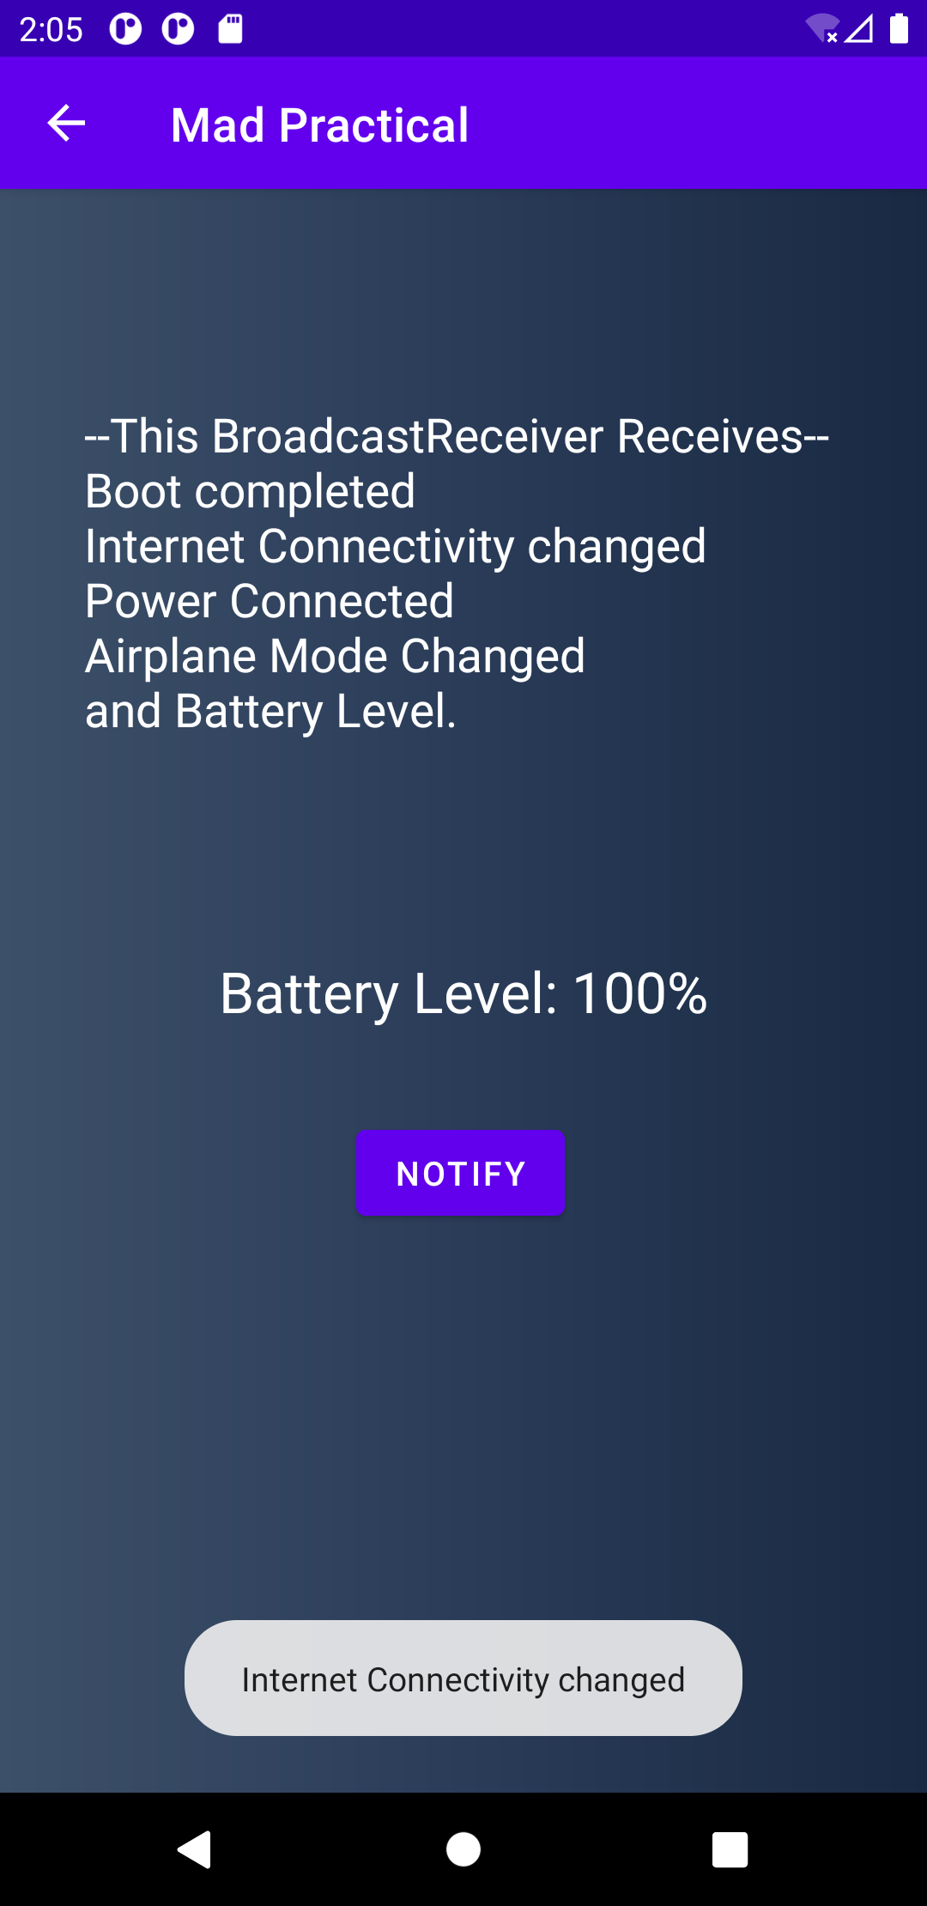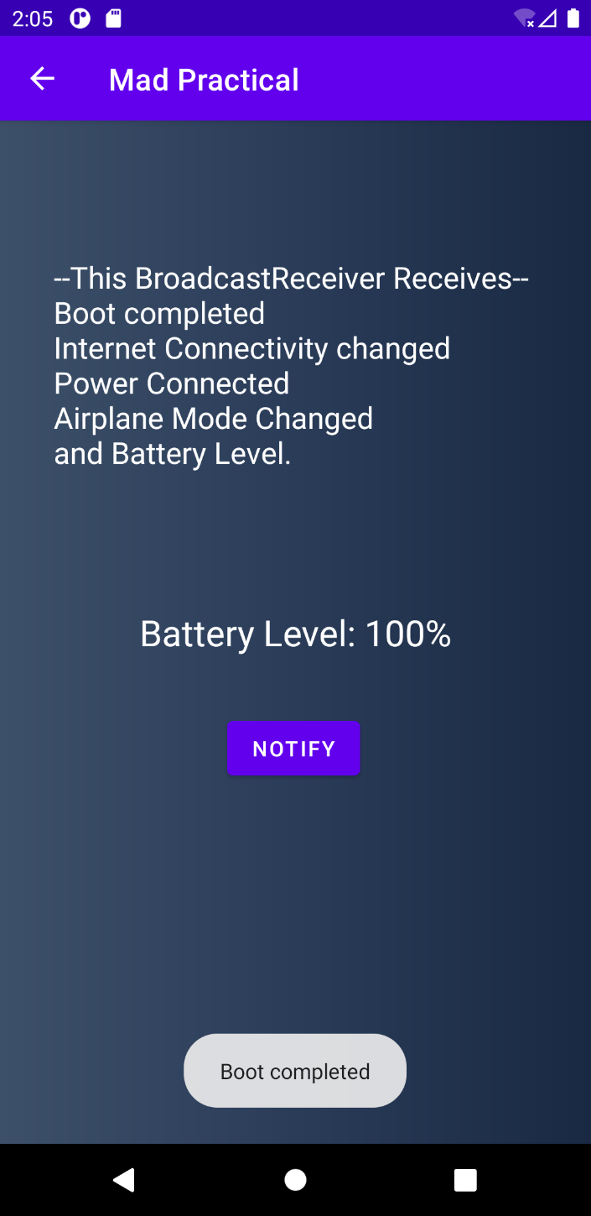

Fig 7.1 & Fig 7.2 Broadcast receiver

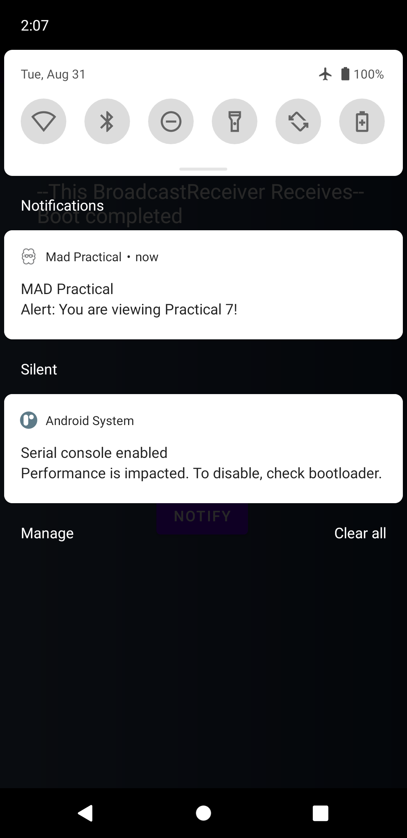

Fig7.3 - Notification

**Practical – 8**

**AIM**: Develop and Mobile Application for following topic

1. Make a use of android system like play audio, Video, Send SMS, Email.

2. Using location service get the current location

3. Display the use of animations

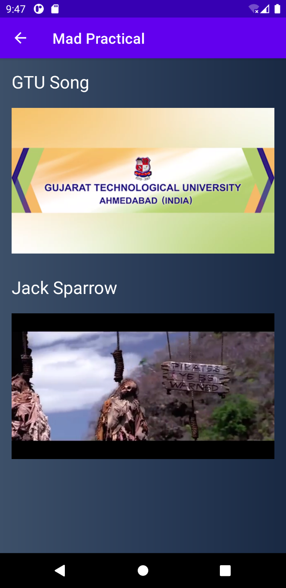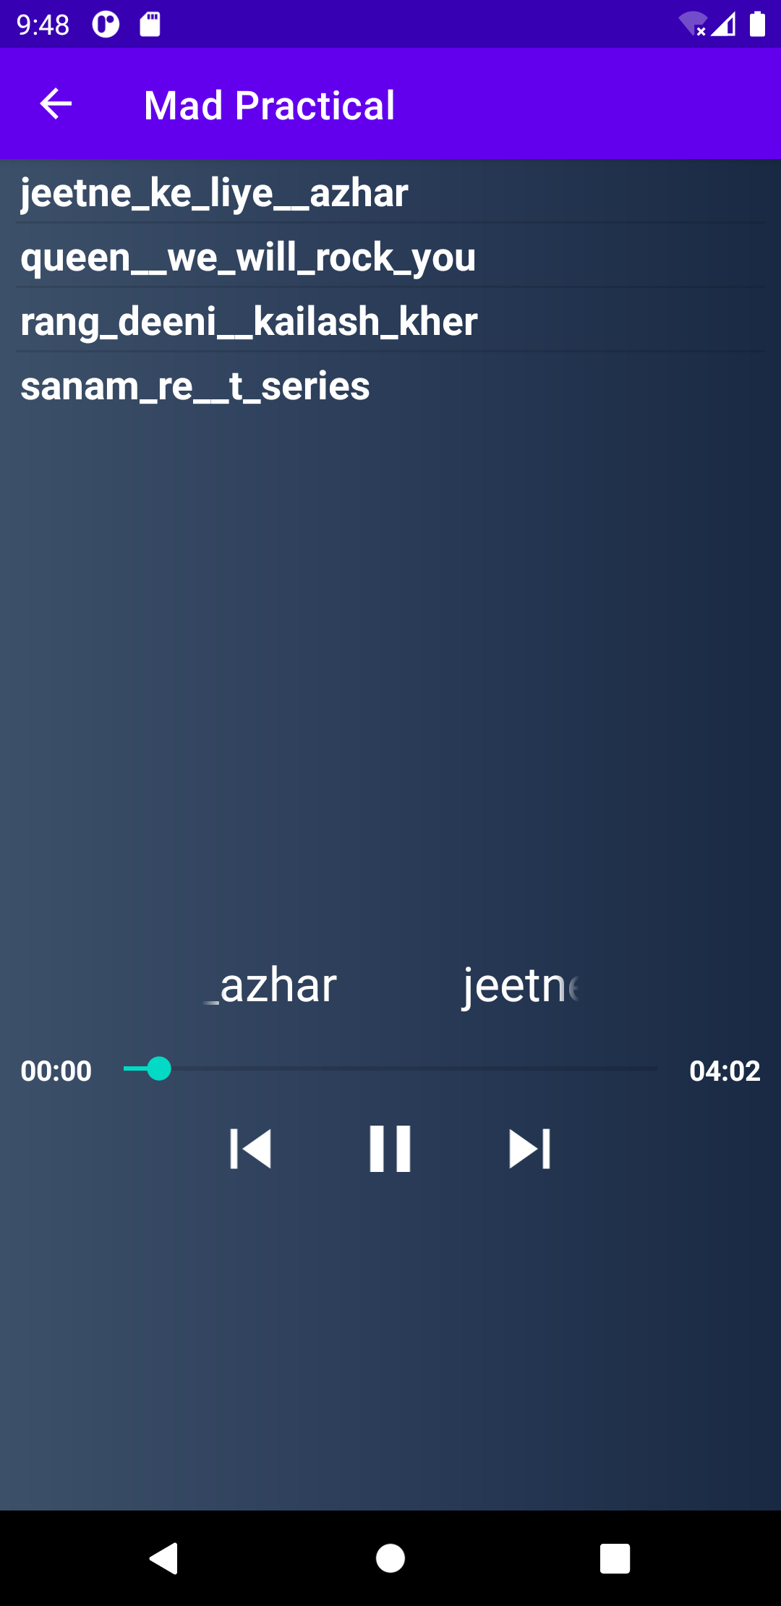

Fig 8.1a Audio Player with controls Fig 8.1b Video Player with controls

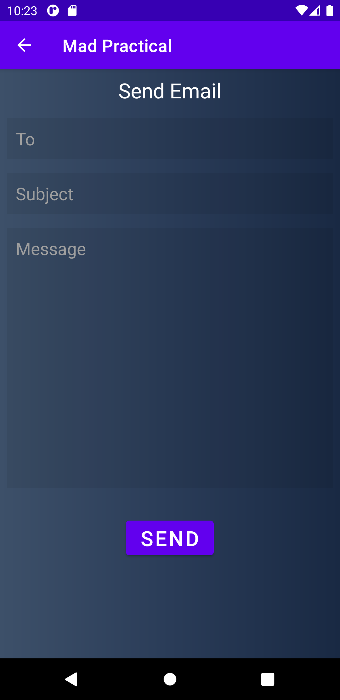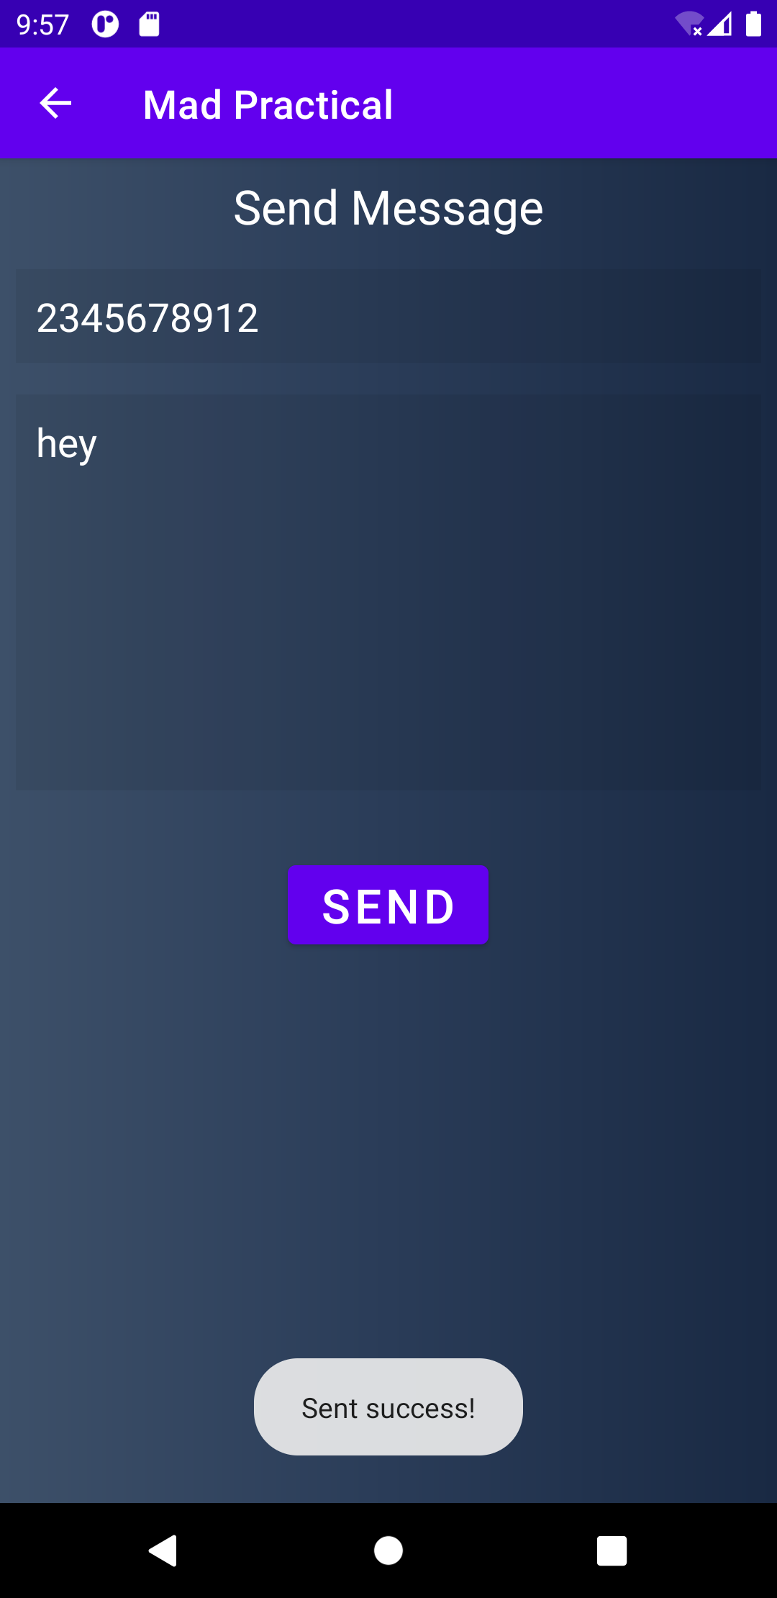

Fig 8.1c Send SMS Fig 8.1d Send Email (Gmail)

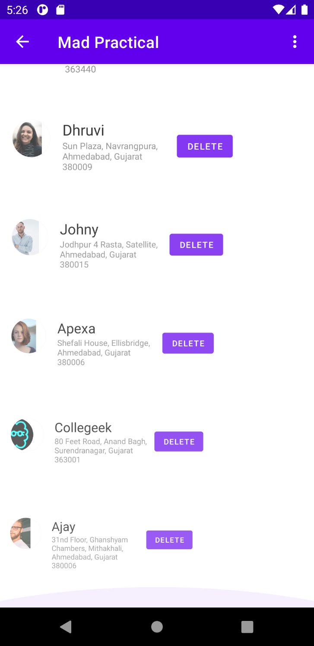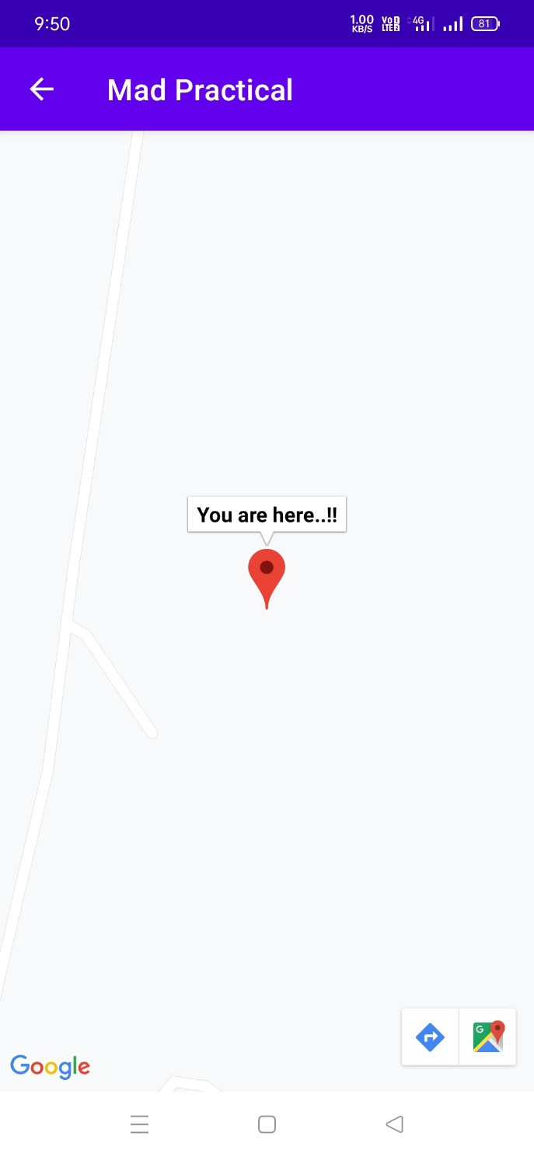

Fig 8.2 Get current location with zoom Fig 8.3 Scroll Animation

Animation

***activity_play_audio.xml***

*<?***xml version="1.0" encoding="utf-8"***?>*<**androidx.constraintlayout.widget.ConstraintLayout xmlns:android="http://schemas.android.com/apk/res/android"  
 xmlns:app="http://schemas.android.com/apk/res-auto"  
 xmlns:tools="http://schemas.android.com/tools"  
 android:layout_width="match_parent"  
 android:layout_height="match_parent"  
 android:background="@drawable/gradient"  
 tools:context=".Play_audio"**>  
  
 <**ListView  
 android:id="@+id/song_list"  
 android:layout_width="match_parent"  
 android:layout_height="wrap_content"  
 android:layout_marginStart="8dp"  
 android:layout_marginLeft="8dp"  
 android:layout_marginEnd="8dp"  
 android:layout_marginRight="8dp"  
 app:layout_constraintEnd_toEndOf="parent"  
 app:layout_constraintStart_toStartOf="parent"  
 app:layout_constraintTop_toTopOf="parent"**>  
  
 </**ListView**>  
  
 <**LinearLayout  
 android:id="@+id/scroll_text"  
 android:layout_width="match_parent"  
 android:layout_height="wrap_content"  
 android:layout_marginTop="20dp"  
 android:gravity="center_horizontal"  
 android:orientation="horizontal"  
 app:layout_constraintBottom_toBottomOf="parent"  
 app:layout_constraintEnd_toEndOf="parent"  
 app:layout_constraintStart_toStartOf="parent"  
 app:layout_constraintTop_toBottomOf="@+id/song_list"**>  
  
 <**TextView  
 android:id="@+id/scrollTxt"  
 android:layout_width="200dp"  
 android:layout_height="wrap_content"  
 android:layout_margin="8dp"  
 android:ellipsize="marquee"  
 android:focusable="true"  
 android:focusableInTouchMode="true"  
 android:freezesText="true"  
 android:gravity="center"  
 android:marqueeRepeatLimit="marquee_forever"  
 android:paddingLeft="5dp"  
 android:paddingRight="5dp"  
 android:scrollHorizontally="true"  
 android:singleLine="true"  
 android:text="@string/blank"  
 android:textColor="@color/white"  
 android:textSize="24dp"** />  
  
 </**LinearLayout**>  
  
  
 <**LinearLayout  
 android:id="@+id/linearLayout"  
 android:layout_width="match_parent"  
 android:layout_height="wrap_content"  
 android:layout_margin="10dp"  
 android:layout_marginTop="20dp"  
 android:orientation="horizontal"  
 app:layout_constraintEnd_toEndOf="parent"  
 app:layout_constraintStart_toStartOf="parent"  
 app:layout_constraintTop_toBottomOf="@+id/scroll_text"**>  
  
 <**TextView  
 android:id="@+id/player_position"  
 android:layout_width="wrap_content"  
 android:layout_height="wrap_content"  
 android:text="00:00"  
 android:textColor="@color/white"  
 android:textStyle="bold"** />  
  
 <**SeekBar  
 android:id="@+id/seek_bar"  
 android:layout_width="0dp"  
 android:layout_height="wrap_content"  
 android:layout_weight="1"** />  
  
 <**TextView  
 android:id="@+id/player_duration"  
 android:layout_width="wrap_content"  
 android:layout_height="wrap_content"  
 android:text="00:00"  
 android:textColor="@color/white"  
 android:textStyle="bold"** />  
  
 </**LinearLayout**>  
  
 <**LinearLayout  
 android:layout_width="match_parent"  
 android:layout_height="wrap_content"  
 android:layout_margin="10dp"  
 android:layout_marginTop="20dp"  
 android:gravity="center_horizontal"  
 android:orientation="horizontal"  
 app:layout_constraintEnd_toEndOf="parent"  
 app:layout_constraintStart_toStartOf="parent"  
 app:layout_constraintTop_toBottomOf="@+id/linearLayout"**>  
  
 <**ImageView  
 android:id="@+id/prev"  
 android:layout_width="60dp"  
 android:layout_height="40dp"  
 android:src="@drawable/ic_baseline_skip_previous_24"** />  
  
 <**ImageView  
 android:id="@+id/play"  
 android:layout_width="60dp"  
 android:layout_height="40dp"  
 android:layout_marginLeft="10dp"  
 android:layout_marginRight="10dp"  
 android:src="@drawable/ic_baseline_play_arrow_24"** />  
  
 <**ImageView  
 android:id="@+id/pause"  
 android:layout_width="60dp"  
 android:layout_height="40dp"  
 android:layout_marginLeft="10dp"  
 android:layout_marginRight="10dp"  
 android:src="@drawable/ic_baseline_pause_24"  
 android:visibility="gone"** />  
  
 <**ImageView  
 android:id="@+id/next"  
 android:layout_width="60dp"  
 android:layout_height="40dp"  
 android:src="@drawable/ic_baseline_skip_next_24"** />  
  
 </**LinearLayout**>  
  
  
</**androidx.constraintlayout.widget.ConstraintLayout**>

***Play_audio.java***

**package** com.example.madpractical;  
  
**import** android.annotation.SuppressLint;  
**import** android.media.MediaPlayer;  
**import** android.os.Bundle;  
**import** android.os.Handler;  
**import** android.view.View;  
**import** android.widget.AdapterView;  
**import** android.widget.ArrayAdapter;  
**import** android.widget.ImageView;  
**import** android.widget.ListView;  
**import** android.widget.SeekBar;  
**import** android.widget.TextView;  
  
**import** androidx.appcompat.app.AppCompatActivity;  
  
**import** java.lang.reflect.Field;  
**import** java.util.ArrayList;  
**import** java.util.concurrent.TimeUnit;  
  
**public class** Play_audio **extends** AppCompatActivity {  
  
 ListView **listView**;  
 ArrayList<String> **arrayList**;  
 ArrayAdapter **arrayAdapter**;  
 MediaPlayer **mediaPlayer**;  
 SeekBar **seekBar**;  
 ImageView **play**, **pause**, **next**, **prev**;  
 TextView **playerPosition**, **playerDuration**, **scroll_text**;  
  
 Handler **handler** = **new** Handler();  
 Runnable **runnable**;  
 **int Pid** = -1;  
  
 @Override  
 **protected void** onCreate(Bundle savedInstanceState) {  
 **super**.onCreate(savedInstanceState);  
 setContentView(R.layout.***activity_play_audio***);  
  
 *// Assign variable* **play** = findViewById(R.id.***play***);  
 **pause** = findViewById(R.id.***pause***);  
 **next** = findViewById(R.id.***next***);  
 **prev** = findViewById(R.id.***prev***);  
 **scroll_text** = findViewById(R.id.***scrollTxt***);  
 **seekBar** = findViewById(R.id.***seek_bar***);  
 **playerPosition** = findViewById(R.id.***player_position***);  
 **playerDuration** = findViewById(R.id.***player_duration***);  
 **listView** = findViewById(R.id.***song_list***);  
 **arrayList** = **new** ArrayList<>();  
  
 *// get song names* Field[] fields = R.raw.**class**.getFields();  
 *// add name to list* **for** (**int** i = 2; i < fields.**length**; ++i) {  
 **arrayList**.add(fields[i].getName());  
 }  
  
 **arrayAdapter** = **new** ArrayAdapter(**this**, R.layout.***simple_list***, **arrayList**);  
 **listView**.setAdapter(**arrayAdapter**);  
  
 *// on click to song name* **listView**.setOnItemClickListener(**new** AdapterView.OnItemClickListener() {  
 @Override  
 **public void** onItemClick(AdapterView<?> parent, View view, **int** position, **long** id) {  
 **Pid** = position;  
 start_MediaPlayer(**Pid**);  
 **play**.setVisibility(View.***GONE***);  
 **pause**.setVisibility(View.***VISIBLE***);  
 }  
 });  
 *// on play* **play**.setOnClickListener(v -> {  
 **if** (**Pid** == -1) {  
 **Pid** = 0;  
 start_MediaPlayer(**Pid**);  
 }  
 **play**.setVisibility(View.***GONE***);  
 **pause**.setVisibility(View.***VISIBLE***);  
 **mediaPlayer**.start();  
 });  
 *// on pause* **pause**.setOnClickListener(v -> {  
 **pause**.setVisibility(View.***GONE***);  
 **play**.setVisibility(View.***VISIBLE***);  
 **mediaPlayer**.pause();  
 });  
 *// on next* **next**.setOnClickListener(v -> {  
 **if** (**Pid** == -1) {  
 **Pid** = 1;  
 start_MediaPlayer(**Pid**);  
 } **else** {  
 **Pid** = Math.*abs*(**Pid** + 1) % **arrayList**.size();  
 start_MediaPlayer(**Pid**);  
 }  
 **play**.setVisibility(View.***GONE***);  
 **pause**.setVisibility(View.***VISIBLE***);  
 });  
 *// on prev* **prev**.setOnClickListener(v -> {  
 **if** (**Pid** == -1) {  
 **Pid** = **arrayList**.size() - 1;  
 start_MediaPlayer(**Pid**);  
 } **else** {  
 **Pid** = (**Pid** - 1) > -1 ? (**Pid** - 1) : (**arrayList**.size() - 1);  
 start_MediaPlayer(**Pid**);  
 }  
 **play**.setVisibility(View.***GONE***);  
 **pause**.setVisibility(View.***VISIBLE***);  
 });  
 }  
  
 *// media player* **private void** start_MediaPlayer(**int** position) {  
 *// free player* **if** (**mediaPlayer** != **null**) **mediaPlayer**.release();  
 *// get id of song* **int** Id = getResources().getIdentifier(**arrayList**.get(position), **"raw"**, getPackageName());  
 *// set Text* **scroll_text**.setText(**arrayList**.get(position));  
 **scroll_text**.setSelected(**true**);  
 *// Initialize media player* **mediaPlayer** = MediaPlayer.*create*(Play_audio.**this**, Id);  
  
 *// Initialize runnable* **runnable** = **new** Runnable() {  
 @Override  
 **public void** run() {  
 *// set progress on seek bar* **seekBar**.setProgress(**mediaPlayer**.getCurrentPosition());  
 *// Handler post delay for 0.5 second* **handler**.postDelayed(**this**, 500);  
 }  
 };  
 *// Get duration of media player* **int** duration = **mediaPlayer**.getDuration();  
 *// Convert millisecond to minute and second* String Duration = convertFormat(duration);  
 *// set duration text* **playerDuration**.setText(Duration);  
 *// Start media player* **mediaPlayer**.start();  
 *// Set max on seek bar* **seekBar**.setMax(**mediaPlayer**.getDuration());  
 *// control using seekbar* **seekBar**.setOnSeekBarChangeListener(**new** SeekBar.OnSeekBarChangeListener() {  
 @Override  
 **public void** onProgressChanged(SeekBar seekBar, **int** progress, **boolean** fromUser) {  
 **if** (fromUser) **mediaPlayer**.seekTo(progress);  
 }  
  
 @Override  
 **public void** onStartTrackingTouch(SeekBar seekBar) {  
  
 }  
  
 @Override  
 **public void** onStopTrackingTouch(SeekBar seekBar) {  
  
 }  
 });  
 *// Start handler* **handler**.postDelayed(**runnable**, 0);  
 }  
  
 @SuppressLint(**"DefaultLocale"**)  
 **private** String convertFormat(**int** duration) {  
 **return** String.*format*(**"%02d:%02d"**,  
 TimeUnit.***MILLISECONDS***.toMinutes(duration),  
 TimeUnit.***MILLISECONDS***.toSeconds(duration) -  
 TimeUnit.***MINUTES***.toSeconds(TimeUnit.***MILLISECONDS***.toMinutes(duration)));  
 }  
}

***activity_playvideo.xml***

*<?***xml version="1.0" encoding="utf-8"***?>*<**androidx.constraintlayout.widget.ConstraintLayout xmlns:android="http://schemas.android.com/apk/res/android"  
 xmlns:app="http://schemas.android.com/apk/res-auto"  
 xmlns:tools="http://schemas.android.com/tools"  
 android:layout_width="match_parent"  
 android:layout_height="match_parent"  
 android:background="@drawable/gradient"  
 android:padding="16dp"  
 tools:context=".Playvideo"**>  
  
 <**ScrollView  
 android:layout_width="match_parent"  
 android:layout_height="match_parent"  
 app:layout_constraintBottom_toBottomOf="parent"  
 app:layout_constraintEnd_toEndOf="parent"  
 app:layout_constraintStart_toStartOf="parent"  
 app:layout_constraintTop_toTopOf="parent"**>  
  
 <**LinearLayout  
 android:layout_width="match_parent"  
 android:layout_height="match_parent"  
 android:orientation="vertical"**>  
 <**TextView  
 android:layout_width="wrap_content"  
 android:layout_height="wrap_content"  
 android:text="GTU Song"  
 android:textSize="24sp"  
 android:textColor="@color/white"  
 android:layout_marginBottom="20dp"**/>  
 <**FrameLayout  
 android:layout_width="match_parent"  
 android:layout_height="200dp"**>  
  
 <**VideoView  
 android:id="@+id/video_view1"  
 android:layout_width="match_parent"  
 android:layout_height="wrap_content"** />  
 </**FrameLayout**>  
 <**TextView  
 android:layout_width="wrap_content"  
 android:layout_height="wrap_content"  
 android:text="Jack Sparrow"  
 android:textSize="24sp"  
 android:textColor="@color/white"  
 android:layout_marginTop="30dp"  
 android:layout_marginBottom="20dp"**/>  
 <**FrameLayout  
 android:layout_width="match_parent"  
 android:layout_height="200dp"**>  
  
 <**VideoView  
 android:id="@+id/video_view2"  
 android:layout_width="match_parent"  
 android:layout_height="wrap_content"** />  
 </**FrameLayout**>  
 </**LinearLayout**>  
 </**ScrollView**>  
</**androidx.constraintlayout.widget.ConstraintLayout**>

***Playvideo.java***

**package** com.example.madpractical;  
  
**import** androidx.appcompat.app.AppCompatActivity;  
  
**import** android.os.Bundle;  
**import** android.widget.MediaController;  
**import** android.widget.VideoView;  
  
**public class** Playvideo **extends** AppCompatActivity {  
  
 @Override  
 **protected void** onCreate(Bundle savedInstanceState) {  
 **super**.onCreate(savedInstanceState);  
 setContentView(R.layout.***activity_playvideo***);  
  
 VideoView videoView1 = findViewById(R.id.***video_view1***);  
 videoView1.setVideoPath(**"android.resource://"**+getPackageName()+**"/"**+R.raw.***gtu_song***);  
 MediaController mediaController1 = **new** MediaController(**this**);  
 mediaController1.setAnchorView(videoView1);  
 videoView1.setMediaController(mediaController1);  
  
 VideoView videoView2 = findViewById(R.id.***video_view2***);  
 videoView2.setVideoPath(**"android.resource://"**+getPackageName()+**"/"**+R.raw.***jack_sparrow***);  
 MediaController mediaController2 = **new** MediaController(**this**);  
 mediaController2.setAnchorView(videoView2);  
 videoView2.setMediaController(mediaController2);  
  
 }  
}

***activity_send_message.xml***

*<?***xml version="1.0" encoding="utf-8"***?>*<**LinearLayout xmlns:android="http://schemas.android.com/apk/res/android"  
 xmlns:tools="http://schemas.android.com/tools"  
 android:layout_width="match_parent"  
 android:layout_height="match_parent"  
 android:background="@drawable/gradient"  
 android:orientation="vertical"  
 tools:context=".Send_message"**>  
  
 <**TextView  
 android:layout_width="wrap_content"  
 android:layout_height="wrap_content"  
 android:layout_gravity="center_horizontal"  
 android:layout_margin="8dp"  
 android:text="Send Message"  
 android:textColor="@color/white"  
 android:textSize="24sp"** />  
  
 <**EditText  
 android:id="@+id/phone"  
 android:layout_width="match_parent"  
 android:layout_height="wrap_content"  
 android:layout_margin="8dp"  
 android:background="#11000000"  
 android:hint="Phone Number"  
 android:importantForAutofill="no"  
 android:inputType="phone"  
 android:padding="10dp"  
 android:textColor="#fff"  
 android:textColorHint="#9e9e9e"  
 android:textSize="20sp"** />  
  
 <**EditText  
 android:id="@+id/phone_message"  
 android:layout_width="match_parent"  
 android:layout_height="200dp"  
 android:layout_margin="8dp"  
 android:background="#11000000"  
 android:gravity="top"  
 android:hint="Type Message"  
 android:importantForAutofill="no"  
 android:inputType="textLongMessage"  
 android:padding="10dp"  
 android:textColor="#fff"  
 android:textColorHint="#9e9e9e"  
 android:textSize="20sp"** />  
  
 <**Button  
 android:id="@+id/send_btn"  
 android:layout_width="wrap_content"  
 android:layout_height="wrap_content"  
 android:layout_gravity="center_horizontal"  
 android:layout_margin="24dp"  
 android:text="Send"  
 android:textSize="24sp"** />  
  
</**LinearLayout**>

***Send_message.java***

**package** com.example.madpractical;  
  
**import** android.Manifest;  
**import** android.content.pm.PackageManager;  
**import** android.os.Bundle;  
**import** android.telephony.SmsManager;  
**import** android.util.Log;  
**import** android.widget.Button;  
**import** android.widget.EditText;  
**import** android.widget.Toast;  
  
**import** androidx.appcompat.app.AppCompatActivity;  
**import** androidx.core.app.ActivityCompat;  
**import** androidx.core.content.ContextCompat;  
  
**public class** Send_message **extends** AppCompatActivity {  
  
 **private** EditText **message**, **phone**;  
 **private** Button **send_sms**;  
  
 @Override  
 **protected void** onCreate(Bundle savedInstanceState) {  
 **super**.onCreate(savedInstanceState);  
 setContentView(R.layout.***activity_send_message***);  
  
 **message** = findViewById(R.id.***phone_message***);  
 **phone** = findViewById(R.id.***phone***);  
 **send_sms** = findViewById(R.id.***send_btn***);  
  
 **send_sms**.setOnClickListener(v -> {  
  
 **if** (ContextCompat.*checkSelfPermission*(Send_message.**this**, Manifest.permission.***SEND_SMS***) == PackageManager.***PERMISSION_GRANTED***) {  
 sendMessage();  
 } **else** {  
 ActivityCompat.*requestPermissions*(Send_message.**this**, **new** String[]{Manifest.permission.***SEND_SMS***}, 100);  
 }  
 });  
  
 }  
  
 **private void** sendMessage() {  
 String sms_text = **message**.getText().toString().trim();  
 String phone_no = **phone**.getText().toString().trim();  
 **if** (sms_text.isEmpty() || phone_no.isEmpty()) {  
 Toast.*makeText*(Send_message.**this**, **"All Fields required!"**, Toast.***LENGTH_LONG***).show();  
 } **else** {  
 **try** {  
 SmsManager smsManager = SmsManager.*getDefault*();  
 smsManager.sendTextMessage(phone_no, **null**, sms_text, **null**, **null**);  
 Toast.*makeText*(Send_message.**this**, **"Sent success!"**, Toast.***LENGTH_LONG***).show();  
 } **catch** (Exception e) {  
 Toast.*makeText*(Send_message.**this**, **"Error!"**, Toast.***LENGTH_LONG***).show();  
 Log.*d*(**"Sms Error"**, e.toString());  
 }  
 }  
 }  
}

***activity_send_email.xml***

*<?***xml version="1.0" encoding="utf-8"***?>*<**LinearLayout xmlns:android="http://schemas.android.com/apk/res/android"  
 xmlns:tools="http://schemas.android.com/tools"  
 android:layout_width="match_parent"  
 android:layout_height="match_parent"  
 android:background="@drawable/gradient"  
 android:orientation="vertical"  
 tools:context=".Send_email"**>  
  
 <**TextView  
 android:layout_width="wrap_content"  
 android:layout_height="wrap_content"  
 android:layout_gravity="center_horizontal"  
 android:layout_margin="8dp"  
 android:text="Send Email"  
 android:textColor="@color/white"  
 android:textSize="24sp"** />  
  
 <**EditText  
 android:id="@+id/email"  
 android:layout_width="match_parent"  
 android:layout_height="wrap_content"  
 android:layout_margin="8dp"  
 android:background="#11000000"  
 android:hint="To"  
 android:importantForAutofill="no"  
 android:inputType="textEmailAddress"  
 android:padding="10dp"  
 android:textColor="#fff"  
 android:textColorHint="#9e9e9e"  
 android:textSize="20sp"** />  
  
 <**EditText  
 android:id="@+id/subject"  
 android:layout_width="match_parent"  
 android:layout_height="wrap_content"  
 android:layout_margin="8dp"  
 android:background="#11000000"  
 android:hint="Subject"  
 android:importantForAutofill="no"  
 android:inputType="text"  
 android:padding="10dp"  
 android:textColor="#fff"  
 android:textColorHint="#9e9e9e"  
 android:textSize="20sp"** />  
  
 <**EditText  
 android:id="@+id/email_message"  
 android:layout_width="match_parent"  
 android:layout_height="300dp"  
 android:layout_margin="8dp"  
 android:background="#11000000"  
 android:gravity="top"  
 android:hint="Message"  
 android:importantForAutofill="no"  
 android:inputType="textLongMessage"  
 android:padding="10dp"  
 android:textColor="#fff"  
 android:textColorHint="#9e9e9e"  
 android:textSize="20sp"** />  
  
 <**Button  
 android:id="@+id/send_btn"  
 android:layout_width="wrap_content"  
 android:layout_height="wrap_content"  
 android:layout_gravity="center_horizontal"  
 android:layout_margin="24dp"  
 android:text="Send"  
 android:textSize="24sp"** />  
  
</**LinearLayout**>

***Send_email.java***

**package** com.example.madpractical;  
  
**import** androidx.appcompat.app.AppCompatActivity;  
**import** androidx.core.app.ActivityCompat;  
**import** androidx.core.content.ContextCompat;  
  
**import** android.Manifest;  
**import** android.content.Intent;  
**import** android.content.pm.PackageManager;  
**import** android.net.Uri;  
**import** android.os.Bundle;  
**import** android.telephony.SmsManager;  
**import** android.util.Log;  
**import** android.widget.Button;  
**import** android.widget.EditText;  
**import** android.widget.Toast;  
  
**public class** Send_email **extends** AppCompatActivity {  
 EditText **email**, **subject**, **message**;  
  
 @Override  
 **protected void** onCreate(Bundle savedInstanceState) {  
 **super**.onCreate(savedInstanceState);  
 setContentView(R.layout.***activity_send_email***);  
  
 **email** = findViewById(R.id.***email***);  
 **subject** = findViewById(R.id.***subject***);  
 **message** = findViewById(R.id.***email_message***);  
 Button send_sms = findViewById(R.id.***send_btn***);  
  
 send_sms.setOnClickListener(v -> {  
 String email_text = **message**.getText().toString().trim();  
 String subject_text = **subject**.getText().toString().trim();  
 String Email = **email**.getText().toString().trim();  
 **if** (email_text.isEmpty() || subject_text.isEmpty() || Email.isEmpty()) {  
 Toast.*makeText*(Send_email.**this**, **"All Fields required!"**, Toast.***LENGTH_LONG***).show();  
 } **else** {  
 **try** {  
 Intent intent = **new** Intent(Intent.***ACTION_VIEW***, Uri.*parse*(**"mailto:"** + Email));  
 intent.putExtra(Intent.***EXTRA_SUBJECT***, subject_text);  
 intent.putExtra(Intent.***EXTRA_TEXT***, email_text);  
 startActivity(intent);  
 } **catch** (Exception e) {  
 Toast.*makeText*(Send_email.**this**, **"Error!"**, Toast.***LENGTH_LONG***).show();  
 Log.*d*(**"Sms Error"**, e.toString());  
 }  
 }  
 });  
 }  
  
}

***activity_practical8a.xml***

*<?***xml version="1.0" encoding="utf-8"***?>*<**RelativeLayout xmlns:android="http://schemas.android.com/apk/res/android"  
 xmlns:app="http://schemas.android.com/apk/res-auto"  
 xmlns:tools="http://schemas.android.com/tools"  
 android:layout_width="match_parent"  
 android:layout_height="match_parent"  
 tools:context=".Practical8a"**>  
  
 <**fragment  
 android:layout_width="match_parent"  
 android:layout_height="match_parent"  
 android:id="@+id/google_map"  
 android:name="com.google.android.gms.maps.SupportMapFragment"** />  
  
</**RelativeLayout**>

Practical8a.java

**package** com.example.madpractical;  
  
**import** androidx.appcompat.app.AppCompatActivity;  
**import** androidx.core.app.ActivityCompat;  
  
**import** android.Manifest;  
**import** android.content.SharedPreferences;  
**import** android.content.pm.PackageManager;  
**import** android.location.Location;  
**import** android.os.Bundle;  
**import** android.util.Log;  
  
**import** com.google.android.gms.location.FusedLocationProviderClient;  
**import** com.google.android.gms.location.LocationServices;  
**import** com.google.android.gms.maps.CameraUpdateFactory;  
**import** com.google.android.gms.maps.GoogleMap;  
**import** com.google.android.gms.maps.OnMapReadyCallback;  
**import** com.google.android.gms.maps.SupportMapFragment;  
**import** com.google.android.gms.maps.model.LatLng;  
**import** com.google.android.gms.maps.model.MarkerOptions;  
**import** com.google.android.gms.tasks.OnSuccessListener;  
**import** com.google.android.gms.tasks.Task;  
**import** com.karumi.dexter.Dexter;  
**import** com.karumi.dexter.PermissionToken;  
**import** com.karumi.dexter.listener.PermissionDeniedResponse;  
**import** com.karumi.dexter.listener.PermissionGrantedResponse;  
**import** com.karumi.dexter.listener.PermissionRequest;  
**import** com.karumi.dexter.listener.single.PermissionListener;  
  
**public class** Practical8a **extends** AppCompatActivity {  
  
 SupportMapFragment **mapFragment**;  
 FusedLocationProviderClient **client**;  
  
 @Override  
 **protected void** onCreate(Bundle savedInstanceState) {  
 **super**.onCreate(savedInstanceState);  
 setContentView(R.layout.***activity_practical8a***);  
  
 **mapFragment** = (SupportMapFragment) getSupportFragmentManager().findFragmentById(R.id.***google_map***);  
 **client** = LocationServices.*getFusedLocationProviderClient*(**this**);  
 *// get location permission using dexter library* Dexter.*withContext*(getApplicationContext()).withPermission(Manifest.permission.***ACCESS_FINE_LOCATION***)  
 .withListener(**new** PermissionListener() {  
 @Override  
 **public void** onPermissionGranted(PermissionGrantedResponse permissionGrantedResponse) {  
 getLocation();  
 }  
  
 @Override  
 **public void** onPermissionDenied(PermissionDeniedResponse permissionDeniedResponse) {  
  
 }  
  
 @Override  
 **public void** onPermissionRationaleShouldBeShown(PermissionRequest permissionRequest, PermissionToken permissionToken) {  
 *// if user denied permission, ask again when user uses service again* permissionToken.continuePermissionRequest();  
 }  
 }).check();  
 }  
  
 **public void** getLocation() {  
 **if** (ActivityCompat.*checkSelfPermission*(**this**, Manifest.permission.***ACCESS_FINE_LOCATION***) != PackageManager.***PERMISSION_GRANTED*** && ActivityCompat.*checkSelfPermission*(**this**, Manifest.permission.***ACCESS_COARSE_LOCATION***) != PackageManager.***PERMISSION_GRANTED***) {  
 *//* ***TODO: Consider calling*** *//* ***ActivityCompat#requestPermissions*** *// here to request the missing permissions, and then overriding  
 // public void onRequestPermissionsResult(int requestCode, String[] permissions,  
 // int[] grantResults)  
 // to handle the case where the user grants the permission. See the documentation  
 // for ActivityCompat#requestPermissions for more details.* **return**;  
 }  
 Task<Location> task = **client**.getLastLocation();  
 task.addOnSuccessListener(**new** OnSuccessListener<Location>() {  
 @Override  
 **public void** onSuccess(Location location) {  
 **mapFragment**.getMapAsync(**new** OnMapReadyCallback() {  
 @Override  
 **public void** onMapReady(GoogleMap googleMap) {  
 **if** (location != **null**) {  
 LatLng latLng = **new** LatLng(location.getLatitude(), location.getLongitude());  
 *//Log.d("location"," "+location.getLatitude());* MarkerOptions markerOptions = **new** MarkerOptions().position(latLng).title(**"You are here..!!"**);  
  
 googleMap.addMarker(markerOptions);  
 googleMap.animateCamera(CameraUpdateFactory.*newLatLngZoom*(latLng, 17));*//10  
 // save user details in SharedPreferences* SharedPreferences preferences = getSharedPreferences(**"last_location_info"**, ***MODE_PRIVATE***);  
 SharedPreferences.Editor editor = preferences.edit();  
 editor.putLong(**"lat"**, Double.*doubleToRawLongBits*(location.getLatitude()));  
 editor.putLong(**"long"**, Double.*doubleToRawLongBits*(location.getLongitude()));  
 editor.putBoolean(**"check"**, **true**);  
 editor.apply();  
 } **else** {  
 *// get data from preferences* SharedPreferences preferences = getSharedPreferences(**"student_info"**, ***MODE_PRIVATE***);  
 Boolean check = preferences.getBoolean(**"check"**, **false**);  
 **if** (check == **true**) {  
 LatLng latLng = **new** LatLng(Double.*longBitsToDouble*(preferences.getLong(**"lat"**, Double.*doubleToLongBits*(23))), Double.*longBitsToDouble*(preferences.getLong(**"long"**, Double.*doubleToLongBits*(23))));  
 *//Log.d("location"," "+location.getLatitude());* MarkerOptions markerOptions = **new** MarkerOptions().position(latLng).title(**"You are here..!!"**);  
  
 googleMap.addMarker(markerOptions);  
 googleMap.animateCamera(CameraUpdateFactory.*newLatLngZoom*(latLng, 17));*//10* }  
  
 }  
 }  
 });  
 }  
 });  
 }  
}

***fade_scale.xml***

*<?***xml version="1.0" encoding="utf-8"***?>*<**set xmlns:android="http://schemas.android.com/apk/res/android"**>  
 <**alpha  
 android:duration="700"  
 android:fromAlpha="0.0"  
 android:toAlpha="1.0"** />  
 <**scale  
 android:duration="700"  
 android:fillBefore="false"  
 android:fromXScale="0.0"  
 android:fromYScale="0.0"  
 android:toXScale="1.0"  
 android:toYScale="1.0"** />  
</**set**>

***slide_in_row.xml***

*<?***xml version="1.0" encoding="utf-8"***?>*<**set xmlns:android="http://schemas.android.com/apk/res/android"**>  
 <**alpha  
 android:duration="500"  
 android:fromAlpha="0.0"  
 android:toAlpha="1.0"** />  
 <**translate  
 android:duration="700"  
 android:fromXDelta="-100%"  
 android:toXDelta="0%"** />  
</**set**>

***Practical_2d.java***

**package** com.example.madpractical;  
  
**import** androidx.appcompat.app.AppCompatActivity;  
**import** androidx.recyclerview.widget.LinearLayoutManager;  
**import** androidx.recyclerview.widget.RecyclerView;  
  
**import** android.os.Bundle;  
**import** android.view.Menu;  
**import** android.widget.LinearLayout;  
  
**import** java.util.ArrayList;  
**import** java.util.List;  
  
**public class** Practical2d **extends** AppCompatActivity {  
  
 RecyclerView **recyclerView**;  
 LinearLayoutManager **layoutManager**;  
 List<recyclerModel> **studentList**;  
 Adapter **adapter**;  
  
 @Override  
 **protected void** onCreate(Bundle savedInstanceState) {  
 **super**.onCreate(savedInstanceState);  
 setContentView(R.layout.***activity_practical3***);  
  
 initData();  
 initRecyclerView();  
 }  
  
 **private void** initData() {  
 **studentList** = **new** ArrayList<>();  
 **studentList**.add(**new** recyclerModel(R.drawable.***sid1***,**"Siddharth"**,**"Gundiyavada, Sayla, Surendranagar, Gujarat, 363440"**));  
 **studentList**.add(**new** recyclerModel(R.drawable.***img3***,**"Dhruvi"**,**"Sun Plaza, Navrangpura, Ahmedabad, Gujarat 380009"**));  
 **studentList**.add(**new** recyclerModel(R.drawable.***img2***,**"Johny"**,**"Jodhpur 4 Rasta, Satellite, Ahmedabad, Gujarat 380015"**));  
 **studentList**.add(**new** recyclerModel(R.drawable.***img1***,**"Apexa"**,**"Shefali House, Ellisbridge, Ahmedabad, Gujarat 380006"**));  
 **studentList**.add(**new** recyclerModel(R.drawable.***co_512***,**"Collegeek"**,**"80 Feet Road, Anand Bagh, Surendranagar, Gujarat 363001"**));  
 **studentList**.add(**new** recyclerModel(R.drawable.***img4***,**"Ajay"**,**"31nd Floor, Ghanshyam Chambers, Mithakhali, Ahmedabad, Gujarat 380006"**));  
  
 *// only for animation* **studentList**.add(**new** recyclerModel(R.drawable.***sid1***,**"Siddharth"**,**"Gundiyavada, Sayla, Surendranagar, Gujarat, 363440"**));  
 **studentList**.add(**new** recyclerModel(R.drawable.***img3***,**"Dhruvi"**,**"Sun Plaza, Navrangpura, Ahmedabad, Gujarat 380009"**));  
 **studentList**.add(**new** recyclerModel(R.drawable.***img2***,**"Johny"**,**"Jodhpur 4 Rasta, Satellite, Ahmedabad, Gujarat 380015"**));  
 **studentList**.add(**new** recyclerModel(R.drawable.***img1***,**"Apexa"**,**"Shefali House, Ellisbridge, Ahmedabad, Gujarat 380006"**));  
 **studentList**.add(**new** recyclerModel(R.drawable.***co_512***,**"Collegeek"**,**"80 Feet Road, Anand Bagh, Surendranagar, Gujarat 363001"**));  
 **studentList**.add(**new** recyclerModel(R.drawable.***img4***,**"Ajay"**,**"31nd Floor, Ghanshyam Chambers, Mithakhali, Ahmedabad, Gujarat 380006"**));  
 **studentList**.add(**new** recyclerModel(R.drawable.***sid1***,**"Siddharth"**,**"Gundiyavada, Sayla, Surendranagar, Gujarat, 363440"**));  
 **studentList**.add(**new** recyclerModel(R.drawable.***img3***,**"Dhruvi"**,**"Sun Plaza, Navrangpura, Ahmedabad, Gujarat 380009"**));  
 **studentList**.add(**new** recyclerModel(R.drawable.***img2***,**"Johny"**,**"Jodhpur 4 Rasta, Satellite, Ahmedabad, Gujarat 380015"**));  
 **studentList**.add(**new** recyclerModel(R.drawable.***img1***,**"Apexa"**,**"Shefali House, Ellisbridge, Ahmedabad, Gujarat 380006"**));  
 **studentList**.add(**new** recyclerModel(R.drawable.***co_512***,**"Collegeek"**,**"80 Feet Road, Anand Bagh, Surendranagar, Gujarat 363001"**));  
 **studentList**.add(**new** recyclerModel(R.drawable.***img4***,**"Ajay"**,**"31nd Floor, Ghanshyam Chambers, Mithakhali, Ahmedabad, Gujarat 380006"**));  
 **studentList**.add(**new** recyclerModel(R.drawable.***sid1***,**"Siddharth"**,**"Gundiyavada, Sayla, Surendranagar, Gujarat, 363440"**));  
 **studentList**.add(**new** recyclerModel(R.drawable.***img3***,**"Dhruvi"**,**"Sun Plaza, Navrangpura, Ahmedabad, Gujarat 380009"**));  
 **studentList**.add(**new** recyclerModel(R.drawable.***img2***,**"Johny"**,**"Jodhpur 4 Rasta, Satellite, Ahmedabad, Gujarat 380015"**));  
 **studentList**.add(**new** recyclerModel(R.drawable.***img1***,**"Apexa"**,**"Shefali House, Ellisbridge, Ahmedabad, Gujarat 380006"**));  
 **studentList**.add(**new** recyclerModel(R.drawable.***co_512***,**"Collegeek"**,**"80 Feet Road, Anand Bagh, Surendranagar, Gujarat 363001"**));  
 **studentList**.add(**new** recyclerModel(R.drawable.***img4***,**"Ajay"**,**"31nd Floor, Ghanshyam Chambers, Mithakhali, Ahmedabad, Gujarat 380006"**));  
 }  
  
 **private void** initRecyclerView() {  
 **recyclerView** = (RecyclerView) findViewById(R.id.***recyclerview***);  
 **layoutManager** = **new** LinearLayoutManager(**this**);  
 **layoutManager**.setOrientation(RecyclerView.***VERTICAL***);  
 **recyclerView**.setLayoutManager(**layoutManager**);  
 **adapter** = **new** Adapter(**studentList**,getApplicationContext());  
 **recyclerView**.setAdapter(**adapter**);  
 **adapter**.notifyDataSetChanged();  
 }  
  
 @Override  
 **public boolean** onCreateOptionsMenu(Menu menu) {  
 getMenuInflater().inflate(R.menu.***menu_layout***,menu);  
 **return true**;  
 }  
}

***Adapter.java***

**package** com.example.madpractical;  
  
**import** android.content.Context;  
**import** android.view.LayoutInflater;  
**import** android.view.View;  
**import** android.view.ViewGroup;  
**import** android.view.animation.Animation;  
**import** android.view.animation.AnimationUtils;  
**import** android.widget.Button;  
**import** android.widget.ImageView;  
**import** android.widget.TextView;  
  
**import** androidx.annotation.NonNull;  
**import** androidx.recyclerview.widget.RecyclerView;  
  
**import** java.util.List;  
  
**public class** Adapter **extends** RecyclerView.Adapter<Adapter.ViewHolder> {  
  
 **private** List<recyclerModel> **studentList**;  
 **private** Context **context**;  
 **public** Adapter(List<recyclerModel> studentList,Context context){  
 **this**.**studentList** = studentList;  
 **this**.**context** = context;  
 }  
  
 @NonNull  
 @Override  
 **public** Adapter.ViewHolder onCreateViewHolder(@NonNull ViewGroup parent, **int** viewType) {  
 View view = LayoutInflater.*from*(parent.getContext()).inflate(R.layout.***recycleview***,parent,**false**);  
 **return new** ViewHolder(view);  
 }  
  
 @Override  
 **public void** onBindViewHolder(@NonNull Adapter.ViewHolder holder, **int** position) {  
 **int** imageview = **studentList**.get(position).getImageView();  
 String name = **studentList**.get(position).getName();  
 String address = **studentList**.get(position).getAddress();  
 holder.**delete**.setOnClickListener(**new** View.OnClickListener() {  
 @Override  
 **public void** onClick(View v) {  
 **studentList**.remove(position);  
 notifyDataSetChanged();  
 }  
 });  
 *// for animation* Animation animation = AnimationUtils.*loadAnimation*(**context**,R.anim.***slide_in_row***);  
 Animation animation_fade = AnimationUtils.*loadAnimation*(**context**,R.anim.***fade_scale***);  
 holder.**imageView**.startAnimation(animation);  
 holder.**itemView**.startAnimation(animation_fade);  
 *// animation over* holder.setData(imageview,name,address);  
 }  
  
 @Override  
 **public int** getItemCount() {  
 **return studentList**.size();  
 }  
  
 **public class** ViewHolder **extends** RecyclerView.ViewHolder{  
  
 **private** ImageView **imageView**;  
 **private** TextView **name**;  
 **private** TextView **address**;  
 **private** Button **delete**;  
  
  
  
 **public** ViewHolder(@NonNull View itemView) {  
 **super**(itemView);  
  
 **imageView** = (ImageView)itemView.findViewById(R.id.***imageView***);  
 **name** = itemView.findViewById(R.id.***name***);  
 **address** = itemView.findViewById(R.id.***address***);  
 **delete** = (Button) itemView.findViewById(R.id.***delete***);  
 }  
  
 **public void** setData(**int** imageview, String name, String address) {  
 **imageView**.setImageResource(imageview);  
 **this**.**name**.setText(name);  
 **this**.**address**.setText(address);  
 }  
 }  
}

**Practical – 9**

**AIM:** Develop a Mobile application for any topic (Mini Project).

ConvertO is developed by,

180170107030 SIDDHARTH GABU

180170107033 CHANDRARAJSINH GOHIL

180170107046 CHIRAG KAVA

180170107048 ADARSH KOSREKAR

Android Project ConvertO is PDF tool Project that enables you to edit, compress, merge, save PDF as well as extract images etc. our aim was to provide free pdf editor tool with ease of use.

Main Features:

* Add Watermark to PDF: add water mark with option of font size, font family, angle and color.
* PDFs Merge: merge multiple pdfs in single pdf.
* PDF Compression: compress pdf up to 34% of original size
* PDF invert: add dark mode in your pdf for ease of reading
* Images to PDF: everyone’s favorite images to pdf
* Extract images from PDF: extract essential images from your pdf

Download APK file from here <https://github.com/sidpro-hash/PDF-tools>

Let’s see some glimpse of ConvertO

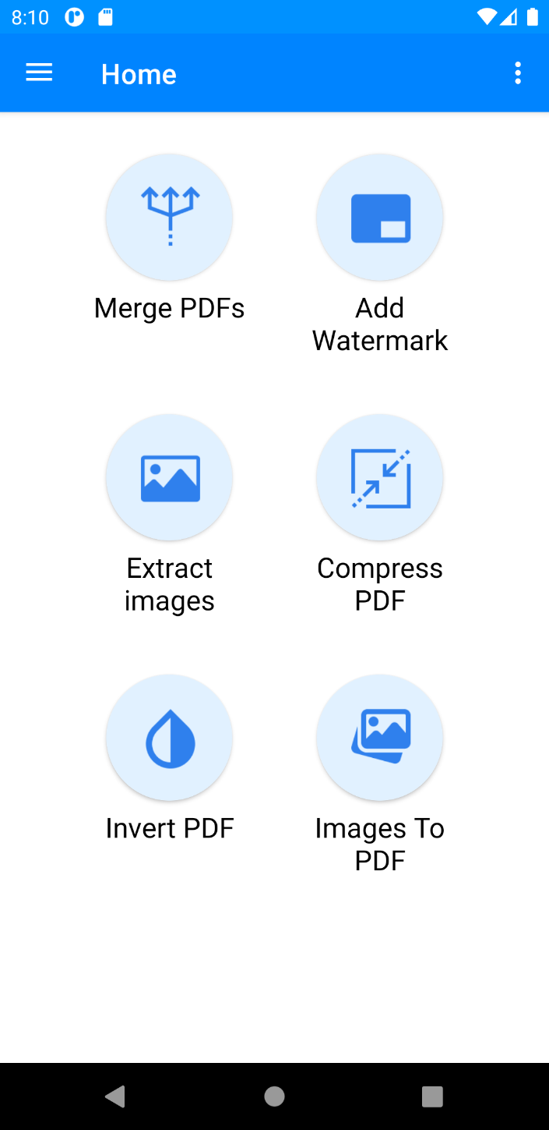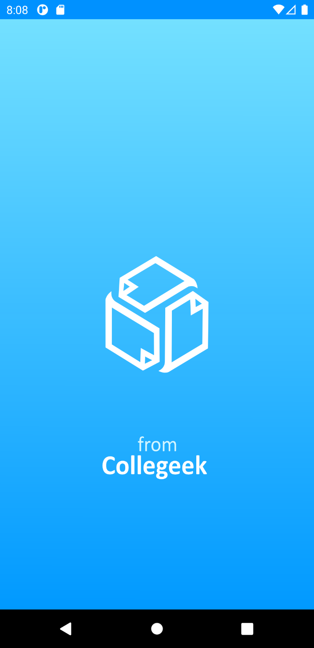

Fig 9.1 – splash screen Fig 9.2 – All features

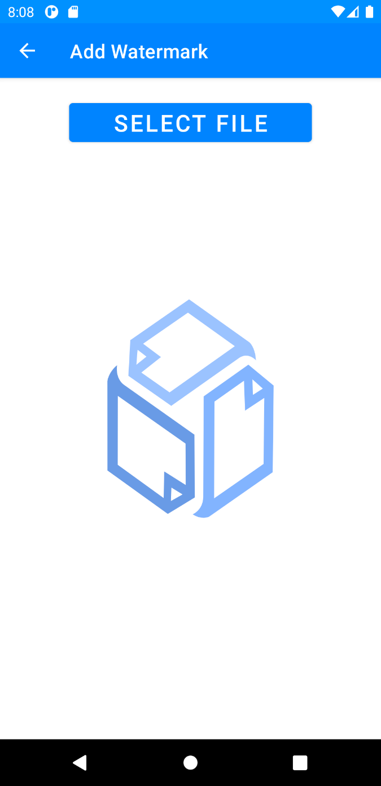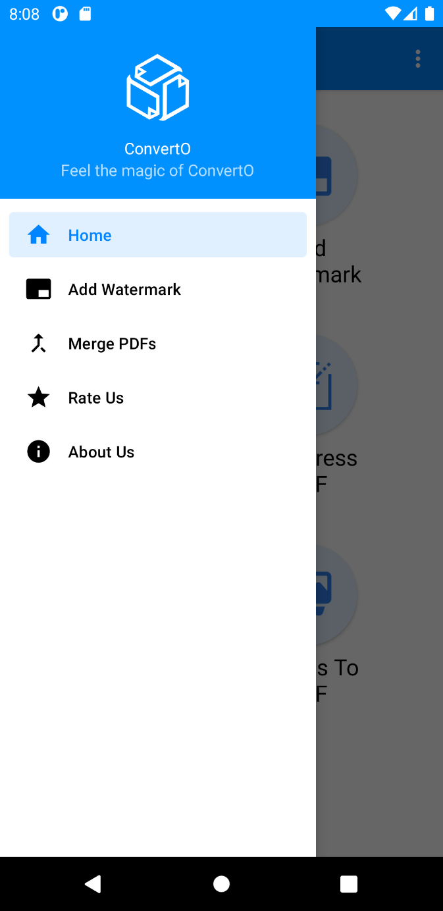

Fig 9.3 – side navigation Fig 9.4 – Let’s add watermark

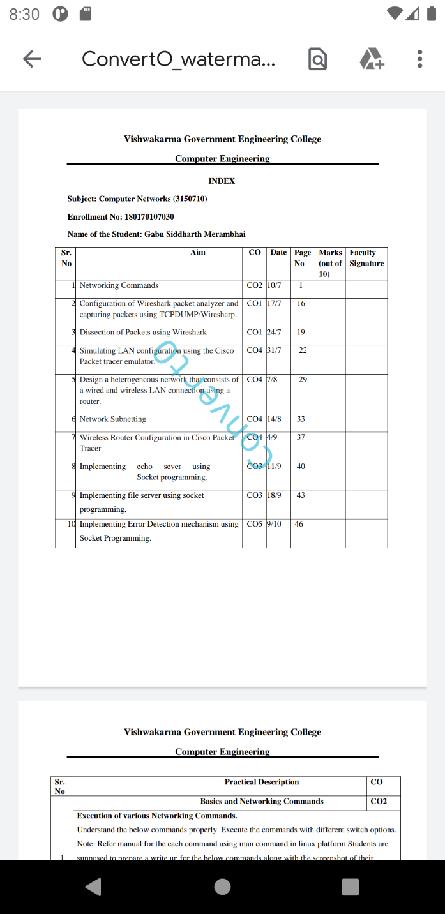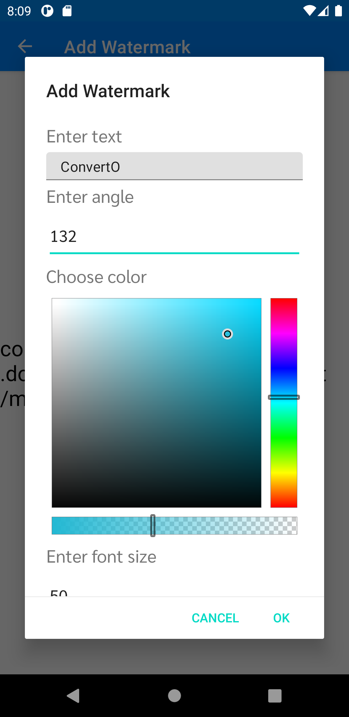

Fig 9.6 – Add watermark Fig 9.7 – Watermark add success

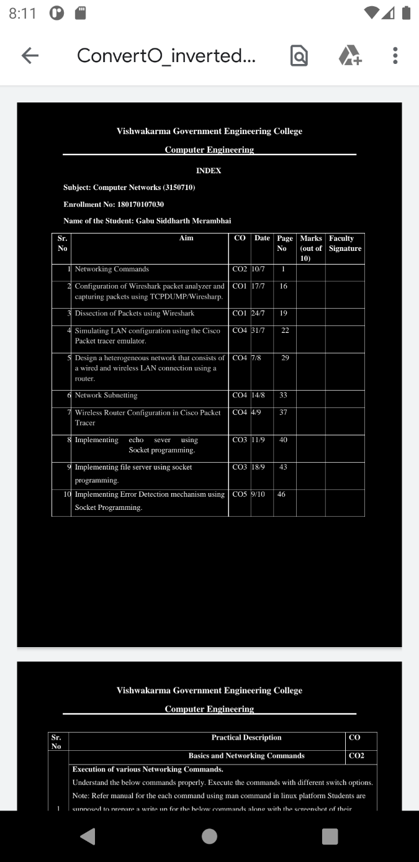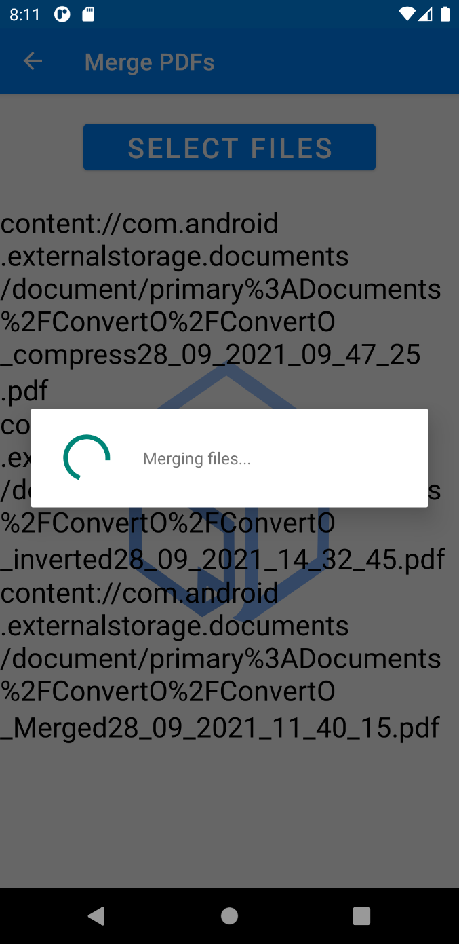

Fig 9.8 – Merging files Fig 9.9 – inverted pdf

Practical – 10

**AIM:** Write Steps to generate an APK File of Mini Project and publish the Application.

**Generate an APK**

Step 1: Go to **Build** 🡪 **Generate Signed Bundle or APK.** Select APK.

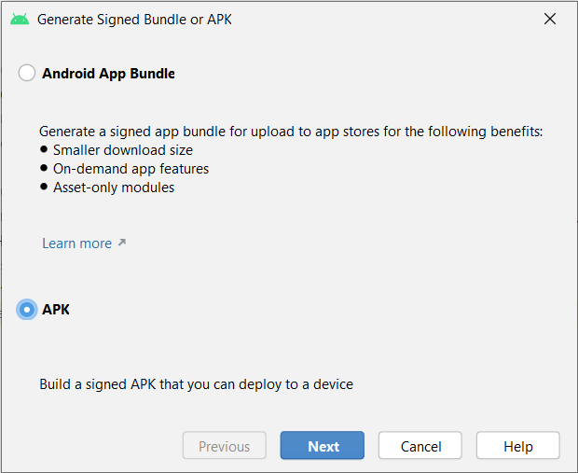

Fig 10.1 – Generate APK

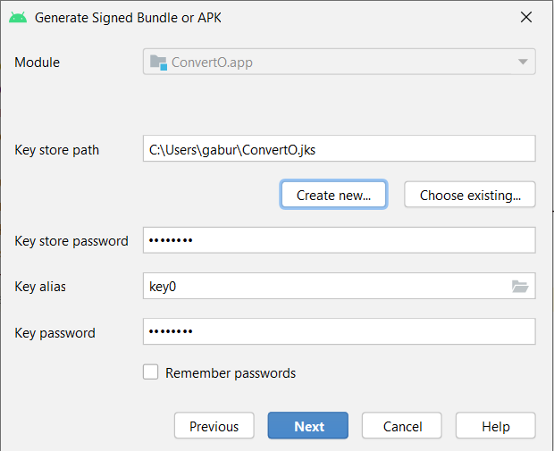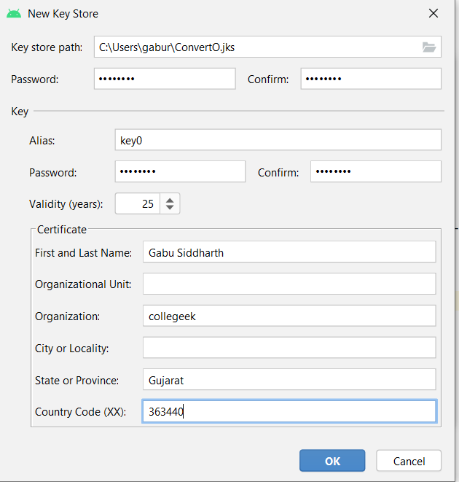

Fig 10.2 Click **Create New** key store Fig 10.3 Create key store

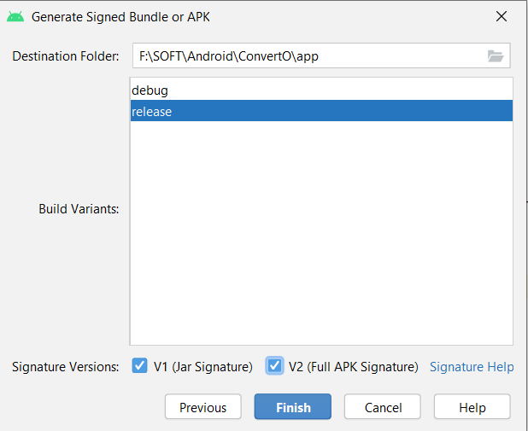Step 2: Create new release

Fig 10.4 create release

Step 3: create new app on Google Play Console

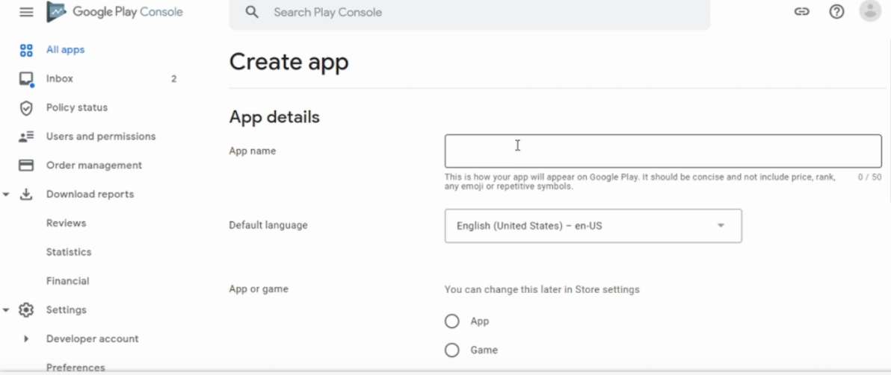

Fig 10.5 create new app on google play store

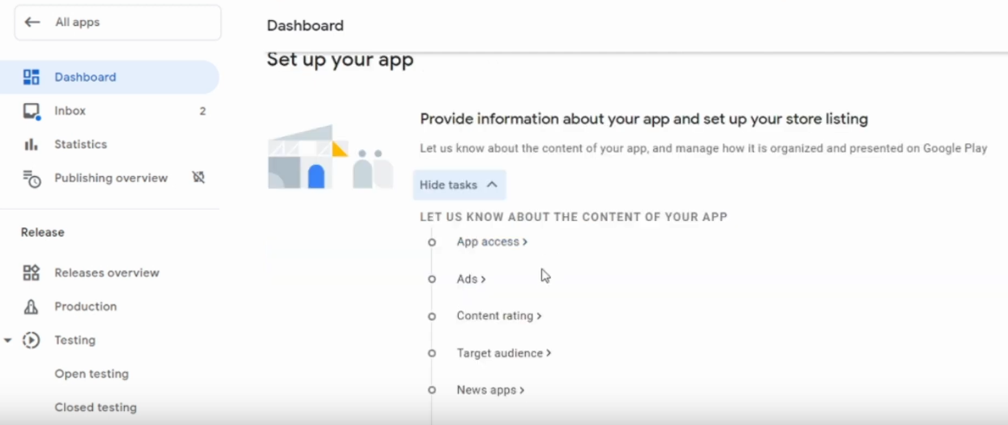Step 4: fill every detail in set up your app

Fig 10.6 – set up app

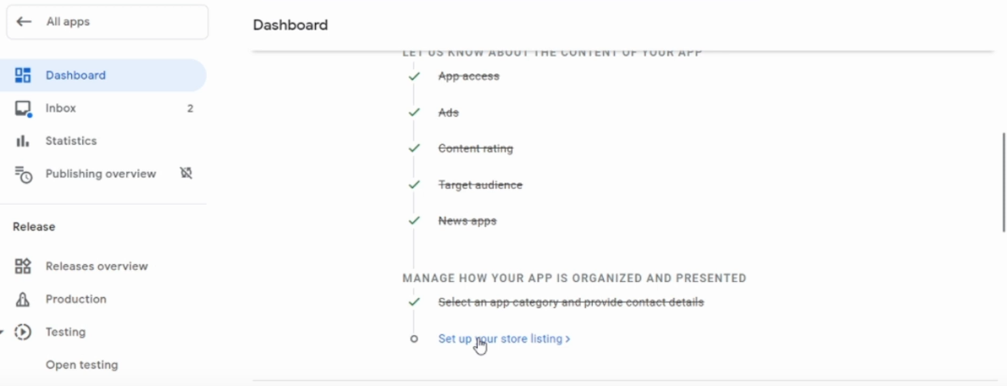

Fig 10.7 – set up app

Step 5: Publish app on google play

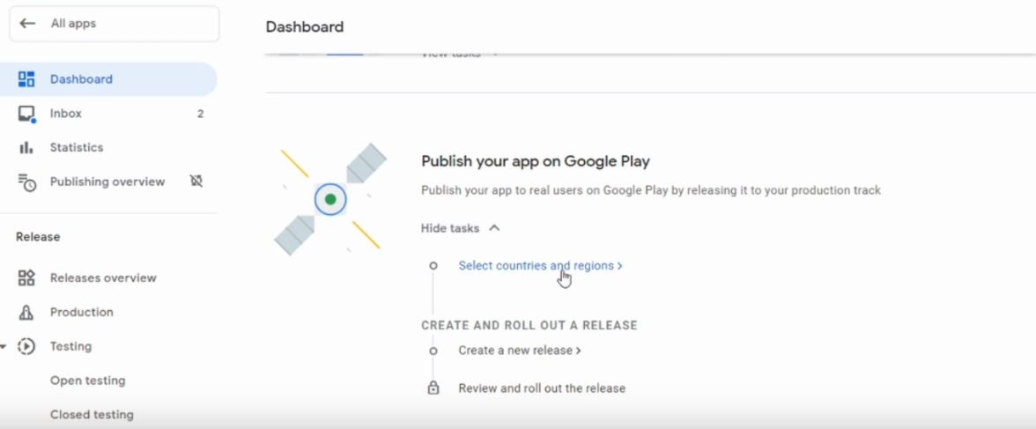

Fig 10.8 – publish app

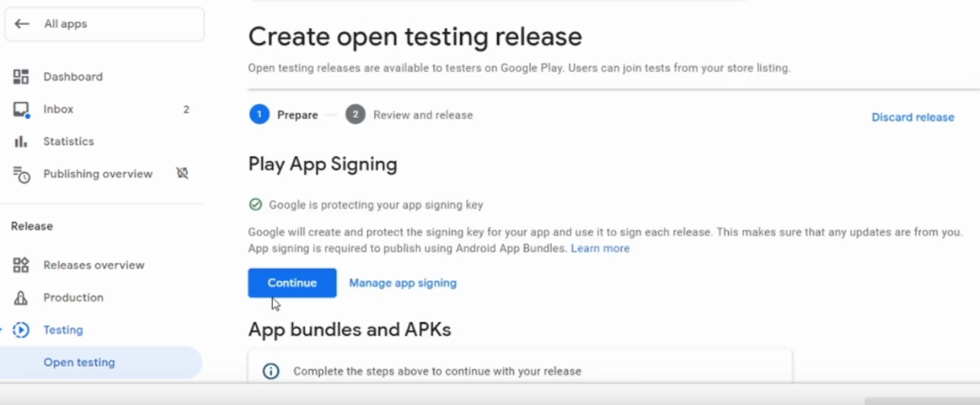

Fig 10.9 – upload signed apk

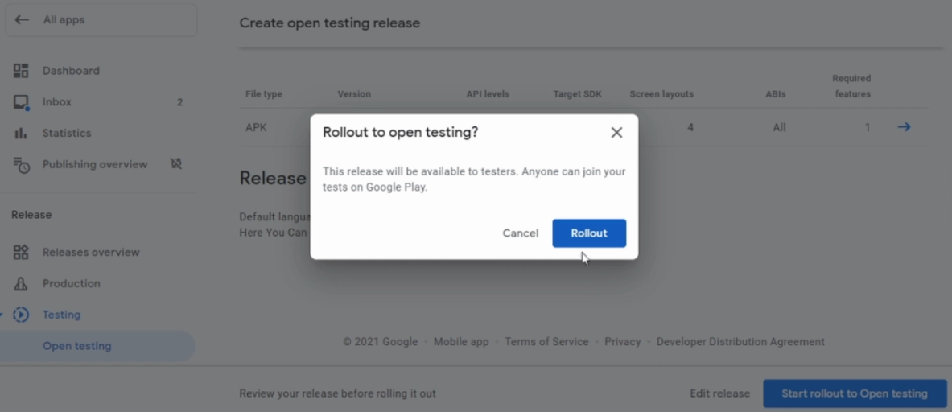

Fig 10.10 – Finally Rollout app